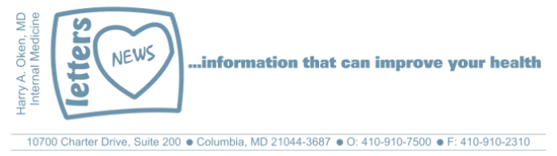
Newsletter 34 – February 2020
Dear Patients,
This infographic puts Coronavirus in perspective for now, but we do not know how this might change in the future.
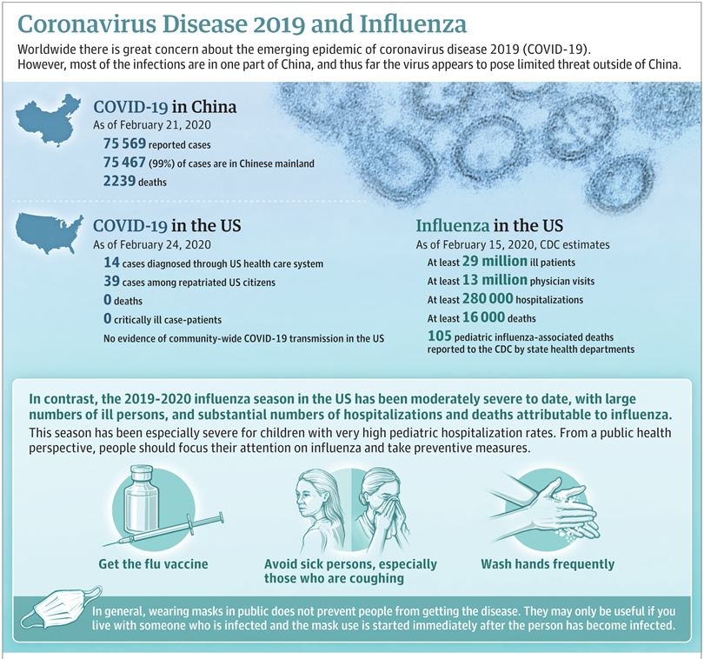
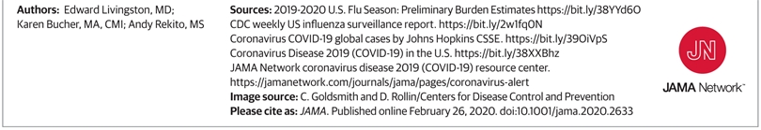
Information is power and I urge you not to just dismiss this as we do not yet know the direction Coronavirus is going.
Let's be in the present moment (no panic) and have a plan going forward. Do not be one of those people that just thinks everything is going to be ok- "the normalcy bias" (everything will be fine just because you are an optimistic person and do not want to plan and because in the past it always seems to be okay).
Here are some things to consider:
- Many of my patients are asking me about overseas travel. Based on what I know today, my advice is not to go overseas. It is less likely you will get the virus, but there is a risk of being caught in a quarantine. And then if you are sequestered in a quarantine your risk for viral transmission likely increases.
- If you get symptoms of a viral infection, cold symptoms, runny nose, cough, sore throat, achy, STAY HOME! As of this writing, the likelihood that this is COVID-19 is extremely low! And if is COVID-19, the likelihood is that it will be a mild, not a severe infection. You may call me at any time to discuss, but we want to minimize you coming to the office, urgent care or ER where you might be infectious to others or pick up something else like COVID-19 or be part of a quarantine situation.
- Presently, travel in this country seems to be safe. Nevertheless, if you are going to airports, subway, train stations, etc. pay particular attention to minimizing your touching of common areas.
- If you are using transportation such as Uber, taxis, etc., be conscious of what you touch. If you are flying or taking a train, use some antibacterial/antiviral wipes and wipe down your area.
- It is now appropriate not to shake hands, use an elbow bump. Go the other way when you see people coughing. Try to wash your hands with soap and water often. If it is not available, use an alcohol-based hand gel.
- Be sure to wash your hands with soap and water (20 seconds) before eating and avoid touching your eyes, nose, and mouth.
- If you are working in an office, start the day by cleaning your phone and keyboard with an antibacterial/antiviral wipe.
- We have no idea if supplements that are routinely taken can be of help, but can they hurt? No. If you are not taking vitamin D-3, take at least 2000 units a day; it is known to have an antiviral effect and it has been shown to decrease the incidence of influenza. It likely has an immune-boosting effect and many people unknowingly are vitamin D deficient.
- If you do not eat well (fresh fruits and vegetables at least 5 servings) take a multivitamin daily.
- There is some question as to whether Turmeric or curcumin can be helpful, it is known to have an antiviral and antibacterial effect, so there is absolutely no downside.
- Presently, there is no role for facemasks, there may be down the road. Unfortunately, N-95 masks are not presently available.
- It is not too late to take the flu shot if for some reason you did not take it.
- Get your rest, fatigue makes you much more susceptible to getting sick.
- Exercise but not too much or not too little, over-exercise can make you more vulnerable to most viral illnesses. Be careful at community pools.
- If you are going to the gym be smart, wipe down your equipment before you start. And after you finish.
- If you have access to a sauna, use it 2-3 times per week. It boosts immunity.
- A few things to be sure you always have on hand: a case of water, plenty of Advil/Aleve, a decongestant (like Afrin nasal spray), consider having a small supply of non-perishable foods such as pasta, rice, oatmeal, canned goods, and batteries.
- There are other foods that boost immunity; check these videos out.
https://nutritionfacts.org/video/boosting-immunity-through-diet/
https://nutritionfacts.org/video/kale-and-the-immune-system/
https://nutritionfacts.org/video/boosting-immunity-while-reducing-inflammation/
https://nutritionfacts.org/2013/12/24/mushrooms-and-immunity/
Be safe and smart, and wishing you well
HAO
Harry A. Oken, M.D.
Office: 410-910-7500 Fax: 410-910-2310 Cell: 443-324-0823
Adjunct Professor of Medicine
University of Maryland School of Medicine

