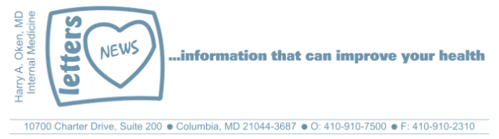
Newsletter 30 – April 1, 2019

Dear Patients,

On March 25, in my role as Medical Director for the Columbia Association, I was one of many who helped to bring our guest speaker, Rip Esselstyn, to Columbia to kick off our Healthy Eating Series. The evening was a success beyond my expectations. Rip gave an inspiring talk about plant-based nutrition, followed by a Q & A with 2 local physicians and a dietitian. We had over 500 people attend and many sponsors, some of which had vendor tables. Our next event will be in the summer so look for details to come.  If you are interested, here is the link to watch the program.  Excerpts from BOOM emails you might enjoy!  On Stress: Click here for music.  Maniac! Okay, we are all a little crazy. Me? I am a maniac, yes, passionate about helping people get healthier! | 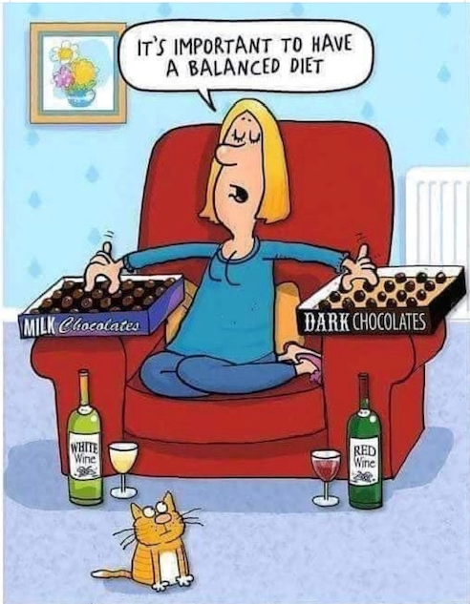
Where your head goes, your body goes -- when things get tough. Translation: how you feel is how you think and how you think is how you feel.
But what about our thoughts? Are they real?
My answer: thoughts are merely thoughts; anxious thoughts make your body feel anxious and an anxious body makes your mind anxious. At the molecular level, thoughts are just chemical energy. Good thoughts can make you feel good and bad thoughts, of course, can pull you down with fear, anger, hopelessness, regret, envy. And what does that do? Well, if you are consumed with bad thoughts, that's called stress and it screws your immune system!
What about the gap between thoughts? Yes, there is a space between thoughts and in that space, nothing is going on. It's quiet, it's tranquil, it is healing. How do we get there? And how can we increase the time gap between thoughts? Generally, that is where exercise takes you: to a head space that is healing and comfortable.
What else can help combat stress?
- Distract yourself with a pleasurable activity (walking, reading, movies, music).
- Enjoy your work!
- Be social!
- Meditation (headspace check it out)
- Acupuncture
- Do not forget to smile and appreciate what you have! Gratitude!
- Eating well is particularly helpful!
On Friendship:
You got a friend? (CLICK!)
When you think of the things that make you happy, what comes to mind? To me, it is family, health, friends, meaningful work and things to look forward to you. These play an integral part of our lives.
Let's talk about friendship, old friends and new friends; they form our social connection and it is indeed a healthy remedy for our being.
And what is the science? Having good friends and participating in social events boosts our immunity, we are social animals!
So be social and cultivate your relationships...it's good for your health! Reach out to your friends and enjoy them!
“A friend is someone who knows all about you and still loves you.” ― Elbert Hubbard
On Self Pity:
Forever--click below
When you're falling in the forest and there's nobody around, do you ever really crash or even make a sound?
Dear Evan Hansen:
Imagine an 18-year-old, his father left when he was very young, his mother was pre-occupied with things other than Evan, and no close friends. Evan is the last person to see his classmate before the classmate commits suicide. Evan then becomes part of a lie that gets out of hand (thank you social media) to the boy's parents and sister. The grieving boy's parents and sister think Evan was best friends with their lost son/brother. They cling to Evan's made up memories of their son/brother. The reality is Evan is isolated, anxious and depressed, and he himself tried to commit suicide (purposeful fall from a tree in the forest, he breaks his arm, not his neck) the summer before 12th grade started. Evan's journey leads to his self-enlightenment about the destructive nature of self-pity.
Putting Evan aside, and again from the book "The Art of the Good Life" by Rolf Dobelli:
"Self-pity is one of the most useless responses to life's trials. Self-pity doesn't change anything. It does the opposite, in fact, because self-pity is an emotional whirlpool, a spiral that sucks you deeper down the longer you're bobbing around it." If you find yourself in a hole, stop digging.
On Making Changes:
"Somebody has to do something, and it's just incredibly pathetic that it has to be us." Jerry Garcia, The Grateful Dead
Keep Truckin On (CLICK IT!)
Yes, one body, one life, what we do with it...it's all up to us.
We oftentimes have people in our lives who we try to help point in the right direction. Or maybe it's ourselves and we are trying to get where we need to go to attain optimal health. For people in our lives, as well as ourselves, we have to find the power, the will, the discipline, to make changes that improve our lives. Why? Because inherently we are not selfish people; we love and care about those who depend on us and we need them.
Why do people make a change? What is the event? What is the trigger?
Sometimes, it's just the sum of many events making you miserable. For most people, if miserable enough, they will make a change. Like the person whose knees hurt so much and they cannot do the things they want or need to do; they either use a wheelchair or lose weight or get a total knee replacement.
Sometimes it's a hurtful comment from someone, sometimes it's visual like seeing a picture of yourself.
Unfortunately, the message is often delivered too late and it's bad news--a heart attack, stroke, cancer, or diabetes.
It is true that most often, no matter what other people say, the person who needs to make change has to make the decision themselves, but understand that a loving family, close friends and health care professionals play a role in leading up to the moment when the switch is triggered and then you find the discipline, willpower, and strength to go for it. So, that is part of my role as a doctor, a teacher, a father, a husband, a friend, to do what I can to point the way and always trying as best as I can to walk the same road. The journey is long, one step at a time, and once you have reached the point of a healthy change; it never, never, never stops--maintenance of the change requires the same hard work!
Do not give up on yourself or the people you care about! BOOM!
Wishing you well
HAO
Harry A. Oken, M.D.
Office: 410-910-7500, Fax: 410-910-2310
Cell: 443-324-0823
Adjunct Professor of Medicine
University of Maryland School of Medicine

 |  |  | 

