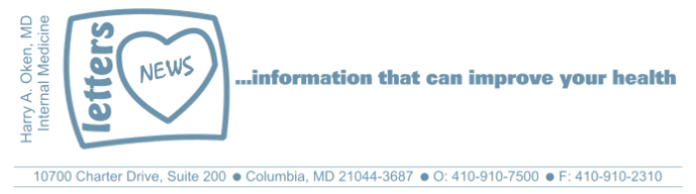
Newsletter 29 – March 5, 2019
Dear Patients,
First, an invitation; mark your calendars and please attend!
Want to learn more about plant-based healthy eating? As the medical director of the Columbia Association, I am helping to lead an initiative to enhance the community's understanding of nutrition. Come to the free kick-off event of our Healthy Eating Series, "Learn What Works for You" on Monday, March 25 at the James Rouse Theater. Free and open to the public but space is limited, register now.
Rip Esselstyn, a firefighter, author of several books and a nationally known speaker, has helped thousands extinguish their unhealthy eating habits. He will talk to us about how he changed his life. I hope you can join us!
An excerpt from a recent BOOM email you might enjoy: Click here for music.
Maniac!
Okay, we are all a little crazy. Me? I am a maniac, yes, passionate about helping people get healthier!
Where your head goes, your body goes, when things get tough.
Translation: how you feel is how you think and how you think is how you feel.
But what about our thoughts? Are they real?
My answer: thoughts are merely thoughts; anxious thoughts make your body feel anxious and an anxious body makes your mind anxious. At the molecular level, thoughts are just chemical energy. Good thoughts can make you feel good and bad thoughts, of course, can pull you down with fear, anger, hopelessness, regret, envy. And what does that do? Well, if you are consumed with bad thoughts, that's called stress and it screws your immune system!
What about the gap between thoughts? Yes, there is a space between thoughts and in that space, nothing is going on. It's quiet, it's tranquil, it is healing. How do we get there? And how can we increase the time gap between thoughts? Generally, that is where exercise takes you: to a head space that is healing and comfortable.
What else can help combat stress?
- Distract yourself with a pleasurable activity (walking, reading, movies, music).
- Enjoy your work!
- Be social!
- Meditation (headspace check it out)
- Acupuncture
- Do not forget to smile and appreciate what you have! Gratitude!
- Eating well is particularly helpful - please come to our first healthy eating seminar!
BOOM - the details:
BOOM stands for Boost Our Own Metabolism and is a program that I developed that combines nutritional instruction with exercise. I teach critical nutritional points and provide tips for improving sleep and stress levels. We spin on the studio bikes to music using a High-Intensity Interval Training (HIIT) format. My assistant, Stacey, leads the spin portion and this is preceded by my brief talk on the topic of the week. An email is sent prior to each BOOM session on the topic of the week. If you're unsure whether or not you are healthy enough to participate, please send me an email and I can let you know if BOOM is right for you.
Here is a video about BOOM: https://youtu.be/kbnhzxjN3YE. Please note that the details regarding days and dates in the video DO NOT pertain to this upcoming session.
Here are the registration instructions:
Columbia Association members (no charge):
CA Fit & Play members can sign up beginning at 2:00 pm on Mondays either through the CA website or app. Alternatively, call the Athletic Club 410-730-6744 beginning 2:00 pm on Tuesdays.
PP CA Fit & Play and 1Fit members can sign up for the class on a space available basis 5 minutes before the start of class.
Non-members:
Registration and payment can be made in person at the front desk of the Columbia Athletic Club or by calling there 410-730-6744. Please note that payment must be made for an entire month; there is no pro-rating or refunds for partial months.
March, April, and May - 4 sessions per month; $40 fee per month

As always, wishing you well--HAO

Harry A. Oken, M.D.
Office: 410-910-7500
Fax: 410-910-2310
Cell: 443-324-0823
Medical Director, The Columbia Association  Adjunct Professor of Medicine  University of Maryland School of Medicine | 