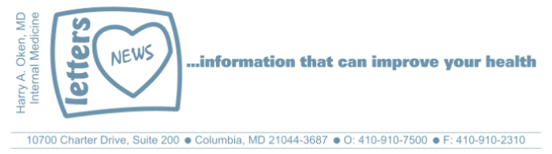
Newsletter 26 – June 14, 2018
Graduations present an opportunity to hear from successful alumni who are asked to give commencement addresses to young students as they embark on new challenges. Michael Keaton ended his commencement speech last month at his alma mater, Kent State University, in the best way possible - by delivering one of his most iconic lines ever and saying "I'm Batman". Keaton played the very first Batman in 1989.
Watch this YouTube video: https://www.youtube.com/watch?v=KAVvny-FxjA
Throughout my 31 years of practice, I have seen countless people who are worried. Sometimes their worries are specific, other times they feel anxious and do not know why. For most of us, the core of our worry is one simple but powerful negative emotion: FEAR. And usually, fear is generated by False Evidence Appearing Real.
Unchecked fear promotes physiologic changes in our body that elevate stress hormones and effect levels of neurotransmitters in our gut and brain that ultimately negatively impact our immune system. A weakened immune system, as you may know, increases our risk of morbidity and mortality (cancer, infections, degenerative diseases and rapid aging).
How we think is how we feel, and how we feel is how we think. If we can acknowledge and understand our fear, we can then move forward. Mark Twain once said: "Courage is resistance to fear, mastery of fear -- not absence of fear."
To me, hearing Keaton saying, "I'm Batman" means to be brave and go forward in the face of fear. Seize the day, take care of yourself, take care of others, eat well, sleep well, and dismiss your fears.
Enjoy this link to The Piano Guys playing the theme music from Batman: "Batman Evolution" . Listening to this music takes me back to my childhood, enjoying comic books, where superheroes like Batman inspired me!

Wishing you good health,
HAO
Harry A. Oken, M.D.
Office:
410-910-7500
Fax: 410-910-2310
Cell: 443-324-0823
Adjunct Professor of Medicine
University of Maryland School of Medicine

