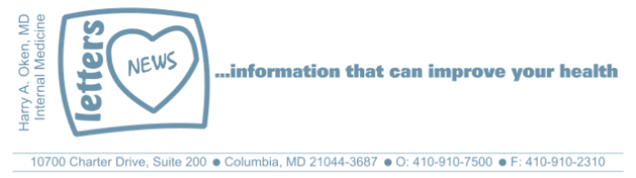

December 2016

Dear Patients,

First, thank you for allowing me the privilege of being your physician.
I recently met with my friend and mentor from medical school, Steve Schimpff. Steve established himself as a world class infectious disease specialist and oncologist, and then later as CEO of a large academic teaching hospital. Since his retirement, Steve has authored a number of books. His most recent book is called the "Fixing the Primary Care Crisis". The theme of the book -- and something I strongly believe -- is that changes in medicine, technology, and hospital care have gradually deteriorated the physician-patient relationship. The result has been an increase in needless testing, a decrease in physician-patient communication, inefficient hospitalizations, patient dissatisfaction, and of course costs, more money.
Through an interesting series of events, Steve's book was brought to the attention of the CEO of an enterprising startup company aimed at driving down health care costs through at-home care. Interested in Steve's message about the primary care system, the CEO asked Steve for a meeting. Steve suggested that I join them, and I agreed.
One statistic in particular stood out to me during that meeting: The average hospital stay for a patient hospitalized with pneumonia is 4.4 days, at a total cost of $16,000. A number of those patients will be readmitted, costing the system even more. Using this startup's inventive approach -- which employs cutting-edge technology, visiting nurses and aides, physical therapy, nutritional support, and (perhaps most importantly!) oversight of a primary care physician -- would cost $8,000 for 30 days of care. This setup would allow patients to be moved swiftly out of the hospital -- an overloaded, expensive, error-ridden atmosphere -- and into their own homes under the care of their primary care physician with much less likelihood of re-admission. I look forward to watching this startup grow and, hopefully, helping this vision come to fruition.
Every once in a while you meet people that have infectious energy and humor that captivate you with their new ideas. During our lunch meeting, I noticed the CEO took notes in a bound notebook, the title on his book was "Make it Happen". I am a list maker and now at the top of every list I start, I write "make it happen". I hope to contribute to this enterprise as it develops. And I want to empower you to "make it happen" in your own life. Remember the "big four" pillars of immunity: good nutrition, the right amount of exercise, restorative sleep, and stress control. Your immune system protects you from infections, searches for and destroys abnormal cells (cancer), and helps to prevent age-related deterioration. Want to learn more? Stay tuned for information on the Columbia Association's BOOM Program, beginning again in mid-January. I will be a part of the program to help you "make it happen." If you are interested, here is a video produced last year about BOOM, the course has changed a bit by the principals are the same: Click Here.

Lastly, as always, a music video for your enjoyment, Chicago "We Can Make it Happen".
Wishing you good health and happy holidays!
HAO

Harry A. Oken, M.D.
Clinical Professor of Medicine
University of Maryland School of Medicine
Office: 410-910-7500, Fax: 410-910-2310
Cell: 443-324-0823

Confidentiality Statement:
This email message, including any attachments, is for the sole use of the intended recipient(s) and may contain confidential and privileged information. Any unauthorized use, disclosure or distribution is prohibited. If you are not the intended recipient, please contact the sender by reply email and destroy all copies of the original message.

