- 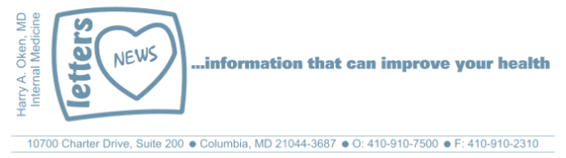

January 24, 2016

Dear Patients,

Recently a woman who I admired and one of my wife's good friends passed away after a battle with cancer. Everyone who knew Sally loved her. How could you not? She was always positive and never let silly little things bother her. Sally was a drama teacher in Howard County; she worked with my kids and touched the lives of thousands of other high schoolers. She inspired her students, some of who continued on to have careers in theater and are now famous. She brought out the best in people; it was hard not smile around her. She was a devoted mother, wife and wonderful friend and she had hundreds of them.

Sally took care of herself, ate well, exercised at Body Pump with my wife for years, loved to do Pilates and she was a genuinely happy person. So when the diagnosis came of advanced cancer, it was just shocking. It's a scary story and causes us to pause. It seems so unfair; Sally was just too young to pass away. How did this happen? Why did it happen? Could this not have been detected sooner to give her a more likely chance for remission? Sadly, there are few answers, just many questions. You might even think what the heck? If this can happen out of the blue to someone who took care of themselves, maybe it doesn't matter what I do. Well, I do have an answer for that one: it does matter. For most of us, we get what we create. For Sally, at present, there is just no explanation. However, I am certain that one day in the near future, we will be able to precisely target many more types of cancer and provide remedies that treat it very effectively. Furthermore, we will have tools to identify cancer at its earliest of stages.

I think most people do some soul searching when they lose someone. I think that many also do some soul searching at the beginning of a new year. We pause and we think about what we can do to be a better person. Here are some of my own musings:

Put your health first, above anything else. You cannot take care of the people you love unless you take care of yourself. It's selfless, not selfish.

- Non judgement. This includes yourself and others, do not beat yourself up and do not judge others. Most people are probably dancing as fast as they can.
- Kindness always. It costs nothing; it is easy to do and feels good.
- No strings attached. If you do something for someone else, expect nothing in return. You might be surprised that doing the right thing comes back to you double!
- Resolve to make a difference everyday no matter how small, a simple smile or acknowledging that you know someone's name really can make a difference.
- Eat better, sleep better, move more.
- Take a few minutes every day to be grateful for what you have.

There are so many situations in life that can get us down: a relationship gone sour, an incapacitating illness, the loss of a loved one or friend. Or the daily turmoil we see playing out in the world: the political theater, the chaotic financial markets, global warming, the Middle East, North Korea, on and on. You may enjoy this passage from Scott Peck's The Road Less Traveled. I read it periodically when I feel there needs to be a reason that bad things happen.

Life is difficult.

This is a great truth, one of the greatest truths. It is a great truth because once we truly see this truth, we transcend it. Once we truly know that life is difficult - once we truly understand and accept it - then life is no longer difficult. Because once accepted, the fact that life is difficult no longer matters.

Most do not fully see this truth that life is difficult. Instead they moan more or less incessantly, noisily or subtly, about the enormity of their problems, their burdens, and their difficulties as if life should be easy. They voice their belief, noisily or subtly, that their difficulties represent a unique kind of affliction that should not be and that has somehow been especially visited upon them, or else upon their families, their tribe, their class, their nation, their race or even their species, and not upon others. I know about this moaning because I have done my share.

Sally helped countless young men and women be better people as their teacher and mentor. She loved Broadway productions; besides providing entertainment, she knew many shows were conveying important messages about life: our ups and downs, our joys and sorrows, about love, relationships and purpose. Enjoy this song and the lyrics from the Broadway show "Wicked". The lyrics are meaningful to me and probably anyone who knew Sally or has lost a loved one or friend.

https://www.youtube.com/watch?v=AvWfHIo5-kU
Happy New Year and wishing you good health – HAO
Harry
Harry A. Oken, M.D.
Clinical Professor of Medicine
University of Maryland School of Medicine

