

March 5, 2015

Dear Patients,
This past weekend, one of our dogs, Cutha, passed away. We rescued her 6 years ago, when she was 8 1/2 years old. When we first adopted her, she was skinny and hungry, she was a counter surfer! She learned quickly though that there was no need to steal food from the counter, but that she would be cared for and nourished with food and love.
Cutha was our second Old English sheepdog, but our first rescue. Instantly and easily she became part of our family. It was only over the last year that her age began to catch up with her; in human years she was 105! We all knew the end was coming and we all dealt with it in different ways, but in the end, we are left with being so thankful we had Cutha!
Losing a dog just once can, for some people, be so hard they may never want to have another. Not so for me, I am just so grateful to have had Cutha. Her leaving reminds me that everything changes and nothing remains the same. When you can learn to accept that instead of clinging to the past, it makes life a bit easier.
How do you go forward in the face of loss or the adversity of challenge?
Be in the moment and make the most of it. Intend to experience the next moment, next hour, next day, next week, next month and the next year, fully. It all starts with the intention to be present and mindful and then that intention turns into action and then you will get what you create.
Extend kindness always. Smile whenever you can. Clear your mind with meditation, exercise daily, eat healthy and sleep well, These healthy practices tip the scales in your favor for a longer, healthier, fuller life. We all have the same ultimate destination; when and how we get there defines the journey. If you are a sailor, you know you cannot control the direction of the wind but you can change the position of the sails.

Enjoy the poem below and in keeping with my Broadway themes in past newsletters, I have selected a YouTube video to improve your outlook on this snowy grey day; "Tomorrow" is just a day a away! Click here: http://youtu.be/lbjfOZiWVbA.
PAWPRINTS LEFT BY YOU
author unknown
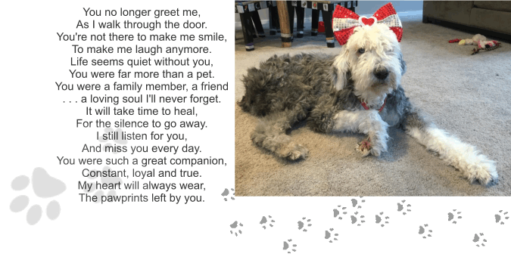
Wishing you good health,
HAO
Harry A. Oken, M.D.
Clinical Professor of Medicine
University of Maryland School of Medicine
Office: 410-910-7500 Fax: 410-910-2310

