
COVID-19-99 – February 10, 2022
Dear Patients:

I am currently reading the book Think Again: The Power of Knowing What You Don't Know by Adam Grant. Trying to solve a problem using the same thinking and tools that did not previously work is unlikely to give you a different result. So go back to the start and think again.

Paraphrased from Adam Grant - things people say instead of rethinking a problem:

- we have always done it that way
- that is not what my experience has shown
- that is too complicated; let us not overthink it
- that will never work here

Grant writes "As we think and talk, we often slip into the mindsets of three different professions: preachers, prosecutors, and politicians. In each of these modes, we take on a particular identity and use a distinct set of tools." "The risk is that we become so wrapped up in preaching that we're right, prosecuting others who are wrong, and politicking for support that we don't bother to rethink our own views."

Maybe the best mode is the scientist mode, a mode of thinking that differs from preaching, prosecuting, and politicking. In the scientist mode, we are searching for the truth: we run experiments to test hypotheses and discover knowledge. When psychologists studied eminent scientists such as Linus Pauling and Jonas Salk, they concluded that what differentiated them from their peers was their cognitive flexibility, their willingness "to move from one extreme to the other as the occasion requires." Doubt what you know and be curious about what you don't know and update your views based on new data.

And so it is with our Pandemic: what we thought we knew when it started and what we know now is far different, and as we go forward, we will have to adjust. Unfortunately, information is politicized, and the media tends to catastrophize every event and then demonize those who go against the groupthink instead of encouraging people to engage in robust debate and share other views to develop a working plan.

-
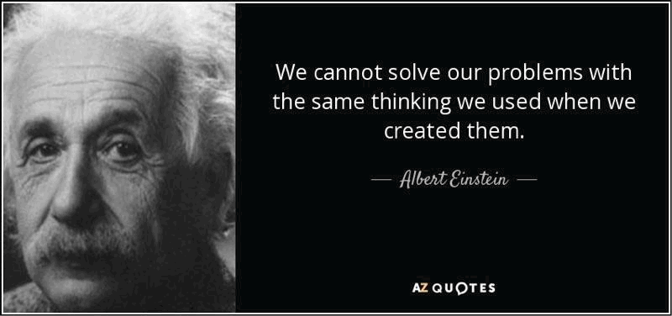
-

COVID-19 Update:
- The Maryland mask mandate has been lifted. That does NOT mean you should not exercise good
judgment and continue to wear a mask in situations that elevate risk such as indoor crowds.
- The 7-day positive prevalence in Maryland has dropped dramatically. As of today, it is 5.1%.
- 81% of Marylanders are fully vaccinated, which means that 1 out of 5 are not.
- An Israeli study shows that a 4th Pfizer booster is not effective for holding off Omicron.
- New generation vaccines may be more durable and broader in protection. The sub-unit protein vaccine
has now been approved in 175 countries and Emergency Utilization Approval has been filed with the
FDA.
- Our strategies for finding remedies for long-haulers are improving - anti-virals, monoclonal antibodies
and anti-inflammatories.
- Take your Vitamin D - at least 2000 units of D-3 per day. In a new study, those with
vitamin D deficiency were 14 times more likely to have severe Covid.

-
On a musical note:

The Scientist, by Coldplay, is a great song, and I particularly like the repeating lyrics "go back to the start."



-

-
On a lighter note:
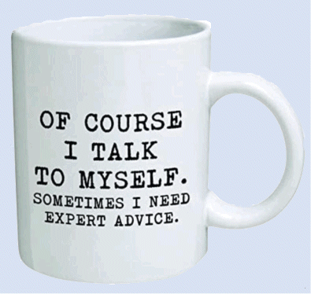

-

As a reminder, I'm updating you periodically. I continue to enjoy writing these updates. Initially, these were only sent to my patients, however, I've been humbled to learn that, through social media, these writings have been forwarded and re-forwarded to many. This has brought me great joy to know that this simple act of sharing facts, thoughts, opinions, and hopes have touched you in some way. Hopefully I've been able to reassure you, maybe make you smile and laugh, soothe your worries, and comfort you. And maybe, just maybe, I've helped you to be in the moment!
Reach out. Stay connected. Stay home. Save lives. The power of one. Be well.
Feel free to forward this on, spread the word, not the virus.
HAO
HAO
Harry Oken, M.D., Adjunct Professor of Medicine, University of Maryland, School of Medicine
Office 410-910-7500 |Fax 410-910-2310 |Cell 443-324-0823

View previous newsletters: http://harryokenmd.com/COVID-19-HOME.htm

Links for today

- “Think Again”, Adam Grant
https://www.amazon.com/Think-Again-Power-Knowing-What/dp/1984878107/ref=sr_1_1?crid=138IF911G6SRB&keywords=think+again+by+adam+grant&qid=1644539584&sprefix=adam+grant+-+think+again%2Caps%2C104&sr=8-1
- 4th Pfizer booster is not effective for holding off Omicron
https://www.reuters.com/world/middle-east/israeli-study-shows-4th-shot-covid-19-vaccine-not-able-block-omicron-2022-01-17/
- Vitamin D deficiency were 14 times more likely to have severe Covid
https://www.forbes.com/sites/michaeltnietzel/2022/02/05/new-research-suggests-importance-of-vitamin-d-in-protecting-against-severe-covid-19/?sh=3f0563222ae4
- “The Scientist”, by Coldplay
https://www.youtube.com/watch?v=s70OsXlDD94

