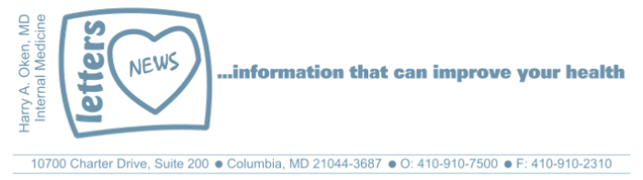
COVID-19-120, December 28, 2023
Dear Patients:
The holiday season, from Thanksgiving to New Year, is a special time for most of us. For me, life slows down a bit and I reflect on gratitude for my family, health, and meaningful work that I am privileged to do. For decades, at Thanksgiving dinner, I have always given a short talk to our assembled family, and below is a summary of what I said.
I asked the group: do you believe in magic?
I do, sort of. Words do matter - they can create magic.
What kind of words? Love, gratitude, forgiveness, trust, hope, and kindness, to name a few.
Let me give you an example of how words can work magic.
Recently, I gave serious health news to a patient. Several days later, I saw him back in the office to talk. He was understandably upset, despondent, and quiet. He could not sleep or eat and hardly interacted with his family or friends. He barely gave me eye contact. We sat together quietly for a while. After some awkward silence, I told him he was loved, that he was not alone, and that he could trust that the people he cared about would be there for him. I put my hand on his shoulder, smiled, and told him we would work together to improve things. He immediately "magically" brightened up and we created a plan. Words that describe feelings and actions can be magical and matter.
_______________________________________________________________________________
On a musical note:
You Can Do Magic, America's last big hit, was written by a British musician, Russ Ballard, who was inspired by his fascination with magical things that could not be explained, and his belief that "we all have a bit of magic in us."
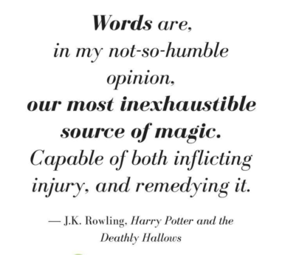
_______________________________________________________________________________
May you all have many days in your life, but more importantly, may you have life in your days. Happy and healthy holidays!
_________________________________________________________________________________________

On a musical note:
You Can Do Magic, America's last big hit, was written by a British musician, Russ Ballard, who was inspired by his fascination with magical things that could not be explained, and his belief that "we all have a bit of magic in us."
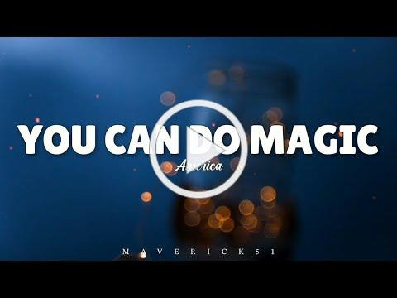
_________________________________________________________________________________________

I continue to enjoy writing these updates. Initially, these were only sent to my patients, however, I continue to be humbled to learn that, through social media, these writings have been forwarded and re-forwarded to many. This has brought me great joy to know that this simple act of sharing facts, thoughts, opinions, and hopes have touched you in some way. Hopefully, I've been able to reassure you, maybe make you smile and laugh, soothe your worries, and comfort you. And maybe, just maybe, I've helped you to be in the moment!

HAO

Harry Oken MD
Former Chairman of Medicine 1994-2008
Howard County General Hospital

View previous newsletters: http://harryokenmd.com/COVID-19-HOME.htm

LINKS FOR TODAY
- You Can Do Magic, Russ Ballard
https://www.youtube.com/watch?v=THtAcf-yT1I

