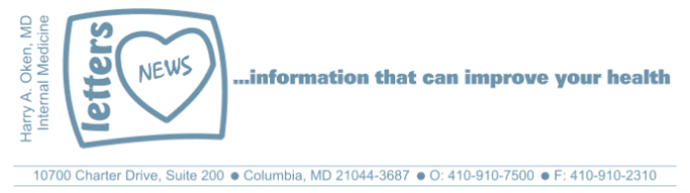
COVID-19-119, October 31, 2023
Dear Patients:

My friend and former partner when we were part of Charter Internal Medicine, Jerry Seals, passed away last week. Many of you may remember Jerry and some of you may have been treated by him. Jerry spent the last seven years of his life at a local Alzheimer's unit, yet I lost him a few years after his dementia diagnosis was made. His health-span was cut short, but his lifespan stretched out. That period of time was agonizing for everyone who loved Jerry.

I think a lot about our purpose, connections, and how to live a productive, rewarding life. I get this image of life. We all start as a large reel of string. And life tugs our string. The circumference of the reel starts huge, but as the string is pulled, the circumference starts to decrease, and the reel turns faster and faster. This could be why it is hard to process how fast time passes.

You can help slow the tug on the reel of string by eating well, getting restorative sleep, and regular exercise. But I am convinced that the most significant factor is how we deal with the stress in our lives. Trying to be a problem solver versus a problem reactor is always important. Giving of yourself to others helps as well. Kindness is a longevity tonic, for sure. Glen Campbell knew this and sang about it in Try A Little Kindness. Glen was also a victim of dementia.

Many of you knew Jerry, but even if you didn't, you might find the memorial that I wrote and was read at his Celebration of Life, fascinating and emblematic of the special kind of person he was (see below):

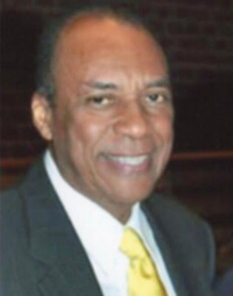
Remembering Jerry

Jerry E. Seals: 11/1/1946 - 10/13/2023

My friend and partner, Jerry Seals, was a physician pioneer in Columbia. He and Bev arrived in 1980 and Jerry established a private practice in internal medicine and infectious diseases. Jerry was one of many young physicians providing care to a growing population in Howard County. Of note, he was one of a small number of young, well-trained African American physicians who established successful practices in Columbia, which we all know is a special place that celebrates diversity and equity. Jerry was the only infectious disease specialist in Howard County until the early 2000s. He was essential to our community; he had his special skills, and he helped to create the first Infection Control Committee for Howard County General Hospital. He was a valued member of the Board of Trustees before our Hospital was part of the Hopkins System. But there is much more....

Jerry began his early life in Mississippi and often talked about his childhood best friend, a dog named Bullet. It is funny that he would remind me often how much he loved that dog. Eventually, the family moved to Buffalo. He earned his bachelor’s degree in Pharmaceutical Science and then went to medical school at Columbia University School of Physicians and Surgeons in New York City. He did his residency at Harlem Hospital. He then went to the CDC and was an infection control officer. It was in Atlanta that he met Beverly, and ultimately, they settled in Columbia, which was still in its teenage years.

Jerry left his own private practice and joined the Columbia Medical Plan in 1985. I met Jerry in the late 1980s. We bonded easily and it began with a most unusual, very ill, ICU patient. Ultimately, we published it as a case report in a supplement of the Maryland Medical Journal. We partnered together to solve this challenging case of a young man who was 18 years old and lived on a Howard County horse farm and presented to the emergency room in a coma. If touched or disturbed, the patient responded with jerky shivery motions and repetitive flexion at the waist. We spent weeks taking care of this young man and made inquiries around the state; there were no clear-cut answers. Together we chipped away at the diagnosis, and we were eventually able to figure him out. This was before we were partners, but it began our strong friendship. The patient ultimately made a total recovery, and we were able to diagnose this as a unique rare case of cat scratch encephalopathy.

In those days, in the 1980s and 1990s, our days started in the early morning at the hospital; this was before there were hospitalists and intensivists. We rounded, then we then saw our patients in the office, and then we often went back to the hospital for the final rounds of the day. Every day, we came to work in a dress sport coat and tie, dapper Jerry always looked good; he was more of a suit guy with a starched white shirt. He walked with a unique swagger and almost always a smile on his face. Jerry loved to laugh and had a wonderful sense of humor. I always enjoyed listening to him tell the story of when he met Oprah, and the story got better every time he told it. In the early 1980s, Oprah was working for the local news channel, she was looking for an interview with a physician about an infectious disease topic; she reached out to Jerry and interviewed him. Jerry was sure she was flirting with him and told me and everybody else who would listen that she called him “Pudding”. That became my nickname for him.

Jerry was a terrific partner, and we had a wonderful practice together. Jerry joined me and Gary Milles in 1991, and later our group included Jon Fish and Kevin Carlson. Until Jon joined, we were known as Milles, Oken and Seals. The practice grew and before we knew it, we moved from Ellicott City to Columbia; our small practice grew to 7 physicians, and we were known as Charter Internal Medicine. We all loved our Friday morning 7 AM partner meetings at the Princess Diner in Ellicott City. It was an excuse to start the day with friends and have a greasy meal; Jerry never missed the opportunity to have a nice big egg and cheese omelet. At the end of most days in the office, after all the patients were gone, we would usually have a few minutes just to exchange what happened during the day as well as what was going on in our lives. Looking back at those moments, I realize that they were so valuable to me, it was a partnership and an enduring friendship. We were all in it together, we had each other's backs. Every day we saw loads of patients and difficult decisions were being made in the hospital, on-call, in the emergency room, in the ICU, and in the office. We would present cases to one another and make a plan; it was quite a different time in medicine.

Jerry had a big heart and was a great friend. You could always ask him for a favor knowing he never would let you down. He was a family man devoted to his wife and children. I saw pictures of his trademark smile when he walked his daughter down the aisle at an earlier stage in his battle with dementia. He loved to play tennis, and he was good, and he loved to cycle. For almost a decade, we cycled all over the county with our other medical friends every Sunday morning from May to September.

I was privileged to be Jerry's friend when he sustained and endured the ultimate stressful insult of the loss of not 1, but 2 sons, and I know, as a physician, the impact this had on his health. I remember many times talking with Jerry about cognitive decline and dementia that we saw in so many patients who could no longer take care of themselves, and we both agreed that none of us would want to spend our last days to weeks to months and in Jerry's case, years, confused, withdrawn and seemingly unaware. Dementia is a tormenting, degenerative, irreversible chronic illness, and it’s terrible for the patient as well as family and friends. Jerry entered Sunrise in 2015, and he received wonderful care; in particular, one of his nurses, Mary, who we knew from the hospital, kept a special eye out for him. I visited him regularly, but unfortunately, by the time he needed to enter Sunrise, he seldom recognized me and for the last few years, absolutely did not know me. Those visits were haunting and of course, made me feel sad for Jerry and his family. As a physician, you try to compartmentalize it and accept it; as a friend, it was very demoralizing to see him slowly slip away both cognitively and physically.

Jerry, it was an honor to be your friend, and I feel fortunate to have known and worked with you for so many years. Your physician skills touched so many patients and made a difference. Your friendship was priceless.

Harry Oken MD
Former Chairman of Medicine 1994-2008
Howard County General Hospital

View previous newsletters: http://harryokenmd.com/COVID-19-HOME.htm

LINKS FOR TODAY
- Glen Campbell: Try a Little Tenderness
Glen Campbell - Try A Little Kindness - live - YouTube
- Cat scratch encephalopathy
https://pubmed.ncbi.nlm.nih.gov/10461442/

