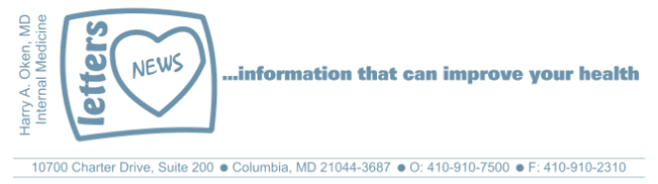
COVID-19-117, October 5, 2023
Dear Patients:

When I listen to Dave Matthews Band, Ants Marching, I envision ants moving in a single line, monotonously moving, doing the same things daily, never taking risks to go out of their lane. It makes me think how easy it is to get caught in the "groupthink." Once you are part of the groupthink, you can always get support for your beliefs by doing an internet search. This is selection bias, and finding what you want is confirmation bias. The challenge to all of us is to look for truth outside the box and embrace academic debate and published peer-reviewed scientific literature.
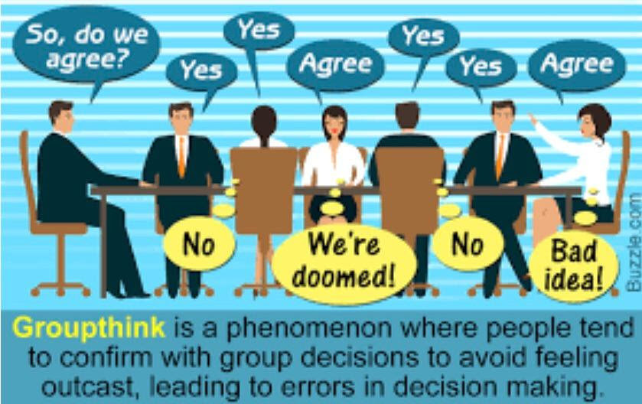

-

As it relates to the COVID pandemic, I have been a doubter because so much of the information we are getting from the CDC and FDA has not been consistent with what science has told us. And unfortunately, we have learned that many academicians who disagreed with the groupthink have been demeaned, shunned, and sometimes even fired. Process this: COVID-19 is a contagious, generally mild, illness for otherwise healthy people. If you have had COVID, and over 80% of the population has, either knowingly or unknowingly, this is your best immunity. And if you have been previously vaccinated with the primary series plus one booster, the benefit of taking the Fall booster is marginal, at best.

Vaccine Update - Flu, RSV and COVID:

- Yes, get your influenza vaccine, if possible, before mid-November.
- The FDA has approved the new RSV vaccine and the CDC said that people >60 years old may get it; however, they did not say they should, so hold off.
- What's the issue with the RSV vaccine? There are two neurological issues that may come to light as more people get the vaccine. So, when weighing the risk vs. benefit, I recommend it only for those >75 years old who have serious heart or lung issues.
- mRNA COVID booster - I don't recommend this - keep reading.
- There are now hundreds of peer-reviewed papers that discuss mRNA COVID vaccine injuries.
- Novavax COVID booster was approved this week. Science says it is more durable and less likely to cause serious adverse effects.
- If you have had two mRNA primary vaccines and at least one booster and have had COVID one or more times, you likely do not need this booster.
- If you feel vulnerable, however, I have no safety concerns about this vaccine, so feel free to take the jab!

Paxlovid Information

- Handing out Paxlovid like M&Ms, when the current variants cause mild illnesses, without doing randomized trials, is not prudent, and not good science.
- The US Government bought 10 billion dollars’ worth of Paxlovid from Pfizer without randomized clinical trial data!
- There is no evidence that taking Paxlovid will reduce your risk of "long COVID."

Below is a summary statement about Paxlovid from Sensible Medicine; the entire article is worth reading.

"The idea that it reduces long COVID is unproven and should not be made by physicians. Paxlovid is a politicized drug in the same way HCQ once was. The difference is it was politicized because democratic politicians bought it before they had data to support it, and then worked to twist the data to suit their preferred conclusion."

-
On a musical note: Ants Marching, by Dave Matthews Band:



-
On a lighter note: (and thanks SM for the reminder to send this update out!)



-
As a reminder, I'm no longer sending out daily updates and instead, I'm updating you periodically. I continue to enjoy writing these updates. Initially, these were only sent to my patients, however, I've been humbled to learn that, through social media, these writings have been forwarded and re-forwarded to many. This has brought me great joy to know that this simple act of sharing facts, thoughts, opinions, and hopes has touched you in some way. Hopefully I've been able to reassure you, maybe make you smile and laugh, soothe your worries, and comfort you. And maybe, just maybe, I've helped you to be in the moment!

Reach out and stay connected. Be well. Feel free to forward this on.

HAO 24/7
Harry Oken, M.D., Adjunct Professor of Medicine, University of Maryland, School of Medicine
Office 410-910-7500 |Fax 410-910-2310 |Cell 443-324-0823

View previous newsletters: http://harryokenmd.com/COVID-19-HOME.htm

Links for today

Dave Matthews Band - Ants Marching (Official Video)
https://www.youtube.com/watch?v=MNgJBIx-hK8&ab_channel=davematthewsbandVEVO

Unraveling the RSV vaccine clinical trial data
https://yourlocalepidemiologist.substack.com/p/unraveling-the-rsv-vaccine-clinical
- Sensible Medicine
https://vinayprasadmdmph.substack.com/p/paxlovid-doesnt-work-in-average-vaccinated?r=1n7nsn

