
COVID-19-115, July 16, 2023
Dear Patients:

What do you do at the end of your day? Me? Well, every night between 10pm and 11pm, I take my dog, Maggie, out for a brief walk. Often, I can see stars and the moon, and I take time to breathe the night air and look at the skyscape. The day is now behind me. It is never to be recaptured; it's over. As we get older, time seems to go by faster and each passing day is gone forever. Appreciating that makes me think that in all I do, be kind, be grateful and make a difference.

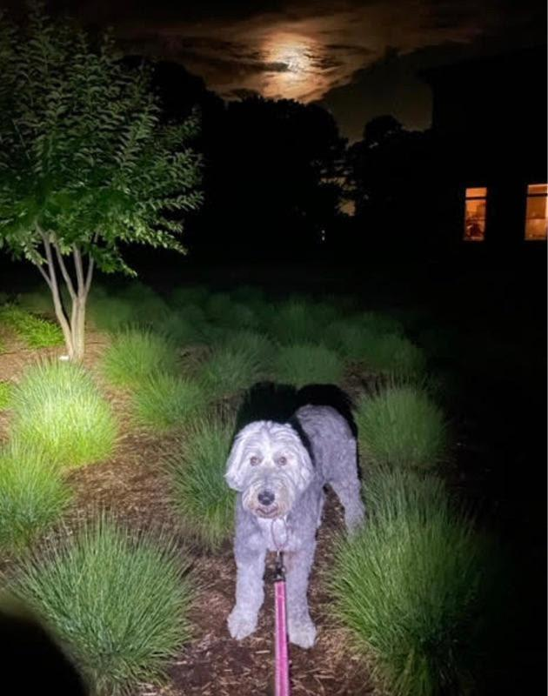
-

Boost Our Own Metabolism: BOOM!

I will be re-starting this program in September at the Athletic Club in Columbia. As we get closer, I'll send out more info. To learn more about BOOM, check out my Toastmasters Webcast using the link below. Or a shameless plug, you can buy the book!

Buy My Book | View My Toastmasters Webcast
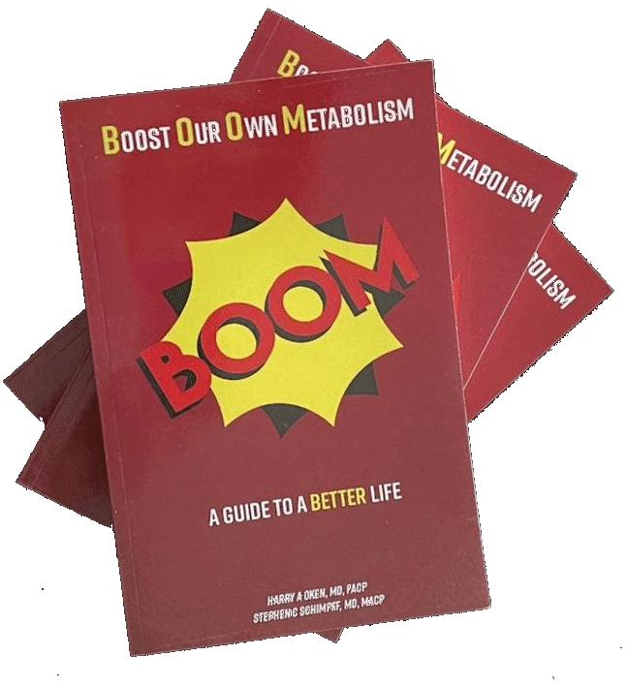 | 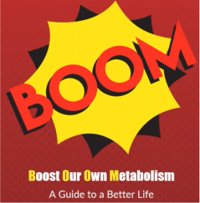
Just Click Graphic | Just Click Graphic  Use Passcode 09+&HiUh

-

COVID update and more:

- I am still not recommending a booster. My advice remains firm: no mRNA vaccines at this time.
- On June 15, 2023, the FDA's vaccine committee voted unanimously to recommend updating the COVID vaccine to a monovalent (single strain) booster to be available in late summer.
- There will be 2 mRNA options (Moderna and Pfizer) and one Protein Subunit vaccine, Novavax.
- I believe there are safety concerns with mRNA vaccines so if appropriate, Novavax, a traditional vaccine, would be my choice.
- However, the problem is that the vaccine currently being made is for the strain XBB.1.5. Several weeks ago, this was 40% of the current cases, but as of today, it has shrunk to 27%.
- Currently, Coronavirus is a mild non-virulent moving target.
- Also, consider that we are a highly immunized population where >80% of us have received our best immunity from having had the infection.
- So again, there is no need for most of us to get a booster!
- Lastly, there is no convincing data that boosters protect us from contracting COVID. They may, for very vulnerable individuals, decrease the likelihood of severe disease that requires hospitalization.

-

Finding Your Wellness: including a link to my latest Podcast.

I interviewed Bryan Curtin, MD. Dr. Curtin is a gastoenterologist who specializes in GI motility. We had a great discussion about a common problem, irritable bowel syndrome.  https://www.podbean.com/ew/pb-wmq5k-1431d5c | 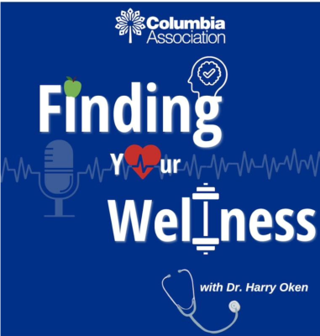
-

On a musical note:

100 Years by Five for Fighting
﻿The song is about aging and the struggle of life from first love to midlife crisis to old age and ultimately, the end of life. I hope you take a moment to listen to this song. I hope it helps you relax and contemplate the precious commodity of time.


On a lighter note:

After the storm Friday, a beautiful rainbow in St. Michaels!

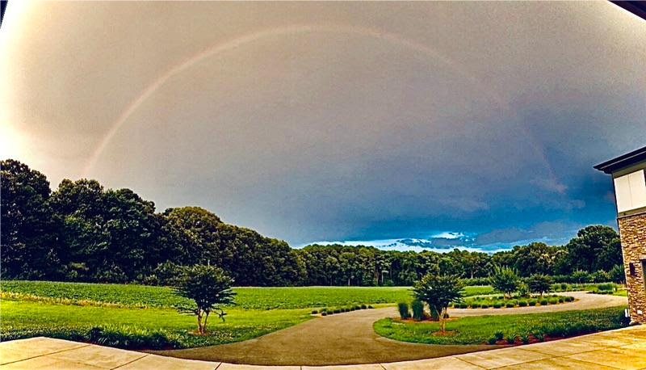

-
As a reminder, I'm no longer sending out daily updates and instead, I'm updating you periodically. I continue to enjoy writing these updates. Initially, these were only sent to my patients, however, I've been humbled to learn that, through social media, these writings have been forwarded and re-forwarded to many. This has brought me great joy to know that this simple act of sharing facts, thoughts, opinions, and hopes has touched you in some way. Hopefully I've been able to reassure you, maybe make you smile and laugh, soothe your worries, and comfort you. And maybe, just maybe, I've helped you to be in the moment!

Reach out and stay connected. Be well. Feel free to forward this on.

HAO 24/7
Harry Oken, M.D., Adjunct Professor of Medicine, University of Maryland, School of Medicine
Office 410-910-7500 |Fax 410-910-2310 |Cell 443-324-0823

View previous newsletters: http://harryokenmd.com/COVID-19-HOME.htm

Links for today

- Buy My Book – BOOM:
https://mail.google.com/mail/u/0/?pli=1#inbox/FMfcgzGtwDCPGxhWDMZxrnFXfXwFHhhR
- View my Webcast about BOOM - Use Passcode 09+&HiUh
https://us02web.zoom.us/rec/share/NYFpwDyR-yjpuMTj3T41AOoGjzb2-h1sVfqz8HODvD6Tohher5tlVJIs39MDKARl.R1MJ22UJgBddpjCT?startTime=1681166339000
- Five for Fighting - 100 Years
https://www.youtube.com/watch?v=tR-qQcNT_fY&ab_channel=fiveforfightingVEVO
- Finding Your Wellness – podcast
https://www.podbean.com/ew/pb-wmq5k-1431d5c

