
COVID-19-114, May 3 2023
Dear Patients:

Stephen Hawking, the British scientist who was stricken with a chronic neurodegenerative disease at the age of 21, retained his genius and communicated via a computer until his death. He emphasized the need to fulfill our potential on earth by making good use of our lives. He answered the question on how we should live: "We should seek the greatest value of our action."

Many religions help people formulate their ideas about what lies beyond our time on earth, and often, those teachings lay out the blueprint for how we should try to live our lives to make it to heaven. The concept of heaven is different for everyone. There may be a way to experience heaven before you die. Can you construct your life now to have heaven on earth?

If you are looking for a meaningful and entertaining mini-series, I enjoyed 1883, about immigrant pioneers trekking across the Midwest and struggling to find a better life. This character's quote got my attention:


-

COVID update:

  - Yes, COVID is still around. I am seeing generally 1 to 2 cases per week. They are mild and last about five days, with most people starting to feel better by day 3.
  - The Cochrane meta-analysis about face masking has been academically debated; I still concur with their conclusions that there is currently no need to mask in day-to-day activities. However, of course, mask if you anticipate contact with someone with respiratory symptoms, as I do in the office. If you come to my office with respiratory issues, we will mask.
- I continue NOT to recommend taking the just-approved current bivalent mRNA booster.
- The majority of my patients have had the original mRNA COVID series and at least one booster, as well as having contracted COVID; this gives you excellent immunity going forward.
- Vinay Prasad, MD, is a brilliant academician. He may turn off some people with his harsh criticism of the CDC, NIH, and the White House, but his points are well taken. This 24-minute video podcast is evidence-based and I largely agree with everything he says. He should, however, work on his anger management. I suspect that most people have lost interest in the topic, but I am still in the COVID weeds.

-

Finding Your Wellness:

My friend and colleague, Dr. Dean Glaros, recently stopped by my podcast, sponsored by the Columbia Association, to discuss eye health. I know you'll find it extremely interesting and informative. Below is the link to listen to it: https://findingyourwellness.podbean.com/e/dr-dean-glaros/

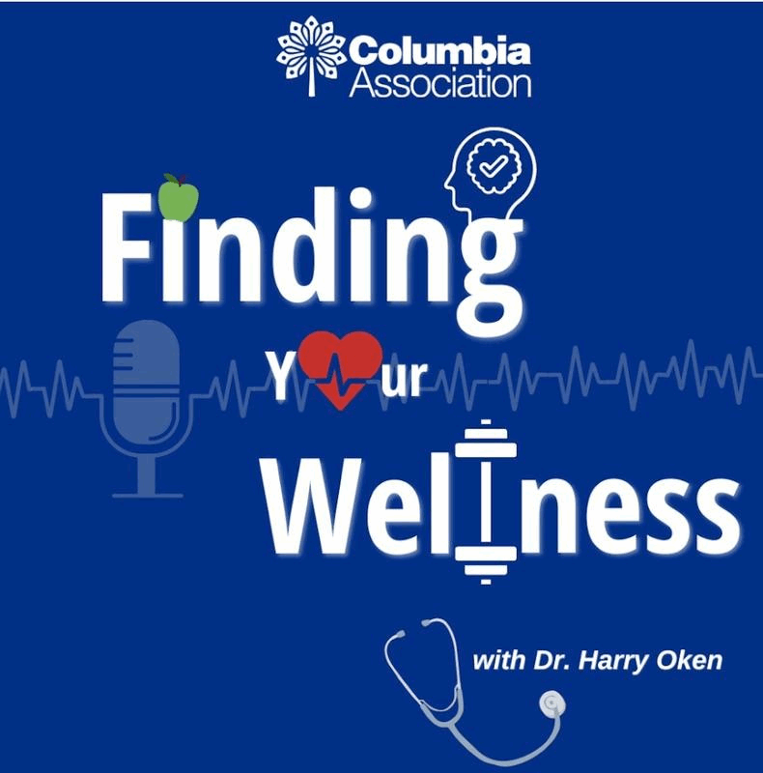

-

On a musical note:

Dream On, by Aerosmith, was written by Steven Tyler, and debuted in 1973. Tyler states "It's about dreaming until your dreams come true." It speaks to me about getting older and inspires me to 'dream on' and along with my memories, to experience heaven on earth.



-

On a lighter note:

Dream on...with my grandson, Benny.

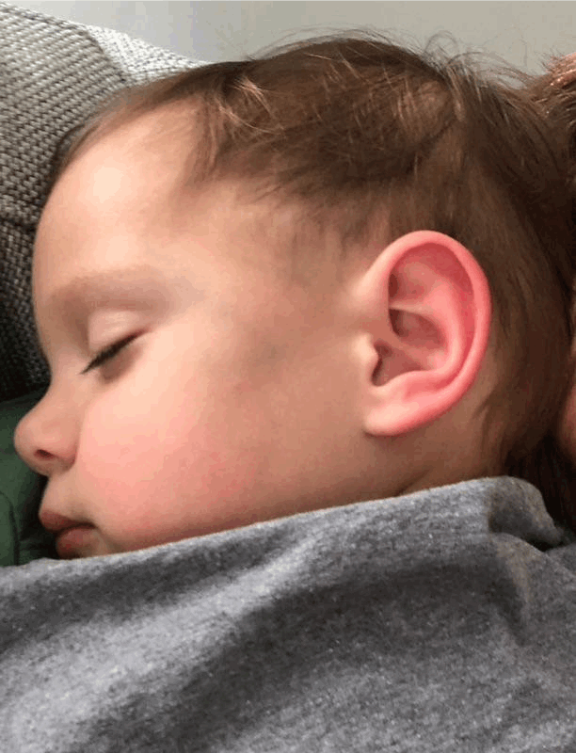
-

I enjoy updating you periodically with the latest and greatest along with my commentary. Initially, these were only sent to my patients, however, I have been humbled to learn that, through social media, these writings have been forwarded and re-forwarded to many. This has brought me great joy to know that this simple act of sharing facts, thoughts, opinions, and hopes has touched you in some way. Hopefully, I have been able to reassure you, maybe make you smile and laugh, soothe your worries, and comfort you. And maybe, just maybe, I have helped you to be in the moment!

Reach out and stay connected. Be well. Feel free to forward this on.

HAO 24/7
Harry Oken, M.D., Adjunct Professor of Medicine, University of Maryland, School of Medicine
Office 410-910-7500 |Fax 410-910-2310 |Cell 443-324-0823

View previous newsletters: http://harryokenmd.com/COVID-19-HOME.htm

Links for today

- 1883: https://www.youtube.com/watch?v=ZkbH1zjsM7g3
- Dr. Dean Glaros, Eve Health: https://www.youtube.com/watch?v=H0HpRTkotE8

The CDC Director is lying about… https://findingyourwellness.podbean.com/e/dr-dean-glaros/

