
COVID-19-112, March 26 2023
Dear Patients:

The song, Little Voice, by Sara Bareilles, recently got my attention. The melody is soothing and the lyrics speak to me in volumes. No matter what other people tell us, the voice in our heads, whether right or wrong, is our loudest voice and often, our truth.
"It's just a little voice
And if you're listening
Sometimes a little voice
Can say the biggest things
It's just my little voice that I've been missing"

Spring is here; I hope you feel it and blossom. Listen to your little voice and enjoy it.

COVID update and more:

- The Cochrane Review recently published a review showing that community masking, as shown by 11 randomized controlled trials, showed no apparent reduction in respiratory viral infection.

- However, medical masking makes sense in a setting with possible exposure to someone potentially infectious. This is why, when you come to my office, as I enter the room, you will see my mask in hand, and I'm prepared to put it on if you have respiratory symptoms.

- I still favor no further COVID boosters.

- The safety and efficacy of mRNA vaccines must be subjected to vigorous and unrestricted debate, and those participating should be respected, not cancelled.

- Many published studies in evidence-based, peer-reviewed journals suggest that multiple COVID boosters increase susceptibility for contracting new strains.

- Further boosters appear to be driving a diversity of escape variants, akin to the problem we have seen with antibiotic resistance.

- Dr. Robert Redfield, former CDC Director, and a colleague of mine from the University of Maryland School of Medicine, believes it is likely that COVID was a gain-of-function virus that accidentally escaped the Wuhan Virology Lab.

BOOM

Join me on Monday, April 10, 6:30 - 7:30 pm, when I will be discussing my book, BOOM: A Guide to a Better Life

Here is the Zoom link to attend:
https://us02web.zoom.us/j/88123474248
Meeting ID: 881 2347 4248
or click below:
Zoom link to listen to my talk (click the blue link) and enter the meeting ID above.

Click flyer to enlarge.
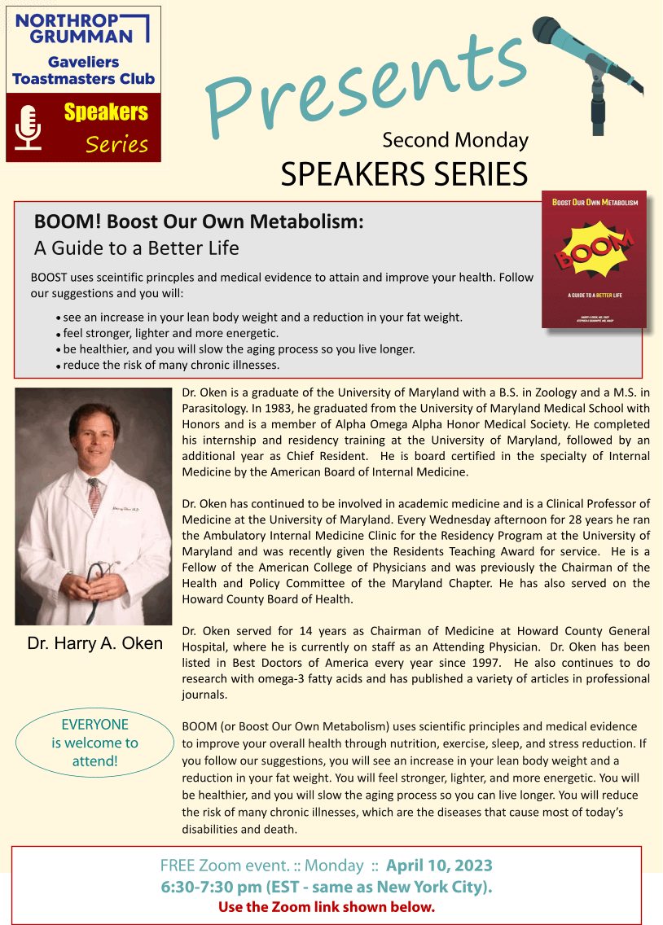
Click flyer to enlarge.

-
On a musical note: Trust me, listen to Little Voice - you will enjoy it. It's the theme song to a miniseries I recently watched on Apple TV+ with the same title. The link is an interview with the songwriter followed by the song.


-

-
On a lighter note: Happy spring!


-

As a reminder, I'm no longer sending out daily updates and instead, I'm updating you periodically. I continue to enjoy writing these updates. Initially, these were only sent to my patients, however, I've been humbled to learn that, through social media, these writings have been forwarded and re-forwarded to many. This has brought me great joy to know that this simple act of sharing facts, thoughts, opinions, and hopes has touched you in some way. Hopefully I've been able to reassure you, maybe make you smile and laugh, soothe your worries, and comfort you. And maybe, just maybe, I've helped you to be in the moment!
Reach out. Stay connected. Stay home. Save lives. The power of one. Be well.
Feel free to forward this on, spread the word, not the virus.
HAO
Harry Oken, M.D., Adjunct Professor of Medicine, University of Maryland, School of Medicine
Office 410-910-7500 |Fax 410-910-2310 |Cell 443-324-0823

View previous newsletters: http://harryokenmd.com/COVID-19-HOME.htm

Links for today

Little Voice, by Sara Bareilles
https://www.youtube.com/watch?v=TiCtGoYowTA&ab_channel=SaraBareillesVEVO
- The Cochrane Review recently published a review showing that community masking, as shown by 11 randomized controlled trials, showed no apparent reduction in respiratory viral infection.
https://www.cochrane.org/CD006207/ARI_do-physical-measures-such-hand-washing-or-wearing-masks-stop-or-slow-down-spread-respiratory-viruses
- BOOM – FREE Zoom event – April 10, 2023, from 6:30 pm to 7:30 pm EST.
https://karenstorey.com/GaveliersWebsite/Second%20Monday.html

