
COVID-19-111, February 14, 2023
Dear Patients:

The other day, I was on the phone with my friend, Steve (co-author of our book BOOM). He asked me how I was doing and I thought, you know, I am starting to feel more joy. Why? The world seems to be opening up. I'm not talking about the state of the world. There is still the usual chaos in politics, war, and natural disasters. Yet our day-to-day lives are trending back to the pre-pandemic norm. There is more socialization with family and friends and less virtual work and meetings. People are going to restaurants and entertainment venues and traveling. Joy. I hope you feel it too!
--------------------------------------------------------------------------------------------------------------------------------------------
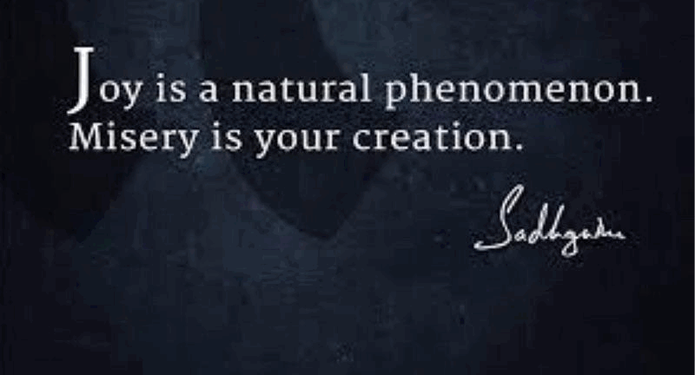
--------------------------------------------------------------------------------------------------------------------------------------------

COVID update and more:

- Influenza and RSV are on the downslide.
- Norovirus (GI virus) cases are up. It is quite contagious and can wreak havoc in your home. Good hand washing!
- COVID cases are up but the good news is that it has been very mild for most people, particularly those who have had the primary series and one booster.
- A new study suggests that post-COVID infection can enhance immunity for up to 8 months in many people.
- I still have the same concerns about continued mRNA boostering for most people. I stand by my recommendation of over 14 months that no further boosters unless there is individual vulnerability.

- In the UK, beginning next month, there will be no further mRNA boosters for patients 50 years and under.
- Rarely am I seeing post-COVID long-haulers issues and in recently published studies, it seems these issues are no more frequent than other post-viral issues.
- mRNA vaccine technology made a difference early on, but we need more safety data to continue to use this platform going forward.
- It seems ridiculous to me to adapt mRNA to future influenza vaccines until we are assured of the safety.

Join me this Saturday, February 18 from 9:00-10:00 am for this month's Walk with a Doc! I'll be hosting this event that meets at the People Tree (near the former entrance to Clyde's Restaurant and the Fountain). It's a fun activity at the Lakefront in Columbia sponsored by the Columbia Association.

Walk with a Doc is a worldwide walking program for anyone interested in taking steps for a healthier lifestyle. We'll take a few minutes to learn about a current health topic - I'll be discussing Light as Medicine - then we'll take a healthy walk around beautiful Lake Kittamaqundi, with the option to take a second loop. It's a great way to get out, get active and enjoy all the benefits that come from walking. There will be additional time for conversations and questions while we walk.

So, consider coming this Saturday at 9:00 am as a great way to start the day!

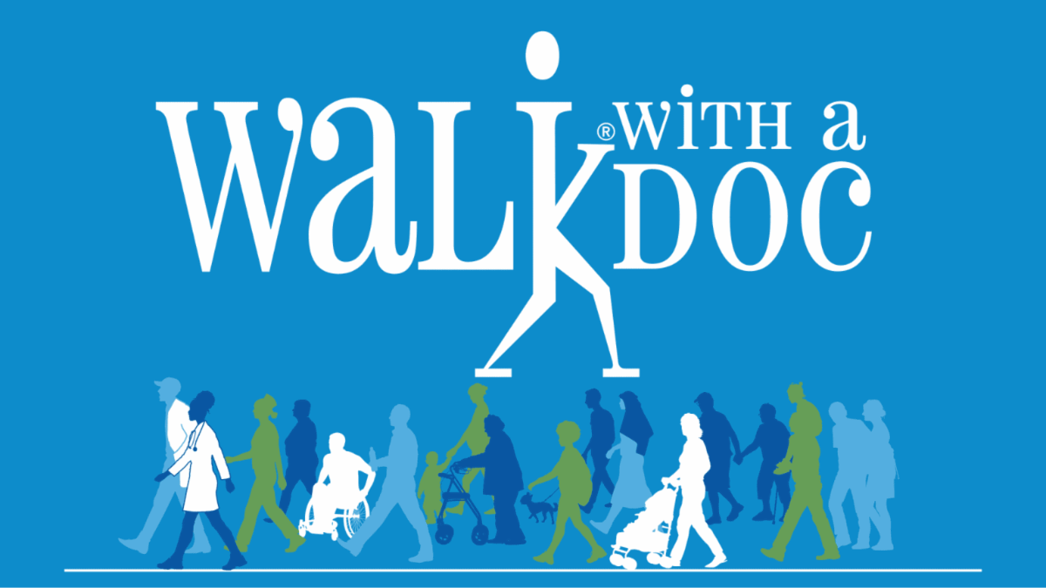

-
On a musical note: Step Out by The Chainsmokers - yup, time to step out!



-

-
On a lighter note: Happy Valentine's Day from my girl, Maggie!

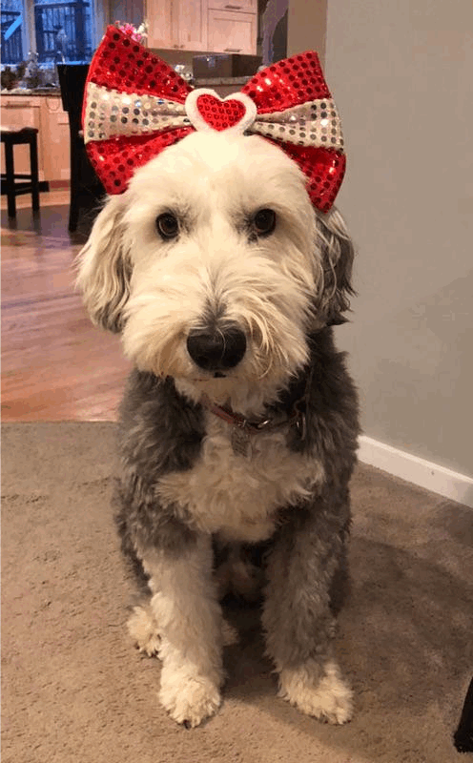

-

As a reminder, I'm no longer sending out daily updates and instead, I'm updating you periodically. I continue to enjoy writing these updates. Initially, these were only sent to my patients, however, I've been humbled to learn that, through social media, these writings have been forwarded and re-forwarded to many. This has brought me great joy to know that this simple act of sharing facts, thoughts, opinions, and hopes has touched you in some way. Hopefully I've been able to reassure you, maybe make you smile and laugh, soothe your worries, and comfort you. And maybe, just maybe, I've helped you to be in the moment!
Reach out. Stay connected. Stay home. Save lives. The power of one. Be well.
Feel free to forward this on, spread the word, not the virus.
HAO
Harry Oken, M.D., Adjunct Professor of Medicine, University of Maryland, School of Medicine
Office 410-910-7500 |Fax 410-910-2310 |Cell 443-324-0823

View previous newsletters: http://harryokenmd.com/COVID-19-HOME.htm

Links for today

BOOM! Boost Our Own Metabolism: A Guide to a Better Life
https://www.amazon.com/BOOM-Boost-Our-Own-Metabolism/dp/B088B4PVZD
- No more frequent than other post-viral issues.
https://www.youtube.com/watch?v=D4tlmsQFyxg&ab_channel=VinayPrasadMDMPH
- Step Out by The Chainsmokers - yup, time to step out!
https://www.youtube.com/watch?v=07kt990Tp3c&ab_channel=PenguinMusic

