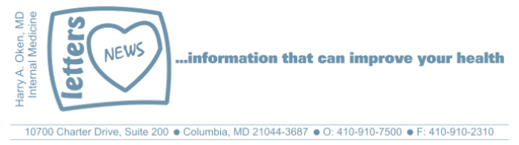
COVID-19-106 October 19, 2022
Dear Patients:

I have been waiting a long time to tell you that there is an alternative to the mRNA vaccine. It was announced today the Protein Subunit Vaccine (PSV) is now approved to be used as a booster. This means that if you have previously had a COVID vaccine (Moderna or Pfizer primary series and booster), you may also get this Novavax PSV. There is data that has shown that the PSV may protect against all known variants.

Today was a great day in that we now have another tool in our kit to help us stay healthy. Another reason it was a terrific day for me is that I was fortunate to meet (over Zoom) Dr. Paul Offit, a 1977 University of Maryland Medical School Alumnus and one of the foremost and respected vaccine experts in the world. Dr. Offit is a Professor of Pediatrics and Vaccinology at the Children's Hospital of Philadelphia and the University of Pennsylvania's Perlman School of Medicine. The full interview will be available soon on my monthly podcast, "Finding Your Wellness" which is supported by The Columbia Association. Once it's available next month, I will send you the link.
--------------------------------------------------------------------------------------------------------------------------------------------

--------------------------------------------------------------------------------------------------------------------------------------------
Recommendations and information regarding vaccines:

- First and foremost, recognize that all approved COVID vaccinations are efficacious in preventing severe disease that could lead to hospitalization, respiratory failure and death; they do not necessarily prevent one from contracting the illness.
- Please know my recommendations are subject to change.
- Many pharmacists, as well as other health care providers, are not aware of this new vaccine. Be specific in your request. Before getting the vaccine, insist on verifying you are getting the Novavax PSV.

- If you have never been vaccinated, get the Novavax PSV as your primary series. This means 2 vaccinations, with the second one eight weeks after the first.
- If you have had COVID within the last 4 months, hold off getting a booster until you are 4 months out. You are protected from severe disease with hybrid immunity.
- If you have had the primary series of an mRNA vaccine (Moderna or Pfizer) but have not had a booster, consider getting the Novavax PSV now.
- If you have had the primary series of an mRNA vaccine (Moderna or Pfizer) and have had one mRNA booster greater than 6 months ago (this would be me), consider getting the Novavax PSV now.
- If you have had 4 or more mRNA vaccines, I would wait at least 6 months after your last vaccine to get another booster. There is currently no data that suggests getting an additional booster will make you less vulnerable to a mild COVID infection.
- Lastly, this is a fluid process; down the road, I may change my recommendations!

-

-

-
On a musical note: Pat Benatar’s Hit Me with Your Best Shot



-

-
On a lighter note:



-

As a reminder, I'm no longer sending out daily updates and instead, I'm updating you periodically. I continue to enjoy writing these updates. Initially, these were only sent to my patients, however, I've been humbled to learn that, through social media, these writings have been forwarded and re-forwarded to many. This has brought me great joy to know that this simple act of sharing facts, thoughts, opinions, and hopes have touched you in some way. Hopefully I've been able to reassure you, maybe make you smile and laugh, soothe your worries, and comfort you. And maybe, just maybe, I've helped you to be in the moment!
Reach out. Stay connected. Stay home. Save lives. The power of one. Be well.
Feel free to forward this on, spread the word, not the virus.
HAO
HAO
Harry Oken, M.D., Adjunct Professor of Medicine, University of Maryland, School of Medicine
Office 410-910-7500 |Fax 410-910-2310 |Cell 443-324-0823

View previous newsletters: http://harryokenmd.com/COVID-19-HOME.htm

Links for today

Pat Benatar’s Hit Me with Your Best Shot: https://www.youtube.com/watch?v=FJQ-m8aF84Y

