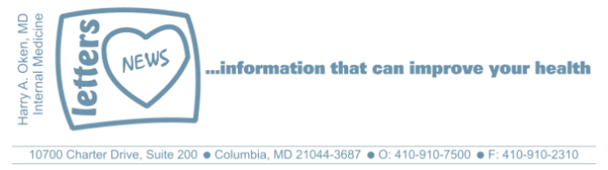
COVID-19-104 September 26, 2022
Dear Patients:

Twenty-eight years ago this week, my father-in-law left for work in the early morning, and while still very close to his home, he was killed in an auto accident. Irv was 71. None of us had a chance to say goodbye. And, of course, none of us ever saw an ending like this for him. I hope he knew how much he was loved.

Sadly, this past week, a long-time patient of mine suddenly passed away. I will miss him as my patients are like my family. When people unexpectedly die, it gets your attention. Families and friends can prepare for death when a chronic illness is unwinding, but when it happens suddenly, it's a reminder that we are here, and then we are not. For me, these unpredictable twists and turns of life make me pause and remember that life is fragile and the time we have with each other is a precious commodity. All the more reason not to sweat the small stuff and to appreciate and be grateful for our family, friends, colleagues, and co-workers.

The Living Years, by Mike + The Mechanics, is written from the perspective of a son. After his father dies, he discovers that he and his dad had a much stronger connection than he realized, and he regrets not saying more to him while he was alive. This is a great message to hear and to remind us to take advantage of our time with family and friends and let them know that your connection is cherished and meaningful.
If you have never been vaccinated, the PSV is available.
PSV as a booster is still awaiting approval.
The PSV, unlike the current mRNA vaccines, has activity against the original strain and all the variants to date.
The PSV has been available for months in many developed countries.


--------------------------------------------------------------------------------------------------------------------------------------------

The flu shot:
- I recommend getting the flu shot mid- to late October. This prevents your immune response from waning before the flu gets here, which is likely in late November through early March.
- If you are 65+, I recommend the senior shot.
- You can get your shot at your local pharmacy, grocery store, etc.
- All insurance carriers, as well as Medicare, cover the cost of this.

COVID booster update:
- The bivalent mRNA booster is available. It was approved based on mice data and will likely not be durable for any large amount of time, probably less than 16 weeks.
- Is it effective? Probably yes in preventing hospitalization and death, but you are still vulnerable to contract Covid; Pfizer's CEO just contracted Covid for the second time.
- I am currently recommending the mRNA booster for the very vulnerable people who need to be aggressively protected. If you need guidance, please reach out to me.
- For most others, I suggest waiting for the Protein Sub-unit Vaccine (PSV) booster. It is awaiting approval by the FDA to be used as a booster.
- The PSV has been approved to be used as a booster in Europe, Israel, South Korea, Canada, UK, Japan, Australia, and many other places. I'm not sure what the hold-up is in the US.
- The PSV is based on traditional vaccine technology and has an excellent safety record. It is durable (>6 months, perhaps 12 months) and seems to have coverage for all the variants.

Finding Your Wellness - a Podcast:
- In my role as the Medical Director for the Columbia Association, I have been doing a monthly podcast, "Finding Your Wellness."
- This month, I interviewed my friend and colleague, Lou Malinow, MD. The topic is "Everything you ever wanted to know about fasting."
- You can listen to the podcast by clicking here.

-
On a musical note: The Living Years I love the lyrics Say it loud, say it clear.

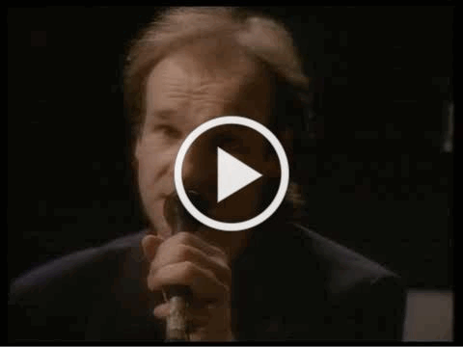

-

-
On a musical note: The Living Years I love the lyrics Say it loud, say it clear.

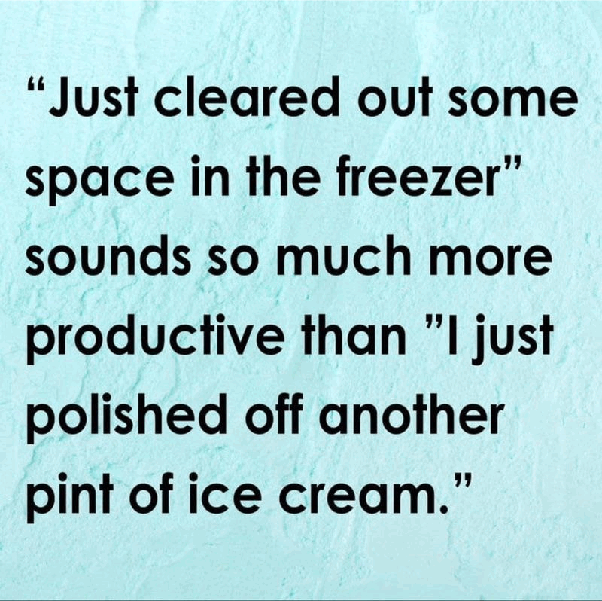

-

As a reminder, I'm updating you periodically. I continue to enjoy writing these updates. Initially, these were only sent to my patients, however, I've been humbled to learn that, through social media, these writings have been forwarded and re-forwarded to many. This has brought me great joy to know that this simple act of sharing facts, thoughts, opinions, and hopes have touched you in some way. Hopefully I've been able to reassure you, maybe make you smile and laugh, soothe your worries, and comfort you. And maybe, just maybe, I've helped you to be in the moment!
Reach out. Stay connected. Stay home. Save lives. The power of one. Be well.
Feel free to forward this on, spread the word, not the virus.
HAO
HAO
Harry Oken, M.D., Adjunct Professor of Medicine, University of Maryland, School of Medicine
Office 410-910-7500 |Fax 410-910-2310 |Cell 443-324-0823

View previous newsletters: http://harryokenmd.com/COVID-19-HOME.htm

Links for today

- Mike + The Mechanics - The Living Years (Official Video)
https://www.youtube.com/watch?v=5hr64MxYpgk
- Finding Your Wellness (Podcast)
https://dragondigitalradio.podbean.com/e/everything-you-ever-wanted-to-know-about-fasting/

