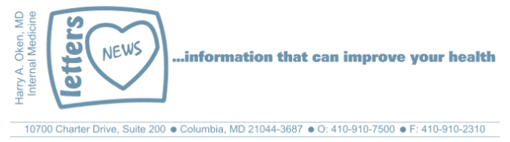
COVID-19-103 September 8, 2022
Dear Patients:

Robert Lamm, one of the original band members of Chicago, has said that their song, 25 Or 6 To 4, is about trying to write a song in the middle of the night, at either 25 or 26 minutes before 4:00am. The title of the song has been interpreted to mean everything from a quantity of illicit drugs to the name of a famous person in code. To me, despite my brain hearing the lyrics and the melody, it was many years until I finally realized that Lamm was frustrated to try and come up with lyrics to this melody. And then, at 25 or 26 to 4:00am, he begins creating. I guess I heard the lyrics, but really did not listen; hearing it now, it is just so obvious.

And so it is, the truth can be right in front of you. You may hear it, maybe even see it, but you can still get fooled in the manner your brain interprets the incoming data. Exchanging information with people and questioning what you read and hear is so important. In today's world, with a 24-hour news cycle, plus social media, there is excessive personal, institutional, community, national and global bias. And further, in today's world, if you do not agree with the group think, you may be cancelled!

Monkeypox (MPV): depending on what you hear and read, it can be chaos!
- Is this a public health emergency? Yes, if you are in a risk group.
- MPV is transmitted by secretions of blood, mucus, semen, and body fluid from infectious pox lesions.
- The risk group of major concern is men who have sex with other men.
- Contaminated surfaces and objects with secretions are unlikely effective mechanisms of transmission.
- What is possible is not always probable, so unless you are in a risk group, contracting MPV is not likely.
- The effective vaccine is the smallpox vaccine, Jynneos. There are over 600,000 doses that have been stockpiled in the US.
- If you were at some point vaccinated for smallpox, you likely have some immunity.
- There is testing capability for processing 80,000 MPV tests per week in the US.
- There is an antiviral treatment that is available for severe cases.

--------------------------------------------------------------------------------------------------------------------------------------------

Covid -19 Update:
- BA5 remains the predominant variant. It is very infectious, but it is typically a mild illness.
- Average daily cases in the US are trending down, currently 70,000; average daily deaths is 330.
- Approximately 80 million people in the US have not received the full primary vaccination.
- Earlier mRNA vaccines presently do not prevent Omicron infections but may decrease the likelihood of becoming significantly ill.
- The protein subunit vaccine (PSV - spike protein plus adjuvant) was approved by the FDA on July 13, 2022, for primary vaccinations.
- If you have never been vaccinated, the PSV is available.
- PSV as a booster is still awaiting approval.
- The PSV, unlike the current mRNA vaccines, has activity against the original strain and all the variants to date.
- The PSV has been available for months in many developed countries.

--------------------------------------------------------------------------------------------------------------------------------------------
Now, here is my opinion:

Ironically, we could shower in the amount of mRNA vaccine that the US government has purchased ($3.6 billion), which offers no protection to Omicron. It is frustrating that the PSV, which has Omicron protection, has not been approved as a booster. Maybe we are making some progress as the PSV was just approved for 12–18-year-olds for primary vaccination; this is an important group since they are more likely to develop myocarditis from the mRNA vaccine (17/100,000)

Israel (population 9M) just purchased 5M doses of the PSV to use for boosters. Israel was one of the first to vaccinate with Pfizer, and later, one of the first to use the PSV after they realized a 4th mRNA booster was not effective. I suspect Israel purchased it based on yet unpublished Israeli data that suggests the superiority of the PSV.

The new bivalent mRNA vaccine is available; it was approved by the FDA without human trial data. Yes, the FDA approved this based on the immune response of mice.

As time goes on, I think we will see that the mRNA vaccines, a 2-billion-person experiment, will give us a trove of scientific information; some of the info is good, probably as it relates to novel ways to treat cancer, but some info may not be so good. Multiple peer-reviewed published papers are now questioning the safety of mRNA vaccines. This contrarian opinion contradicts the current "group think," and too often, if you espouse it, it may mean the group cancels you. I think we are doing a disservice for not having an academic debate about the safety of mRNA vaccines.

So, what to do now? If you are not in a group who needs to be aggressively protected against this relatively mild variant, and that includes most of us, and you've had the primary vaccination and one or two boosters, I would advise waiting until more information about the bivalent mRNA is available.

Once the PSV is available as a booster, you will hear from me immediately, and I will review whether or not this is a good booster option.

-
On a musical note:
Ironic by Alanis Morrisette I love the lyrics "It's like ten thousand spoons when all you need is a knife."

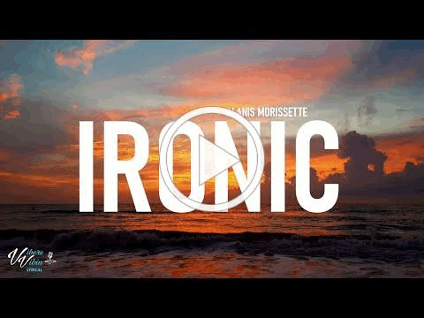
-

-
On an honorable note: Queen Elizabeth II: 1926-2022



-

As a reminder, I'm updating you periodically. I continue to enjoy writing these updates. Initially, these were only sent to my patients, however, I've been humbled to learn that, through social media, these writings have been forwarded and re-forwarded to many. This has brought me great joy to know that this simple act of sharing facts, thoughts, opinions, and hopes have touched you in some way. Hopefully I've been able to reassure you, maybe make you smile and laugh, soothe your worries, and comfort you. And maybe, just maybe, I've helped you to be in the moment!
Reach out. Stay connected. Stay home. Save lives. The power of one. Be well.
Feel free to forward this on, spread the word, not the virus.
HAO
HAO
Harry Oken, M.D., Adjunct Professor of Medicine, University of Maryland, School of Medicine
Office 410-910-7500 |Fax 410-910-2310 |Cell 443-324-0823

View previous newsletters: http://harryokenmd.com/COVID-19-HOME.htm

Links for today

Alanis Morissette - Ironic (Lyrics
)https://www.youtube.com/watch?v=JOImSuV6aQo&ab_channel=VibersVibin

