
COVID-19-101 July 10, 2022
Dear Patients:

Yes, I know, it's been a long time since my last email, but I just did not know what to say. We have been flying blind for a long time in this pandemic.

If knowledge is power, knowing what we don't know is wisdom (from Adam Grant, Think Again). According to Grant, the process of rethinking begins with intellectual humility: knowing what we don't know.

When the pandemic began in March 2020, I was quite sure it would be over by July 2020 and the death toll would be no more than seasonal influenza (<40,000). In Maryland alone, there have been over 1 million documented cases and undocumented cases perhaps doubles this figure; that is 1 out of every 6 people, and sadly, over 14,500 reported deaths. How could I get it so wrong? Placing the tragedy of loss aside, we should learn and discover from being wrong.

-

-

COVID Update
- Maryland's 7-day prevalence has risen to >9%, however, this is greatly underestimated since people are largely testing at home.
- Omicron, for most people, has been a mild illness.
- The predominant strain is now Omicron BA-5 and is an upper respiratory illness; it is less likely to affect smell and taste and some people experience night sweats.
- The first symptom can be an urticarial rash (hives).
- If you had COVID earlier this year, it was likely Omicron BA-1 or 2, however, you can still get BA-4 or 5.

About the Vaccines
- The CDC states that those who are vaccinated and boosted at least once are less likely to get seriously ill.
- The current vaccines do not provide protection from Omicron.
- If you test positive, begin counting the days of the illness at the start of the symptoms; this is Day Zero. There is no need to re-test at any point.
- You should wear a KN95 mask around others through Day 10.
- I am only recommending the 4th booster for a small number of compromised patients, generally >75 years old and/or those with multiple health issues.
- The 4th booster is identical to the first 3 vaccinations; it will raise your antibody level to the original strain for <8 weeks in most people; it does not protect against any of the Omicron variants.
- The 2nd generation protein sub-unit vaccine awaits FDA approval. This Novovax vaccine arrived in the US from an overseas manufacturer on July 1. An FDA Advisory Committee recommended approval to the FDA on June 7; the vote was 21-0. Countries with stringent drug approval processes, such as Canada, Japan, Australia, the EU and UK, approved this vaccine months ago. This vaccine protects against the original COVID strain; it also seems to protect against Delta and the Omicron variants.

Regarding the Anti-viral
- Our government has purchased $1.7 billion of Paxlovid from Pfizer, and it is free when needed.
- Anti-virals can be prescribed for people at high risk or with progressive symptoms; I prescribe them on a case-by-case basis. Pharmacists are now allowed to prescribe it as well.
- For people with mild COVID symptoms that are not progressing and don't have significant risk factors, in my opinion, the benefit does not outweigh the risk. Possible issues include GI intolerance, interaction with other medications (statins and anti-coagulants) and rebound effects after 5 days of treatment.
- Dr. Fauci had Paxlovid rebound and said the rebound was worse than the original symptoms.
- Going forward, we will be dealing with COVID for a long time and we are learning new things every day.

-
On a musical note: Humble and Kind by Tim McGraw by Dave Mason



-

-
On a lighter note:

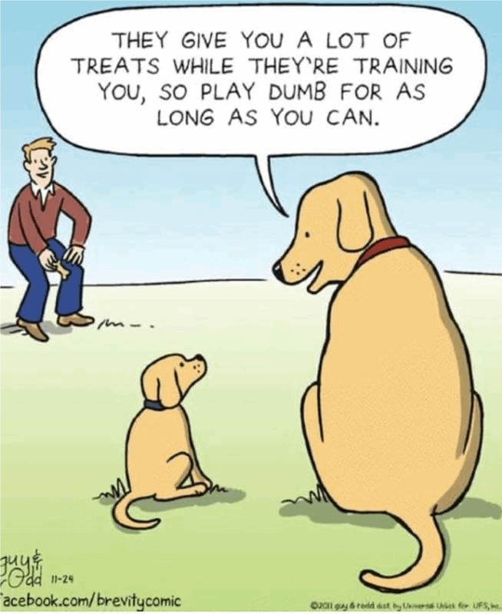
-

As a reminder, I'm updating you periodically. I continue to enjoy writing these updates. Initially, these were only sent to my patients, however, I've been humbled to learn that, through social media, these writings have been forwarded and re-forwarded to many. This has brought me great joy to know that this simple act of sharing facts, thoughts, opinions, and hopes have touched you in some way. Hopefully I've been able to reassure you, maybe make you smile and laugh, soothe your worries, and comfort you. And maybe, just maybe, I've helped you to be in the moment!
Reach out. Stay connected. Stay home. Save lives. The power of one. Be well.
Feel free to forward this on, spread the word, not the virus.
HAO
HAO
Harry Oken, M.D., Adjunct Professor of Medicine, University of Maryland, School of Medicine
Office 410-910-7500 |Fax 410-910-2310 |Cell 443-324-0823

View previous newsletters: http://harryokenmd.com/COVID-19-HOME.htm

Links for today

- Fauci Says He Had Paxlovid Rebound
https://www.webmd.com/lung/news/20220630/fauci-paxlovid-rebound-worse-symptoms
- On a musical note: Humble and Kind by Tim McGraw by Dave
Masonhttps://www.youtube.com/watch?v=awzNHuGqoMc

