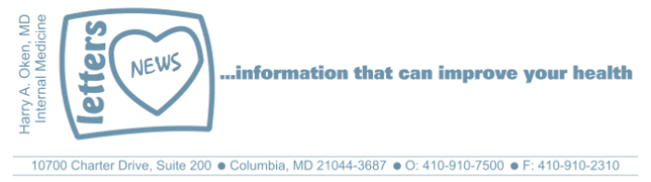
COVID-19-96 – January 7, 2022
Dear Patients:

Below are some FAQs to give you guidance regarding Omicron:

I have been exposed to Covid and now I have symptoms! What should I do?

For most people, stay home and isolate. Treat symptoms with over-the-counter medication such as Robitussin-DM for cough, ibuprofen (Advil) or acetaminophen (Tylenol) for muscle aches, fever, and fatigue, and rest and hydration. If you have a very stuffy nose and need a decongestant, it is okay to use over-the-counter Afrin for a maximum of 3 days.

Should I get tested?

Obtaining a timely PCR test is difficult because of the volume of people requesting the test. If you do a rapid test, and it's positive, there is no need for a PCR: a positive is a positive. If you have had a direct exposure to someone who has tested positive and you develop symptoms 2-5 days later, assume you have Covid. There is likely no need to get tested.

When should you contact me?

If you feel your symptoms are very significant, with a fever greater than 102, persistent achiness, severe fatigue, worsening cough or shortness of breath, please call. Most people feel progressively better within 5 days.

What about treatments?

On occasion, and particularly for unvaccinated patients and sometimes unboosted patients, certain therapies (monoclonal antibody and antiviral drugs) may be helpful. Unfortunately, they are in limited supply and decisions are made on a case-by-case basis. High risk patients such as those with immune deficiency, renal transplant patients, ongoing cancer treatment, significant heart and lung disease, diabetes, and obesity may benefit from intervention.

The monoclonal antibody infusion had been very helpful for those with the Delta variant, however, only 1 of the 3 monoclonal infusion therapies works for Omicron.

There are 2 oral antiviral drugs that are available, however, in a very limited supply. The decision to prescribe these is based on risk and degree of symptoms.

When am I free to stop isolating?

If you were not tested, you can stop isolating after 5 days from the start of symptoms, as long as you no longer have symptoms (no fever, no cough). If you had a positive test, you can stop isolating 5 days after the positive result, with day one being the day after the positive test, again, only if you no longer have symptoms. You need to wait at least 24 hours past any symptoms to be around others.

Once you are past the isolation period above, you can resume normal activities, but you need to mask (Level 3 surgical mask or KN95) for the next 5 days. You should stay away from crowded indoor activities. At 10 days, you can assume that you are no longer contagious (carrying replication competent virus) and you shouldn't be a risk to others.

What can I do to minimize my likelihood of getting Omicron?

Get completely vaccinated, wear your mask, stay away from crowds, especially indoors.

Of Covid patients at The University of Maryland Medical System over the past 30 days:
- 74% were unvaccinated
- 24% were vaccinated
- 2% had received boosters

Feel free to contact me with questions—anytime! Please send your questions to me by email unless they are urgent. If they are urgent, call me. Please do NOT text them!

-
On a Lighter Note:
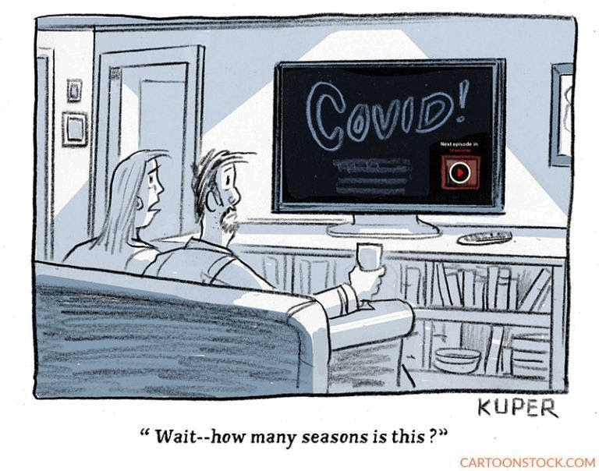
-

As a reminder, I'm updating you periodically. I continue to enjoy writing these updates. Initially, these were only sent to my patients, however, I've been humbled to learn that, through social media, these writings have been forwarded and re-forwarded to many. This has brought me great joy to know that this simple act of sharing facts, thoughts, opinions, and hopes have touched you in some way. Hopefully I've been able to reassure you, maybe make you smile and laugh, soothe your worries, and comfort you. And maybe, just maybe, I've helped you to be in the moment!
Reach out. Stay connected. Stay home. Save lives. The power of one. Be well.
Feel free to forward this on, spread the word, not the virus.
HAO
HAO
Harry Oken, M.D., Adjunct Professor of Medicine, University of Maryland, School of Medicine
Office 410-910-7500 |Fax 410-910-2310 |Cell 443-324-0823

View previous newsletters: http://harryokenmd.com/COVID-19-HOME.htm

