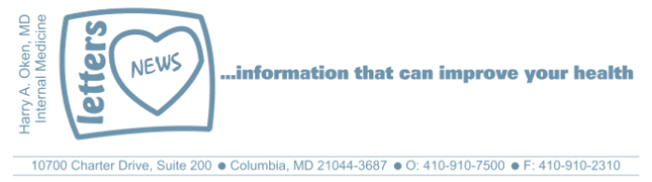
COVID-19-95 – January 2, 2022
Dear Patients:

If you have been vaccinated, and hopefully boosted, be reassured that if you get Covid symptoms, they should be short-lived and mild. If you are over 55 years old, with obesity, diabetes, heart disease, lung disease, cancer therapy, kidney disease or immuno-suppressed, there may be an intervention that I might recommend, so feel free to reach out. Only 1 of the current 3 monoclonal infusions is helpful against Omicron and it is in short supply.

Maryland has acquired a very small supply of an antiviral medication that is effective against Omicron, however, I haven't received any guidance regarding availability. I will send out an update if/when I get further information.

Omicron mainly infects the upper airway; it is less likely to drop down to the lower respiratory tract, and therefore we are seeing fewer hospitalizations and complications. It remains a fact that the vaccinated are still 10 times less likely to develop complications and being boosted enhances this.

Once infected, the virus rapidly replicates in the upper airway for 2 to 3 days, and a brief exposure to an infection person - less than 15 minutes, perhaps as short as 1 to 2 minutes - can transmit the virus.

Here is a list of symptoms in order of most common:
- sore throat, tickle in back of throat
- stuffy nose
- cough with little to no sputum production
- headache
- fatigue
- body aches
- loss of appetite
- loss of taste and smell
- fever generally less than 102, lasting less than 3 days

Treatment is with fluids, rest, ibuprofen (Advil) or acetaminophen (Tylenol).

Call me with persistence of symptoms greater than 4 days, worsening cough with shortness of breath, fever over 103, or any other concerns.

If you test positive, or began with the above symptoms, you need to isolate for 5 days (with day 1 being the first day after the positive test or symptoms). You may return to work, etc., after the 5 days and you have been asymptomatic for greater than 24 hours.

After the above 5 days of quarantine, when you go out, wear a face mask - either N95, KN95 or Level 3 surgical mask - for at least an additional 5 days. Update your mask as it has been found that cloth masks alone may not be able to protect against Omicron. The better the fit, the better it will protect you. Eliminate the gaps! And double masking is even better; consider a cloth mask over top one of the above.

There is no need, unless required by work or for travel, to retest. These recent guideline changes from the CDC are as a result of findings showing that transmission occurs during the early course of the illness.

Testing supplies are extremely limited and wait times are long. Assume that if you have the above symptoms, you have Covid. Stay home and follow the above advice. Remain calm and be reassured this should be over soon. Once this surge recedes, the general population will have enhanced immunity and resistance to future outbreaks. I am cautiously optimistic that this will settle down over the next 4 to 6 weeks.

Please email me - do not text - for any non-urgent issue. I am available 24/7 for issues and questions.

-
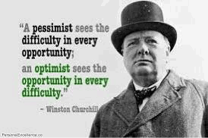
-

As a reminder, I'm updating you periodically. I continue to enjoy writing these updates. Initially, these were only sent to my patients, however, I've been humbled to learn that, through social media, these writings have been forwarded and re-forwarded to many. This has brought me great joy to know that this simple act of sharing facts, thoughts, opinions, and hopes have touched you in some way. Hopefully I've been able to reassure you, maybe make you smile and laugh, soothe your worries, and comfort you. And maybe, just maybe, I've helped you to be in the moment!
Reach out. Stay connected. Stay home. Save lives. The power of one. Be well.
Feel free to forward this on, spread the word, not the virus.
HAO
HAO
Harry Oken, M.D., Adjunct Professor of Medicine, University of Maryland, School of Medicine
Office 410-910-7500 |Fax 410-910-2310 |Cell 443-324-0823

View previous newsletters: http://harryokenmd.com/COVID-19-HOME.htm

