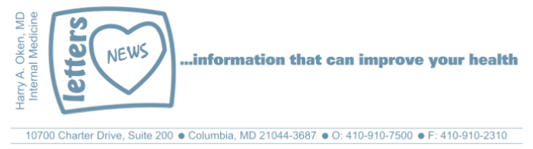
COVID-19-94 – December 27, 2021
Dear Patients:
Rent, a classic musical, (click on the link to enjoy the song while reading) where the lyrics proclaim that one year is 525,600 minutes.

How do you measure a year? Maybe you measure in love; I hope you have had plenty of love because if you had love, 2021 was not all that bad.

And the future is brighter. I think Omicron, although much more contagious but less virulent, is pushing down Delta, and with that, we as a population are becoming more immune. I predict by early February we will be in a better place. Get your booster!

Below is my 2021 year in review - snippets from my emails from the last 12 months!
January 2021: vaccine time and think about what you want out of 2021! Take the pledge! Here is a quote from the book The Art of the Good Life by Rolf Dobelli: "Once you have pledged something, you don't then have to weigh up the pros and cons each and every time you're faced with a decision. It's already been made for you, saving you mental energy." Take the pledge this year: I will put my health first, above everything else. Yes, it sounds selfish, but it is not. If you are healthy, the people who depend on you will be taken care of that much better. This takes discipline and willpower and that starts with the pledge. The more you use your willpower, the stronger it becomes. I just wanted to show you my dog, Maggie. No other messages than that! | 

March: hope springs eternal Hope, of course, is not a strategy. Nonetheless, it is empowering and can be the engine that drives planning and strategy, as it inspires intention that springs us forward into action. If you intend something to happen, you are that much closer to seeing that something become a reality. Hope, and all that comes with it - determination, longing, wishing - got my daughter and son-in-law through this next part of their journey and they used these emotions to develop a plan. They alternated spending 24-hour shifts with Benny in the NICU, so he was never without a parent (grandparents and visitors are not allowed due to COVID). They held him skin-to-skin as much as possible, they worked to feed him every 2 to 3 hours and took over as much of his care as allowed by the medical team. That was the plan, powered by hope, to get Benny home as soon and as healthy as possible. And what we all hoped for actually happened. After 23 days in the NICU, he was able to come home.
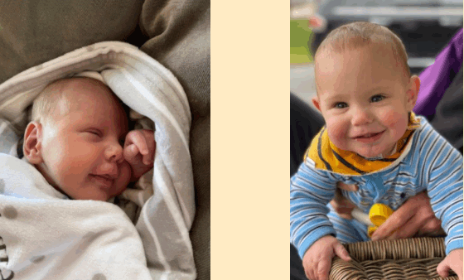
February: are you a 1A or 1B or ???? Isaac Newton was one of the most influential scientists in history. I love this quote of his: "Tact is the knack of making a point without making an enemy." More importantly, Newton conceptualized the third law of motion: for every action, there is an equal and opposite reaction. My translation: we all get what we create. This applies to everything, including our risk for COVID, and further, the actions and in-actions that lead to the spectacle we witnessed this week. This applies to everything we do or decide not to do. | 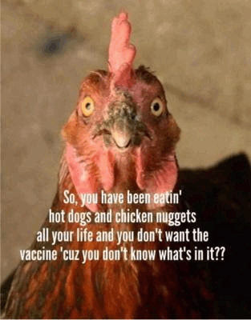

April: it's all relative

Life is full of good and bad, and over time, things tend to balance out. Positive and negative phenomena are always happening. Negative things seem to take longer for us to work through than enjoying the good. Unpleasant issues tend to slow time, while enjoyable phenomena seem to speed it up. This is an observation consistent with Eisenstein's Theory of Relativity. Nevertheless, a year goes by and we go full circle, that is just the way it is. Perhaps, however, we are different, maybe more patient, maybe more loving, maybe more enlightened.

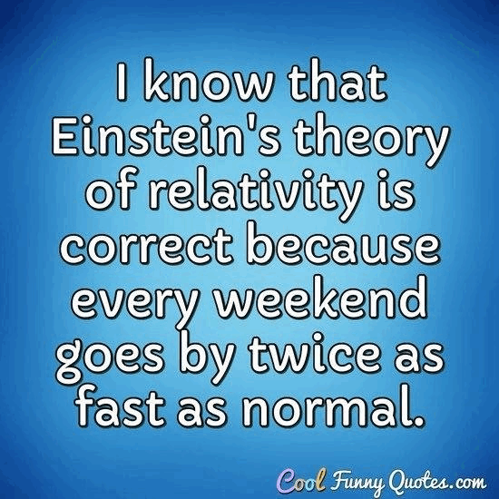
May: the situation has improved!  Hmmm...our perception is our reality. It is nice to be on the same page with our family, peers, colleagues, and friends, but that is not likely. The same information is coming in, yet we may not see, hear, smell, or feel it in the same way. Our interpretation of the information may be different. But this is okay; in fact, this can inspire innovation and creativity, but can also provoke dissent, frustration, distrust, and controversy.  As the data comes in, we use the integrating power of our brain to decipher the information. | 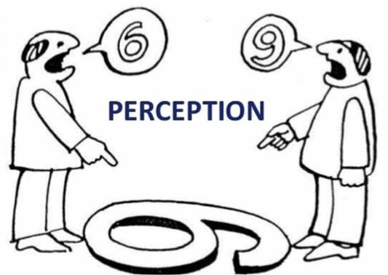

Cross-referencing this information with past experiences (which may or may not be accurate), we come up with our reality and create our truth. This is particularly true with our own self-appraisal. We tend to be harder on others and soft-pedal on ourselves. That's why a partner or a friend or a trusted professional is our best mirror. So, try not to reflexively dig your heels in (backfire effect) when someone you trust conveys information that does not compute in your human flawed hard drive of a brain. Have a discussion, listen to each other, share views, and develop a consensus.

June: the ripple effect

With our circumstances over the past 15 months, most of us have had plenty to think about and lots of time to sort out our lives. Maybe, with everything that has been thrown at us, your morning default is not so rosy. Nonetheless, we can grow with time, or at least we should try. I think it is worth it to spend a few moments every day to self-evaluate. We may forget that our actions or inactions cause ripples in other people's life. Unfortunately, we tend to be poor evaluators of how we come off. We get it wrong a lot; I know I do. Best intentions are often misunderstood. Sometimes, saying something you think may be helpful, or even funny, can be misinterpreted as hurtful. Sometimes saying nothing at all is worse.

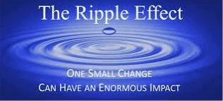
August: to boost or not to boost

"To be, or not to be" is the opening phrase of a soliloquy by Hamlet as he contemplates death and suicide. Hamlet is mad at his mom; she married his uncle who killed his father. And so, one of the themes is whether to take action (revenge) or not to take action. It is an emotional and psychological conundrum. Hamlet finds himself going crazy as he is unable to make a decision and then stick with it. Some of the more impulsive characters in the play, like Hamlet's uncle, find tragedies coming their way due to their excessive willingness just to act.

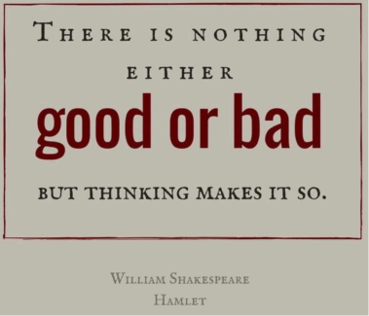

September: Delta is here!

"Why do you see the speck in your neighbor's eye, but do not notice the log in your own eye?... You hypocrite, first take the log out of your own eye, and then you will see clearly to take the speck out of your neighbor's eye." The Happiness Hypothesis

Doesn't it seem hypocritical when an "anti-vaxxer" gets sick enough to need the monoclonal antibody infusion and agrees to take the treatment? More importantly, doesn't this person realize that in the early phases of their infection, they may have infected other vulnerable people and possibly caused them harm, possibly resulting in hospitalization, or perhaps worse? Don't they realize that they are consuming an expensive medication that is in short supply; additionally, they are exposing health care workers to an avoidable infection had they only been vaccinated?
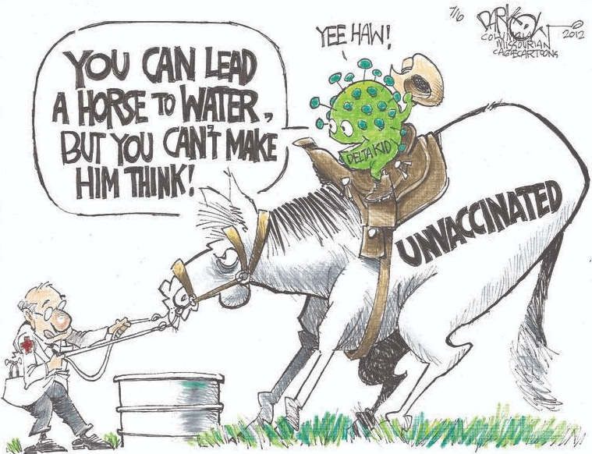
October: "You would have done the same"
﻿
Come From Away is a Broadway musical I saw pre-Covid, and the movie is now available as a filmed version of an onstage Broadway performance on Apple TV+. I watched the movie this past weekend and remembered the impact it had on me. You may not know the plotline of this true story: on 9/11, with airspace suddenly closed, planes are diverted and grounded. In the small town of Gander in Newfoundland, with a population of 9,000 residents, they have just absorbed 28 large aircraft with 7,000 stranded airline crew members and passengers. These are people from all over the world who had been headed all over the world, but definitely not to the dark, rock island that happens to have a huge airport. The Gander residents collected clothing, blankets, and food. They've made sandwiches and hosted cookouts for 5 days. They've hosted the "plane people" in their homes.

The experience created lifelong new friendships and when the guests departed with lunch bags for their trip home, they tried to re-pay their hosts. But the people of Gander would not hear of it. Their consistent response was "you would have done the same."

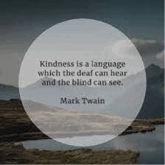
November: Stressed? Just breathe!

Breathing - we don't think about it much until we can't breathe. Then, it becomes our life. Perhaps you might not have noticed that when you are upset, your breathing may become more shallow, and your rate increases. Hyperventilation can be subtle and as it happens, carbon dioxide in your bloodstream starts to drop enough to make you feel uneasy. The low carbon dioxide causes arteries in your brain to constrict ever so slightly, but enough that you may start to feel light-headed or hear ringing in your ears. You now feel fear, your adrenaline is surging causing your heart to race, you become sweaty, maybe nauseous, you may feel like you are going to pass out.

Okay, slow down, Ted Lasso, just breathe, nice and slow and steady.

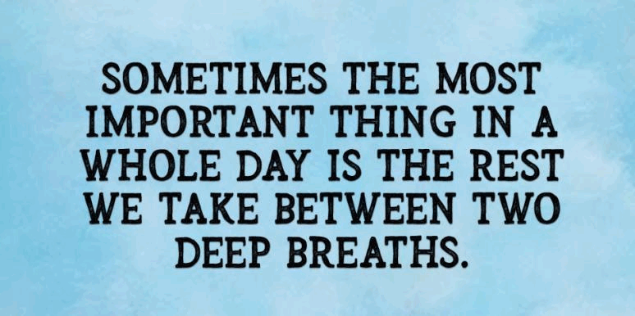
December: always have a plan

There is always bad news out there: global warming, astonishing inflation, crime rates rising, and now, we are at the beginning of a new Covid surge.

Then, there is really bad news that stops you in your tracks. For most of us, the worst news is when someone you care about, maybe a family member, or a good friend, learns they have a serious illness. The bad news hits hard. Sometimes, I am the purveyor of bad news but it's part of my job. When I deliver the bad news, I try to make sure my patient knows that they are not alone, and I make sure they clearly hear that there are always remedies and there is a plan. There must be a plan.
To the person who gets bad news, it's like a cold slap in the face. They may never have seen it coming. Good health and time are life's most precious commodities. And family and friends are the glue that binds us tightly to each other so that we can hold on. When you hear about someone who seems fine and abruptly, they are not fine, it's scary. You might even think, this could have been me. You may have had issues with people you care about who are the recipients of bad news. Suddenly you may realize how unimportant, in the big cosmic picture, those issues were. Hopefully, any previous hurt, conflict, insults, or slights fall like hot lead in cold water and hit the bottom of the bucket, never to rise again. Too bad that it took bad news to bring that into focus.

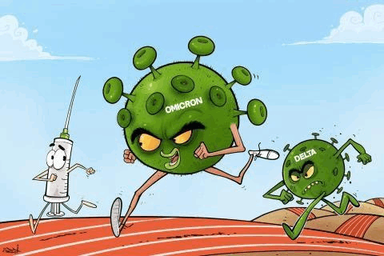
Wishing you a happy healthy new year and stay tuned!
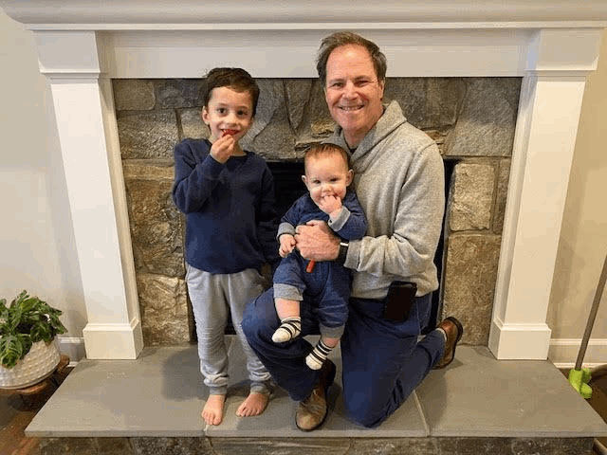

As a reminder, I'm no longer sending out daily updates and instead, I'm updating you periodically. I continue to enjoy writing these updates. Initially, these were only sent to my patients, however, I've been humbled to learn that, through social media, these writings have been forwarded and re-forwarded to many. This has brought me great joy to know that this simple act of sharing facts, thoughts, opinions, and hopes have touched you in some way. Hopefully I've been able to reassure you, maybe make you smile and laugh, soothe your worries, and comfort you. And maybe, just maybe, I've helped you to be in the moment!

Reach out. Stay connected. Stay home. Save lives. The power of one. Be well.
Feel free to forward this on, spread the word, not the virus.
HAO
HAO
Harry Oken, M.D., Adjunct Professor of Medicine, University of Maryland, School of Medicine
Office 410-910-7500 |Fax 410-910-2310 |Cell 443-324-0823

View previous newsletters: http://harryokenmd.com/COVID-19-HOME.htm

Links for today

- Come From Away:
https://tv.apple.com/us/movie/come-from-away/umc.cmc.262n0v53nmotkz7ulzuuco7rq
- Slow Down, Ted Lasso:
https://www.youtube.com/watch?v=Z0duv3d3M54
- Rent, a classic musical:
https://www.youtube.com/watch?v=RJIlHuMLOkE

