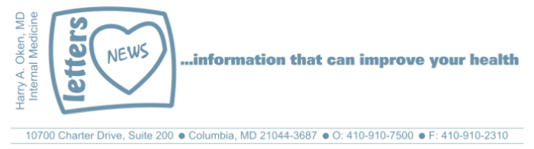
COVID-19-93 – December 20, 2021
Dear Patients:
Bad news...well, that got your attention.

There is always bad news out there: global warming, astonishing inflation, crime rates rising, and now, we are at the beginning of a new Covid surge.

Then, there is really bad news that stops you in your tracks. For most of us, the worst news is when someone you care about, maybe a family member, or a good friend, learns they have a serious illness. The bad news hits hard. Sometimes, I am the purveyor of bad news but it's part of my job. When I deliver the bad news, I try to make sure my patient knows that they are not alone, and I make sure they clearly hear that there are always remedies and there is a plan. There must be a plan.

To the person who gets bad news, it's like a cold slap in the face. They may never have seen it coming. Good health and time are life's most precious commodities. And family and friends are the glue that binds us tightly to each other so that we can hold on. When you hear about someone who seems fine and suddenly, they are not fine, it's scary. You might even think, this could have been me. You may have had issues with people who you care about who are the recipients of bad news. Suddenly you may realize how unimportant, in the big cosmic picture, those issues were. Hopefully, any previous hurt, conflict, insults, or slights fall like hot lead in cold water and hit the bottom of the bucket, never to rise again. Too bad that it took bad news to bring that into focus.

People with serious illness often are afraid. Our first job is to let them know they are not alone, and we are here to help. So, after you process really bad news, maybe in the "calm of the morning" let go of stupid stuff that might keep you from reaching out, and extend yourself with compassion and love to help do whatever you can do.  COVID-19 Updates:  - In Maryland, there are about 1,200 people hospitalized presently, so 12% of the hospital beds on average are taken up by COVID patients, the majority of whom are unvaccinated.  - The Omicron variant is a milder illness; the | 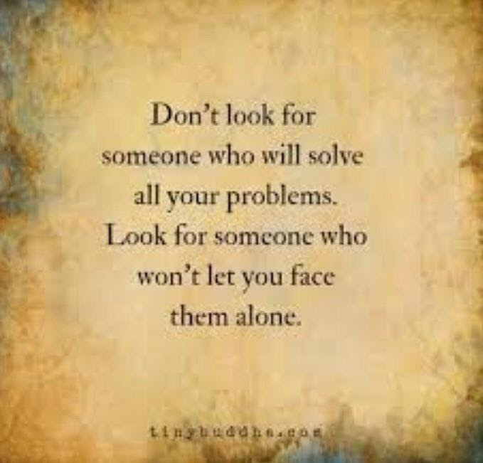
predominant strain is still the Delta in Maryland.
- One fact remains clear: full vaccination decreases your likelihood of being hospitalized, needing respiratory assistance, and death by a factor greater than 10.
- Boosters are available to everyone. The vaccine efficacy wanes after 6 months. The increase in cases makes me an advocate for everyone to get the booster.
- The Pfizer oral drug, Ritonavir (Paxlovid), was found to reduce the risk of hospitalization or death by 89% compared to placebo. It has been submitted to the FDA for emergency use authorization.
- The monoclonal antibody cocktail remains an excellent intervention for early infection with the Delta variant. It can be used for breakthrough infections in individuals at high risk, as well as the unvaccinated, if given early. It is not clear yet what its efficacy is for the Omicron variant.
- The Novovax vaccine (a non-mRNA vaccine) has been approved in India and has been submitted for approval in the UK, Australia, and the European Union and WHO. It has fewer side effects but is at least as effective. This may be an excellent option for mRNA vaccine-hesitant people.
- There is some speculation that Omicron could play a role in making our pandemic resolve more quickly. The Omicron is highly transmissible; more people can get it and it is more likely to evade the vaccine. This may put more pressure on Delta and force it into hibernation, at the same time, raising herd immunity. Maybe there is a silver lining??

Carole King's You've Got a Friend - when facing tough times, we have each other to get us through.



-

On a lighter note:


As a reminder, I'm no longer sending out daily updates and instead, I'm updating you periodically. I continue to enjoy writing these updates. Initially, these were only sent to my patients, however, I've been humbled to learn that, through social media, these writings have been forwarded and re-forwarded to many. This has brought me great joy to know that this simple act of sharing facts, thoughts, opinions, and hopes have touched you in some way. Hopefully I've been able to reassure you, maybe make you smile and laugh, soothe your worries, and comfort you. And maybe, just maybe, I've helped you to be in the moment!

Reach out. Stay connected. Stay home. Save lives. The power of one. Be well.
Feel free to forward this on, spread the word, not the virus.
HAO
HAO
Harry Oken, M.D., Adjunct Professor of Medicine, University of Maryland, School of Medicine
Office 410-910-7500 |Fax 410-910-2310 |Cell 443-324-0823

View previous newsletters: http://harryokenmd.com/COVID-19-HOME.htm

Links for today

- Calm of the Morning:
https://www.amazon.com/Darling-at-Campsite-Andy-Abramowitz/dp/154202014X"
- You’ve Got a Friend:
https://www.youtube.com/watch?v=VbMI4imWFzY
- God’s Tech Support:
https://www.youtube.com/watch?v=BwaQRTo1Efo

