
COVID-19-92 – October 31, 2021
Dear Patients:
Breathing - we don't think about it much, until we can't breathe. Then, it becomes our life.

Perhaps you might not have noticed that when you are upset, your breathing may become more shallow and your rate increases. Hyperventilation can be subtle and as it happens, carbon dioxide in your bloodstream starts to drop enough to make you feel uneasy. The low carbon dioxide causes arteries in your brain to constrict ever so slightly, but enough that you may start to feel light-headed or hear ringing in your ears. You now feel fear, your adrenaline is surging causing your heart to race, you become sweaty, maybe nauseous, you may feel like you are going to pass out.

Okay, now, slow down, Ted Lasso, just breath, nice and slow and steady.

"Breathing in, I calm my body and mind.
Breathing out, I smile.
Dwelling in the present moment I know this is the only moment."
Thich Nhat Hanh

-
I have written about the vagus nerve before; it's also known as the wandering nerve. The vagus connects our brain to our chest and our gut, and it is influenced by our breathing. If we breathe just right, we can use it to decrease inflammation in our body and modulate the autonomic nervous system. Many activities, such as yoga and Pilates, can stimulate the vagus nerve and promote relaxation. This is likely one of the reasons these practices improve pain, asthma, fibromyalgia, depression, anxiety, blood pressure and decrease inflammation.

Think about your breath and practice breathing shallowly; take 5 or 6 breaths per minute, 5 seconds in, 5 seconds out, for 3 to 5 minutes every day and hack into your vagus nerve. At the very least, after you finish this exercise, you will feel refreshed and more at ease. And long term, you are decreasing your inflammation, which is a key player in illness and rapid aging.

COVID Update:

- This graphic supports the fact that vaccination avoids trouble: hospitalization, mechanical ventilation and death all decrease. As of October 29, 57% of the US population has been fully vaccinated. In Maryland, 86% of the population has had at least one vaccine.

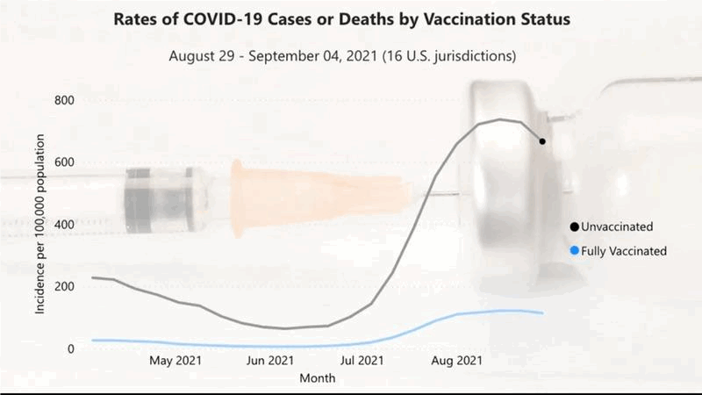

-

- The Pfizer vaccine for children ages 5 to 12 has been approved by the FDA.

- The Novovax nanoparticle sub-unit vaccine is getting closer to being available. This is a more traditional vaccine that doesn't use mRNA to create immunity. The company has submitted documents for approval in the UK and Australia. It doesn't require ultra-low temperatures for handling and shipping.

- Two drugs have been repurposed and seem to be effective in small studies for decreasing serious outcomes in patients with COVID. Fenofibrate (Tricor) and Fluvoxamine (Luvox) are drugs that are available as generics and have been shown to be valuable. They are off-patent and generic and that means inexpensive (a few dollars). Compare that to the anticipated cost to give Merck's new drug, Molnupiravir ($700/treatment.) We will see how this pans out.

- The positive prevalence in Maryland is currently hovering at around 3.0%.

-
-
On a musical note:

Just Breathe by Pearl Jam, a song about living for today.



-
-
-
-
-

On a lighter note:
Have a fun and safe Halloween!

 | 

-

As a reminder, I'm no longer sending out daily updates and instead, I'm updating you periodically. I continue to enjoy writing these updates. Initially, these were only sent to my patients, however, I've been humbled to learn that, through social media, these writings have been forwarded and re-forwarded to many. This has brought me great joy to know that this simple act of sharing facts, thoughts, opinions, and hopes have touched you in some way. Hopefully I've been able to reassure you, maybe make you smile and laugh, soothe your worries, and comfort you. And maybe, just maybe, I've helped you to be in the moment!

Reach out. Stay connected. Stay home. Save lives. The power of one. Be well.
Feel free to forward this on, spread the word, not the virus.
HAO
HAO
Harry Oken, M.D., Adjunct Professor of Medicine, University of Maryland, School of Medicine
Office 410-910-7500 |Fax 410-910-2310 |Cell 443-324-0823

View previous newsletters: http://harryokenmd.com/COVID-19-HOME.htm

Links for today

- Ted Lasso: Ted's First Panic Attack:
https://www.youtube.com/watch?v=Z0duv3d3M54
- "Just Breathe" - Live At Austin City Limits - Pearl Jam
https://www.youtube.com/watch?v=Eo-UKCxCglg

