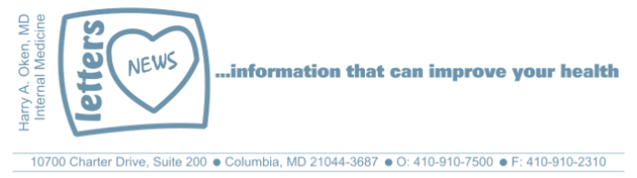
COVID-19-85 – July 9, 2021
Dear Patients:

Remember when you were a kid, you woke up with boundless energy ready to face the day with optimism and spunk? But now, maybe not so much? What are your very first thoughts when you first wake up? What is your mood? Are you happy, sad, angry, or just plain blah? Okay, so you get out of bed, go to the bathroom, maybe take out the dog, turn on the coffee.

And then, how do you feel? I really like a quote I saw several times in my cousin's latest book, Darling At The Campsite, "waiting for the common sense of the morning." Like Andy Abramowitz's previous novels, this is a great read that is ripe with humor but also speaks to trying to figure out how past events have brought you to where you are today. Decisions that seemed small and insignificant end up delivering you to your current state. This message rings true multiple times in this novel. Like teasing a neighbor kid, Ted the albino, then years later, Ted is a policeman that, by happenstance, you run into at the site of a motor vehicle accident and he remembers your juvenile name-calling.

How am I in the morning? I am sort of in neutral. I can't say I am happy or sad; as I begin to wake up, I become engaged, ambitious, optimistic. It's my morning automatic default. You might feel otherwise, depending on what is going on in your life. I know the way I want to feel, something I have written about in previous emails. I want to be imperturbable, so nothing gets me to be unkind, irritable, angry or frustrated. So, ask yourself after being awake for a few moments, where are you? How do you feel? How did you sleep? What do you want to accomplish today? This simple exercise might frame your mood and make for a better day.

With our circumstances over the past 15 months, most of us have had plenty to think about and lots of time to sort out our lives. Maybe, with everything that has been thrown at us, your morning default is not so rosy. Nonetheless, we can grow with time, or at least we should try. I think it is worth it to spend a few moments every day to self-evaluate. We may forget that our actions or inactions cause ripples in other people's life. Unfortunately, we tend to be poor evaluators of how we come off. We get it wrong a lot; I know I do. Best intentions are often misunderstood. Sometimes, saying something you think may be helpful, or even funny, can be misinterpreted as hurtful. Sometimes saying nothing at all is worse.

I try not to be tribal. In our day-to-day lives, there are no good guys or bad guys; there are just people trying to do what they think is right and they have the same painful problems that you and I have. The person on the other end of the Amazon customer service line is probably dancing as fast as they can; try to be patient and kind. The driver who cuts in front of you in the car is likely in a hurry and is wrong, but no need to incite them to road rage with a sustained horn blast or a gesticulation.

Here is a recently published study that looked at how a small event can trigger a bad day - if you let it. "One way to think about it is the longer your brain holds on to a negative event, or stimuli, the unhappier you report being." So let it go! Yes, and strive for being imperturbable, as it is Nirvana!

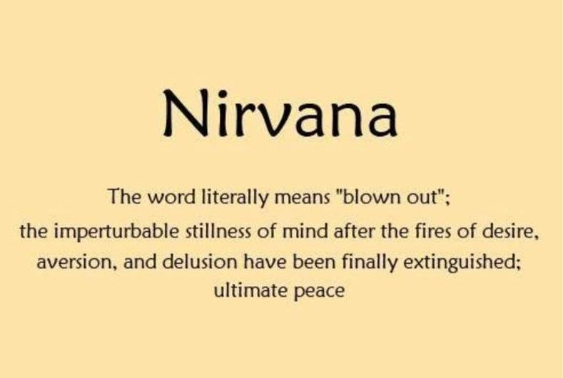

COVID faqs:

So where are we now?
Now that the incidence of positive cases in the US is <10/100,000, and in Maryland, it is 1/100,000, we can feel safe regarding the State's recommendations, yet our vaccination rate nationally is is only slightly more than 50%.

How long does it take to get immunity from the vaccine?
14 days after the second mRNA vaccine (Pfizer or Moderna), people will have 99.5% protection from getting a significant infection or being hospitalized or death. Similar data is available using the J&J vaccine.

How likely am I to contract COVID from a contaminated surface?
Very unlikely. Nevertheless, this pandemic has led to a better understanding of the transmission of all types of infections. Going forward, I think the practice of washing hands frequently throughout the day will help us see fewer colds, less flu and food-borne illness, and, of course, help control COVID. This virus is spread very efficiently by small particles that get aerosolized and hang in the air of confined indoor areas. Similar pathogens are TB, measles, and influenza; we need to keep our guard up as this could happen again.

I am healthy and under age 50, so why should I get vaccinated?
People under the age of 50 who even just get a mild case of COVID have the risk of developing "long hauler's syndrome." The frequency is not known, but it is thought to be between 10% and 30%. This syndrome is like chronic fatigue syndrome characterized by headaches, fatigue, periodic fever and is not something one would want dragging on for 3 to 6 months. Additionally, if you are not willing to get vaccinated for yourself, do it for the vulnerable people who you come into contact with. For the month of June, in Maryland, every single COVID death was in a person who did not get vaccinated.

If I contract COVID after I have been vaccinated but I have not reached full immunity, is there a role for the monoclonal antibody infusion?
Absolutely if you are vulnerable. Vulnerable people are those over 65 and those over 55 with a co-morbidity such as diabetes, lung disease, heart disease, obesity, or issues that affect the immune system. If you have tested positive with either the antigen quick test or PCR test, the time to receive the monoclonal antibody is before you get significantly ill.

When must I wear a face mask?
There is no longer a mandatory masking order in effect in Maryland; this is in line with the latest guidance coming from the CDC. However, also in alignment with this CDC guidance, face masks are still required on public transportation, in schools and child care and health care settings. Hopefully the mandate in schools and child care will change soon - I think it should.

-

Administrative update:

My office hours from now until the week after Labor Day are:

Monday, Tuesday, Wednesday, and Thursday, 9am to 4pm; closed on Friday.

When the office is closed, for urgent issues, I am still easily available by calling my cell 24/7. Otherwise, please send me an email to HarryOkenMD@gmail.com

-

On a musical note:

Morning Has Broken by Cat Stevens:

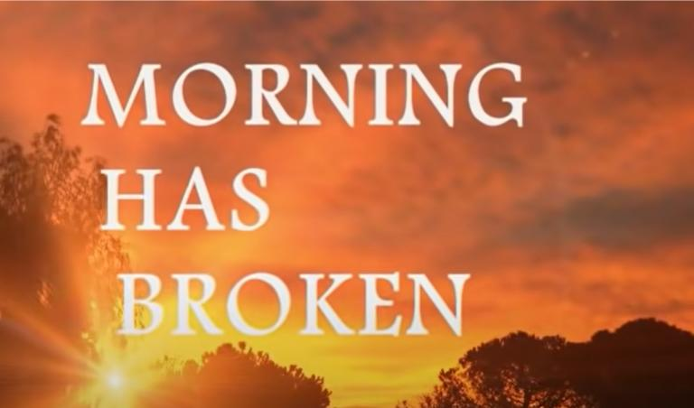

-

-

On a lighter note:

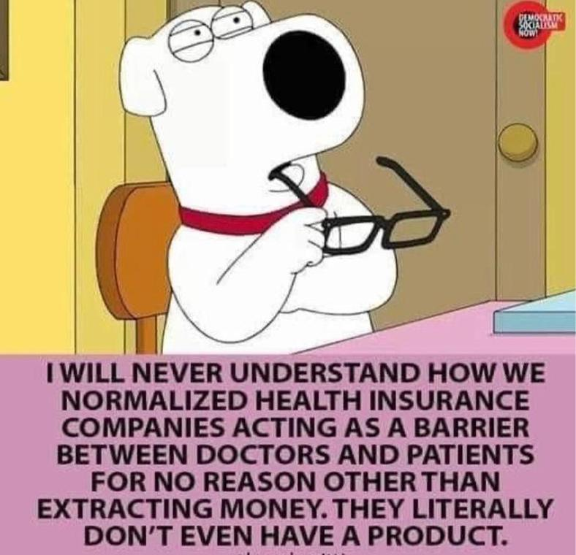

-

As a reminder, I'm no longer sending out daily updates and instead, I'm updating you periodically. I continue to enjoy writing these updates. Initially, these were only sent to my patients, however, I've been humbled to learn that, through social media, these writings have been forwarded and re-forwarded to many. This has brought me great joy to know that this simple act of sharing facts, thoughts, opinions, and hopes have touched you in some way. Hopefully I've been able to reassure you, maybe make you smile and laugh, soothe your worries, and comfort you. And maybe, just maybe, I've helped you to be in the moment!

Reach out. Stay connected. Stay home. Save lives. The power of one. Be well.
Feel free to forward this on, spread the word, not the virus.
HAO

HAO

Harry Oken, M.D.
Adjunct Professor of Medicine
University of Maryland, School of Medicine
Office 410-910-7500 |Fax 410-910-2310 |Cell 443-324-0823

View previous newsletters: http://harryokenmd.com/COVID-19-HOME.htm
Links for Today

- "For Good" Performed by Kristin Chenoweth and Idina Menzel | WICKED the Musical.
https://www.youtube.com/watch?v=TZ0pXUb5jVU

- Enlarge baby Bennett’s photo:

