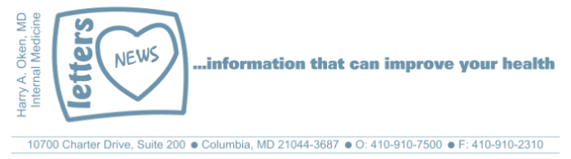
COVID-19-81 –January 23, 2021
Dear Patients:

Do you remember in A Few Good Men Jack Nicholson yells at Tom Cruise, you can't handle the truth?

Well, maybe we can handle it if we allow ourselves to see it. Your emotional brain can fool you; it kicks in and often keeps you from adjudicating the facts using the logical part of the brain. The emotional brain can take a leap and allow you to believe erroneous information. And once the brain imprints it, it can be there forever, and it often is resistant to believe alternate factual information. From Carl Sagan's writing on Baloney Detection, " try not to get overly attached to a hypothesis just because it is yours."

From my previous emails about metacognition (the science of thinking about thinking), you have read about confirmation bias, normalcy bias, and the backfire effect. Mankind has a long history of failing to give consideration to new ideas and inquiry; it is replete with intolerance for people who are not part of the group think. Indeed, we see this often in medicine. This is a published piece that I co-authored with my friend and mentor, Dr. Steve Schimpff, about delays and mistakes in medicine that have hindered progress.

My friend EN sent me the selection below, written by Gary Trudeau, the creator of Doonesbury. So, recognize and challenge the group think!

Going against group think, with new ideas that improve our lives, is not the same as being non-supportive or divisive. Challenging dogma in life can be and should be a constructive way to improve our lives if we do this by building a consensus with peaceful intent. Despite all our problems, which seem worse than ever, the United States is the most free, greatest, most innovative, and tolerant place in the world, and of course, that is why so many want to come here.

The impertinent question is the glory and engine of human inquiry.
﻿
Copernicus asked it and shook the foundations of Renaissance Europe.
Darwin asked it and redefined humankind's very sense of itself.
Thomas Jefferson asked it and was so invigorated by the asking.
that he declared one of our inalienable rights.
The Wright Brothers asked it and were ignored for five years.
Bill Gates asked it and was ignored for five minutes,
which was long enough for him to dominate the industry.

Whether reviled or revered in their lifetimes, history's movers
framed their questions in ways that were entirely disrespectful of
conventional wisdom. Civilization has always advanced in the shimmering
wake of its discontents.

About the COVID Vaccine:
- Howard County has done a great job of quickly dispersing their allotment; they are scheduling appointments as vaccine becomes available.
- Here is a link to find a vaccination-clinics in Maryland once you are eligible.
- I will keep you up to date on local availability!

The numbers:

Maryland: The current Rt has fallen to 0.95 which is a good sign. Remember that consistently less than 1.0 is the road to recovery!

USA: "The devastating fall and winter wave of coronavirus infections that is causing so much misery across the US appears to have finally peaked, according to several researchers who are closely tracking the virus." The article adds, "While another surge remains possible, especially with new, more infectious variants on the horizon, the number of new daily infections in the current wave appears to have hit a high in the past week or two and has been steadily declining in most states." Look at this link for a graphic overview.

The science of COVID:
- The J&J vaccine may be ready for review by the FDA in two weeks. This is a one-dose vaccine with comparable efficacy and would dump 100 million doses into the mix!
- Ivermection remains an interesting option. This recently published Lancet article supports the contention that it has little downside for vulnerable patients.
- The Monoclonal Antibody Infusions for patients who are positive for COVID and are >55 years old with a co-morbidity or >65 years old, is more available and easier to order in Maryland. It still is not perfect; we should have a central facility that is open 24/7 where vulnerable people with symptoms or a bonafide exposure can get a rapid test, wait for results, and if their test is positive, be treated on the spot.
- We should also have a mobile van that can go to nursing facilities and can immediately give the Monoclonal Antibody Infusion on site for residents who test positive. We have the drug - let us use it!
- I have continued to be vocal to elected officials that they need to do more. I have reached out to suggest that patients on dialysis, those patients who are working with oncologists, rheumatologists, and gastorenterologists and are on immuno-modulating drugs should be able to get vaccinated now. Let your elected officials know this. Call your County Executive's office, and Governor Hogan's office - make some noise. They work for us!

On a musical note:  I know you may feel you are Running On Empty (Jackson Browne) but I am really optimistic there is good reason to believe things are looking up! We are in the final stretch...keep it going! | 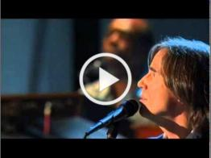

On a lighter note:

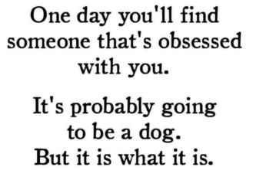 | 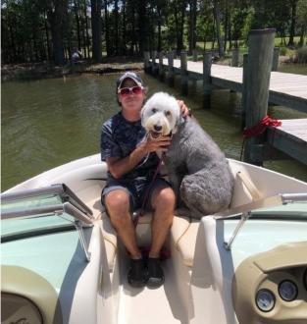

As a reminder, I am no longer sending out daily updates and instead, I am updating you periodically as things change. Just like yesterday, face masks, social distancing, hand washing and/or sanitizer whenever you need to leave your safe zone. Stay home if you display any symptoms.

I continue to enjoy writing these updates. Initially, these were only sent to my patients, however, I have been humbled to learn that, through social media, these writings have been forwarded and re-forwarded to many. This has brought me great joy to know that this simple act of sharing facts, thoughts, opinions, and hopes have touched you in some way. Hopefully, I have been able to reassure you, maybe make you smile and laugh, soothe your worries, and comfort you. And maybe, just maybe, I have helped you to be in the moment!

Reach out. Stay connected. Stay home. Save lives. The power of one. Be well.
Feel free to forward this on: spread the word, not the virus.

HAO

Harry Oken, M.D.
Adjunct Professor of Medicine
University of Maryland, School of Medicine

Office 410-910-7500 |Fax 410-910-2310 |Cell 443-324-0823

View previous newsletters: http://harryokenmd.com/COVID-19-HOME.htm

Links for Today

- A few Good men - You Can’t handle the Truth:
https://www.youtube.com/watch?v=5j2F4VcBmeo&ab_channel=PheasantBreezy
- Carl Sagan's writing on Baloney Detection:
https://www.brainpickings.org/2014/01/03/baloney-detection-kit-carl-sagan/
- Published piece I co-authored:
https://www.kevinmd.com/blog/2017/11/medical-experts-really-know-best.html
- COVID – Maryland: https://coronavirus.maryland.gov/
- Rt Maryland: https://rt.live/us/MD
- US Overview: https://covidtracking.com/data/charts
- Lancet Article: https://www.thelancet.com/journals/eclinm/article/PIIS2589-5370(20)30464-8/fulltext
- Monoclonal antibodies vs Nursing Homes:
https://www.sciencemag.org/news/2021/01/monoclonal-antibodies-can-prevent-covid-19-successful-vaccines-complicate-their-future

