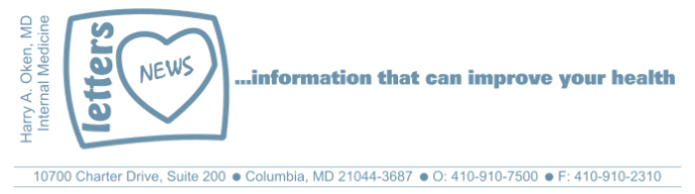
COVID-19-80 –January 18, 2021
Dear Patients:

For those of you who are Maryland residents and in Phase 1B, below is a link to register to be notified to be given a vaccination at one of the University of Maryland Medical System Hospitals - see details below:

Phase 1B includes:

- People 75 years or older
- People who live in assisted or senior living facilities
- People who live in a developmental disabilities/behavioral health group home
- Teachers, childcare providers, and other education workers
- Government workers

The vaccinations through this link are given at one of many of the University of Maryland Medical System member hospitals. When you register, you pick which location you want. Click here to go to the information page on how to get the COVID-19 vaccine. And this brings you to the actual request form.

On a musical note:

Did you know that I am a Quintuple Terp: BS, MS, MD, Residency, and Faculty for many years? My alma mater is coming through for you! While you are registering, play the Maryland Fight Song:



On a lighter note:

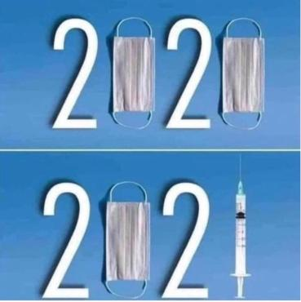

As a reminder, I am no longer sending out daily updates and instead, I am updating you periodically as things change. Just like yesterday, face masks, social distancing, hand washing and/or sanitizer whenever you need to leave your safe zone. Stay home if you display any symptoms.

I continue to enjoy writing these updates. Initially, these were only sent to my patients, however, I have been humbled to learn that, through social media, these writings have been forwarded and re-forwarded to many. This has brought me great joy to know that this simple act of sharing facts, thoughts, opinions, and hopes have touched you in some way. Hopefully, I have been able to reassure you, maybe make you smile and laugh, soothe your worries, and comfort you. And maybe, just maybe, I have helped you to be in the moment!

Reach out. Stay connected. Stay home. Save lives. The power of one. Be well.
Feel free to forward this on: spread the word, not the virus.

HAO

Harry Oken, M.D.
Adjunct Professor of Medicine
University of Maryland, School of Medicine

Office 410-910-7500 |Fax 410-910-2310 |Cell 443-324-0823

View previous newsletters: http://harryokenmd.com/COVID-19-HOME.htm

Links for Today

- How to Get the COVID Vaccine: https://www.umms.org/ummc/coronavirus/get-vaccine
• COVID-19 Vaccine Request Form:
https://app.smartsheet.com/b/form/8daed98395fb431c8206b1241fe9602f
- University of Maryland's "Victory Song":
https://www.youtube.com/watch?v=FtfW4pFmRf8&ab_channel=Thewolfdog83

