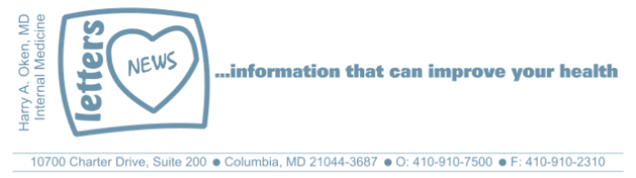
COVID-19-73 – November 8, 2020
Dear Patients:

Election Anxiety Disorder, EAD, is a real entity. I've witnessed it on a daily basis with my patients and have felt it myself. More than ever, this election seemed to have greater significance than any previous elections. You may be happy with the result or you may not, but we will go forward. If you voted, then you exerted the control you could, and now there's a new beginning for all of us. It's a fresh slate and let's unite as a nation.

There is something else related to this that I've been thinking about and I want to share. Thinking about the way one is thinking is a process called meta-cognition. Psychologists tell us that once you add something to your collection of beliefs, you unconsciously protect it from harm. You may have experienced this when you are confronted with information that you may not agree with. Your thinking process instinctively kicks in.

Confirmation bias is the term to describe the practice of looking for information that supports our way of thinking and disregarding information that does not. You can find anything in a Google search to confirm your convictions. The backfire effect is the phenomenon that occurs when your beliefs only grow stronger after being presented contradictory evidence. The evolutionary neural wiring of the brain promotes our emotional brain to override the cognitive brain almost every time. Both of these concepts are important in the wake of a newly elected President during this divisive time. Just understand that we have these reflex ways of thinking and depending on how our way of thinking is presented, it can cause great emotional harm to the people we care about. If we can acknowledge and understand the way we think, then perhaps we can mend our disagreements that may have invoked harm to long-cherished relationships. Interested in more on this? Check out this article.

Going forward, how can we heal? Let's find things we can agree on and be thankful that we live in a democracy. | 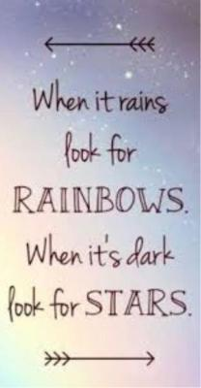
The numbers:

USA: This site shows the national trend; note the cases are up, but hospitalizations have not reached earlier peaks. The death rate is down and the population who contracts COVID-19 is generally younger and healthier.

Maryland: The Rt is up across the country; in Maryland it is 1.20; we want it to be <1.0. Next, look at these graphs (be sure to select Maryland in the top right corner). Daily tests, cases, and hospitalizations are up and at the same level as the last surge in July and August. However, the death rate is falling and currently in Maryland it is 2.6%. If we look at the death rate in Maryland for those under 50, it is very low at

0.2%. If you add in under 60, it is 0.45%, and if you add under 70, it is 0.87%. These numbers are very close to seasonal influenza. The message is the same; we need to be very protective of the vulnerable: people over the age of 60, and those with co-morbidities (obesity, diabetes, heart and lung disease, and those who are immuno-compromised).

The science of COVID:
- No new studies to discuss.
- Natural infection, combined with the anticipated vaccine, will be the ultimate solution.

On a musical note:

We Can Work It Out by The Beatles


On a lighter note:

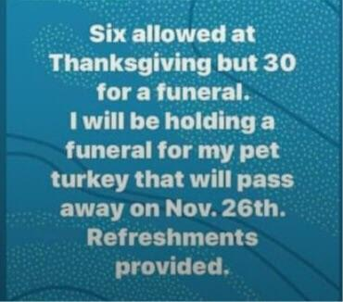

As a reminder, I'm no longer sending out daily updates and instead, I'm updating you periodically as things change. Just like yesterday, face masks, social distancing, hand washing and/or sanitizer whenever you need to leave your safe zone. Stay home if you display any symptoms.

I continue to enjoy writing these updates. Initially, these were only sent to my patients, however, I've been humbled to learn that, through social media, these writings have been forwarded and re-forwarded to many. This has brought me great joy to know that this simple act of sharing facts, thoughts, opinions, and hopes have touched you in some way. Hopefully, I've been able to reassure you, maybe make you smile and laugh, soothe your worries, and comfort you. And maybe, just maybe, I've helped you to be in the moment!

Reach out. Stay connected. Stay home. Save lives. The power of one. Be well.
Feel free to forward this on: spread the word, not the virus.
HAO
24/7

Links for today.

- The Backfire Effect: https://medium.com/homeland-security/the-social-psychology-of-the-backfire-effect-locking-up-the-gears-of-your-mind-a79d4e6e8061
- National Trend: https://twitter.com/COVID19Tracking/status/1325232274783281153
- Maryland: https://coronavirus.maryland.gov/
- Maryland Rt: https://rt.live/?fbclid=IwAR1wdbbX1wtiPpnATDwr1fqRzgTXQZhomcO1lCk6bGrxae0ia8KUWOSa2HM#FL
- Key Metrics: https://covidtracking.com/data/charts/all-metrics-per-state
- We Can Work It Out by The Beatles: https://www.youtube.com/watch?v=Qyclqo_AV2M

