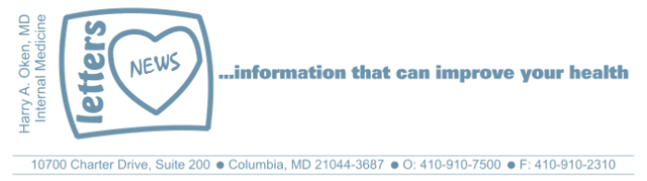
COVID-19-70 – September 22, 2020
Dear Patients:

The pandemic: so often, I think 'I am so over this.' I sometimes get this feeling in the pit of my stomach; ugh, another day of restrictions and impositions and news devised to scare us. I am so over this. But then, I snap out of it. How? I realize how fortunate I am. My family, my friends, my privilege of being a physician with purposeful work, all of these are my anchors. I bet that if you think about it, you are also blessed with an anchor or two as well. Just pause, maybe close your eyes, and think about it.

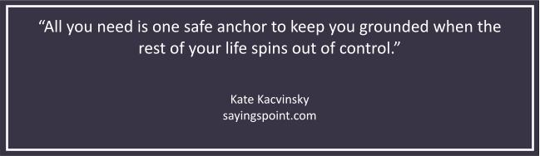

Flu shot information: I recommend that all my patients get the quadrivalent flu shot. This is an inactivated (not live) safe vaccine that will immunize you for 4 strains of the flu. It takes 10 to 14 days to get a rising concentration of antibody, which peaks at 5 to 8 weeks and then starts to decline. For this reason, the best time to get your shot is from now to the end of October.

Please stop by the office for your flu shot between 8:30 and 11:45 am, Monday through Friday. When you arrive in the parking lot, call my office 410-910-7500 to let us know you are here. You will be instructed when to come up, wearing your properly fitting face mask; this means it covers your mouth and nose. Instead of entering the waiting room, continue straight, pass the restroom on the left, and enter the next door on the left. Come in through the door, make an immediate left and you will see a sign "Flu Shot Room". Enter the room and we will meet you there to give you your shot. Please try to wear a short sleeve shirt to minimize the time it takes. If you have an upcoming appointment, we will give you your shot at your appointment.

If coming to the office is not convenient, many stores are now offering them, such as CVS, Walgreens, Target, etc., and many are free of charge and some offer appointments.

The numbers:

Maryland continues to improve. The fatality rate has decreased to 3.09%. Hospitalizations and ICU admissions are down. The fatality rate for 0 to 19 years of age is 0.014%.

Maryland Rt: Now 0.96, we want to see it persistently <1.0. Wear your face mask, wash your hands frequently, and social gatherings <10 people.

Influenza activity remains very low in the Southern hemisphere. If you remember a few weeks ago, the news was telling us there may be a "Twindemic" on our doorstep. I am not saying we do not need to be on alert, we need to get our flu shots, but we also need to be wary of the news. So far, the facts are that there is little flu in the Southern hemisphere, and this is the barometer for our flu season. It appears that it is less likely flu will be a significant problem this year, but things can quickly change. Get your flu shot!

The science of COVID:
- Wear your face mask. This is a great article with lots of good information about the value of masking.
- The science behind the risk for COVID-19 and blood type is weak says this article from JAMA.
- We are now no longer worried about aspirin, ibuprofen (Advil and Aleve) causing more significant COVID-19 illness.
- There is currently no evidence that taking anti-hypertensives that are ACE inhibitors or ARBs causes any increase in the risk or severity of COVID-19 illness.
- For sure, however, we know that age and co-morbidities such as obesity, diabetes, heart and lung disease do raise the risk.
- Again, more information that Vitamin D deficiency raises your risk for COVID-19 and influenza. Take at least 2000 units of Vitamin D-3 daily to avoid Vitamin D deficiency.
- Those who get their nose swabbed for COVID-19 often say they pushed the swab into my brain (thanks LO). The correct swab technique goes straight back along the floor of the nose.

-

On a musical note:

Maybe you're old enough to remember Woodstock; a time when people came together. We are stardust. We are golden.


-

On a lighter note:

Do you think Lucy's facial expressions explain how our year has been?

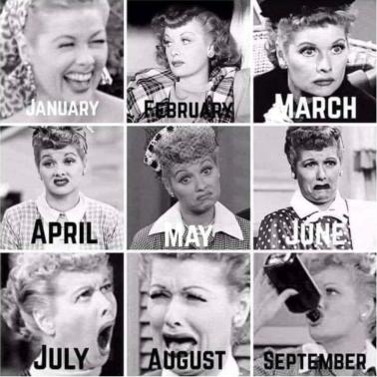

As a reminder, I'm no longer sending out daily updates and instead, I'm updating you periodically as things change. Just like yesterday, face masks, social distancing, hand washing and/or sanitizer whenever you need to leave your safe zone. Stay home if you display any symptoms.

I continue to enjoy writing these updates. Initially, these were only sent to my patients, however, I've been humbled to learn that, through social media, these writings have been forwarded and re-forwarded to many. This has brought me great joy to know that this simple act of sharing facts, thoughts, opinions, and hopes have touched you in some way. Hopefully, I've been able to reassure you, maybe make you smile and laugh, soothe your worries, and comfort you. And maybe, just maybe, I've helped you to be in the moment!

Reach out. Stay connected. Stay home. Save lives. The power of one. Be well.
Feel free to forward this on: spread the word, not the virus.
HAO
24/7

Links for Today

- Crosby, Stills and Nash: Woodstock: https://www.youtube.com/watch?v=4lx86B6a3kc
- Maryland Covid-19 Dashboard: https://coronavirus.maryland.gov/
- Maryland Rt: https://rt.live/?fbclid=IwAR1wdbbX1wtiPpnATDwr1fqRzgTXQZhomcO1lCk6bGrxae0ia8KUWOSa2HM#FL

- Decreased Coronavirus Activity: https://www.cdc.gov/mmwr/volumes/69/wr/mm6937a6.htm?s_cid=mm6937a6_w
- Science Behind Wearing a Mask:
https://www.ucsf.edu/news/2020/06/417906/still-confused-about-masks-heres-science-behind-how-face-masks-prevent
- Correct Swab Technique:
https://jamanetwork.com/journals/jamaotolaryngology/fullarticle/2770786?utm_source=silverchair&utm_campaign=jama_network&utm_content=covid_weekly_highlights&utm_medium=email

