
COVID-19-66 – May 30, 2020
Dear Patients,

Picture this: it is a sunny day, there is a summer breeze and you are walking up a mountain trail. Instead of being close to the mountainside on your right, you are walking on the side of the path which is closest to the edge. Pre-occupied with your thoughts, your mind is somewhere else. As you are walking, you stumble and your right foot comes off the path and drags against the outer edge of the path. It happens suddenly, it's unexpected and it jolts your attention to the present moment. You are able to recover without falling down the incline to your right. Yikes! That was a close one. It could have been bad but you were lucky. This time.

Okay, but what does this have to do with COVID-19? Well, in Maryland, the Governor has eased lock-down restrictions as of yesterday at 5:00 PM. I welcome it. Businesses can slowly open up. Restaurants that are able can serve outside. Outdoor pools can be at 25% capacity. Yet, just like taking a nice hike up a mountain path, be cautious, stay alert, be in the moment, one step at a time. Wear your face-mask, socially distance, wash your hands, isolate yourself if you are not feeling well. Be careful in areas out of your safe zone and sanitize your hands once back in your safe zone. Remember, however, that this is a respiratory virus. Yes, you can contract it by contact, but according to the CDC, this is <6% of the cases.

The reality of the lock-down is that it worked. The curve flattened and we avoided a surge in our hospitals. Now, we are prepared in our hospitals. We have strict standard operating procedures for our most vulnerable in senior nursing facilities. We have adequate personal protective gear and testing for our health care workers. The reality is that as we ease back into our lives, we have to learn to live with COVID-19 and we have to get back to work. Overall, as statisticians and epidemiologists learn from the pandemic, you will see more and more information that supports re-opening in a logical, targeted manner. And hopefully, with this new understanding of the biology and epidemiology of the pandemic, school reopening in the fall is beginning to become a reality in many places. The data is clear that people with co-morbidities and under the age of 60 are at very low risk for complications from a COVID-19 infection.

I have attached recent Senate testimony by Scott Atlas, M.D. and his colleagues from Stanford University; they have a common-sense plan for re-opening the country. Based on what we now know, it is very practical. As I have said before, as information becomes available every day, news is reported that makes us stop and say "I am even more confused!" Hang in there! Overall, we are making good progress with COVID-19.

"Going through challenging things can teach you a lot,
and they also make you appreciate the times that aren't so challenging."
Carrie Fisher

The numbers:
Yes, we have surpassed 100,000 US deaths.

Maryland: 50,988 cases -/- 2,348 deaths -/- 4.6% fatality rate
Greater than 50% of the deaths in Maryland continue to be nursing facility residents or staff.
The Maryland Rt was updated yesterday and is 0.89 (it continues to decline); the lower the better.

Diagnostics and Therapeutics:
- French tests show that even mild coronavirus illness leads to antibodies.
- Contrary to previous reports, sunlight does not effectively kill COVID-19..
- Invisible ultraviolet light (UVC) does kill viruses and bacteria; it is being employed as a cleanup strategy for NYC subway cars overnight.
- New technology, using very specific wavelengths of UVC is being developed and should be a powerful mitigation strategy.
- Dr. Fauci recently said a second wave is "not inevitable."

My book update:
Thanks to all of you who have purchased BOOM, 100% of the profits are going to support COVID-19 research at the University of Maryland. Now, more than ever, is a great time to take a fresh look at your health, nutrition and stress management.

 | 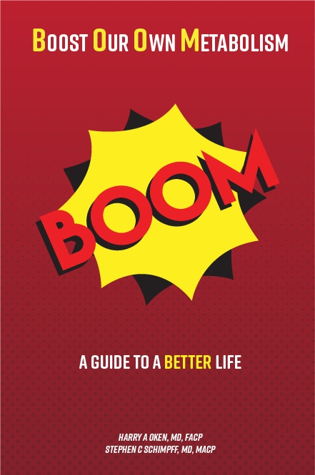
  

On a Musical Note: The Bitch is Back by Elton John



On a lighter note:

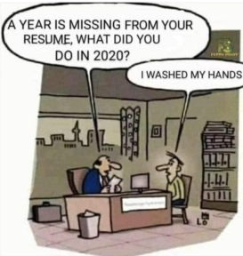

As a reminder, I'm no longer sending out daily updates and instead, I'm updating you periodically as things change. Just like yesterday, face masks, social distancing, hand washing and/or sanitizer whenever you need to leave your safe zone. Stay home if you display any symptoms.

I continue to enjoy writing these updates. Initially, these were only sent to my patients, however, I've been humbled to learn that, through social media, these writings have been forwarded and re-forwarded to many. This has brought me great joy to know that this simple act of sharing facts, thoughts, opinions, and hopes have touched you in some way. Hopefully I've been able to reassure you, maybe make you smile and laugh, soothe your worries, and comfort you. And maybe, just maybe, I've helped you to be in the moment!

Reach out. Stay connected. Stay home. Save lives. The power of one. Be well.
Feel free to forward this on: spread the word, not the virus.

HAO, 24/7
Harry A. Oken, M.D.
Office: 410-910-7500, Fax: 410-910-2310, Cell: 443-324-0823
Adjunct Professor of Medicine, University of Maryland School of Medicine

Links for Today
- The Bitch is Back by Elton John: https://www.youtube.com/watch?v=upR7GQ5ToCs&has_verified=1
- Seals and Crofts Summer Breeze: https://www.youtube.com/watch?v=gIU50ZSLIrE
- The Maryland Rt: https://rt.live/?fbclid=IwAR1wdbbX1wtiPpnATDwr1fqRzgTXQZhomcO1lCk6bGrxae0ia8KUWOSa2HM#FL
- Senate testimony by Scott Atlas, M.D.: https://files.constantcontact.com/b6935121801/1b592d97-ea47-4751-94d1-a82c77ad2c08.pdf
- Mild coronavirus illness leads to antibodies.
- Contrary to previous reports, sunlight does not effectively kill COVID-19..
- NYC subway cars overnight: https://www.timeout.com/newyork/news/watch-a-subway-car-get-blasted-with-uvc-light-to-get-disinfected-052020
- Specific wavelengths of UVC is being developed and should be a powerful mitigation strategy: https://www.cbsnews.com/news/coronavirus-crisis-far-uvc-light-microbe-blasting-uv-technology-could-kill-covid-19-public-places/
- A second wave is "not inevitable: https://www.cnbc.com/2020/05/27/dr-anthony-fauci-says-a-second-wave-of-coronavirus-is-not-inevitable.html

