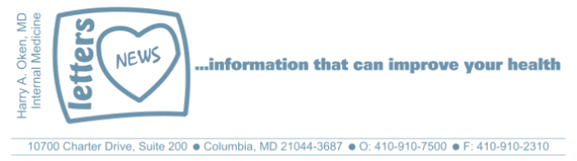
COVID-19-64 – May 21, 2020
Dear Patients,

Turn on the tv or radio, coronavirus, check your computer, coronavirus, read the paper, coronavirus. It's everywhere, and we are tired of it. Coronavirus fatigue syndrome.

Life is going on all around us, all 50 states have reopened to some extent. What do we do now? Cautious, incremental, moving forward. We now know, according to the latest CDC data, that contact spread is less likely. Primarily, the infection is spread by respiratory droplets from presymptomatic, asymptomatic and infected patients. This is how we are most likely to get it. So of course, if you are sick, you must stay home and isolate yourself. If you are not sure why you are sick, reach out to me and we will get you tested if appropriate. This virus can be transferred within a home of an infected person; the likelihood of infection is all about proximity to an infected source as well as the degree of exposure to the infected source. Constant exposure to an infected family member or co-worker increases our risk.

When you go out of your safe zone, wear your face masks and frequently wash your hands or use a hand sanitizer. Will face masks be advised for the foreseeable future? Yes. Forever? Definitely no. I am reasonable certain that once we begin to see that the number of admissions to the hospital for COVID-19 infections becomes minimal and the daily death rate is likewise minimal, face mask use will drop significantly and be used for high-risk settings like hospitals and nursing facilities as well as in medical and dental offices where the risk is elevated. When will this happen? It all depends on the prevalence of the infection. Bottom line: every day we get closer and closer to restoring our previous lives.

For now: face mask, frequent hand-washing or hand sanitizer, gatherings of less than 10 people, 6 feet of social distancing, and isolation of anyone who may have symptoms suggestive of COVID-19.

"When you reach the end of your rope,
tie a knot in it and hang on"
Franklin D. Roosevelt

The numbers:
Maryland: 43,531 cases -/- 2,045 deaths -/- 4.7% fatality rate
Greater than 50% of the deaths in Maryland continue to be nursing facility residents or staff.
The Maryland Rt was updated yesterday and is 0.98 (up slightly); the lower the better.

Diagnostics and Therapeutics:
Nothing new to report.

My book update:
Thank you to all who have made a donation by purchasing my book. I truly appreciate it! If you haven't made a purchase, if these daily emails have touched you, soothed you, reassured you in anyway, please let me know by making a donation by purchasing BOOM!

If you've already purchased BOOM, please go back into your Amazon account, in the search bar at the top, type "BOOM and Oken" and write a review! These reviews are really important (and so far, we don't have any)!

 | 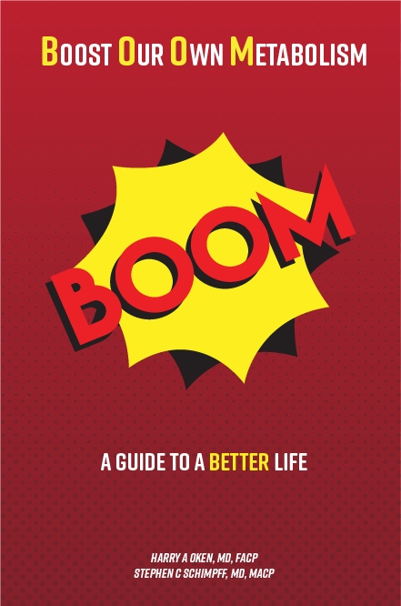
  Please consider purchasing a copy or copies today. Remember, all proceeds benefit COVID-19 research at the University of Maryland Medical Center. Ordering instructions are below.
  

On a Musical Note: Hang on Sloopy by The McCoys | On a lighter note.
 | 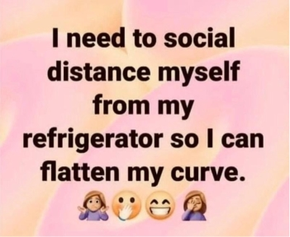

Reach out. Stay connected. Stay home. Save lives. The power of one. Be well.
Feel free to forward this on: spread the word, not the virus.

HAO, 24/7
Harry A. Oken, M.D.
Office: 410-910-7500, Fax: 410-910-2310, Cell: 443-324-0823
Adjunct Professor of Medicine, University of Maryland School of Medicine

Links for Today
- Hang On Sloopy by The McCoys: https://www.youtube.com/watch?v=2NUZzB8_XHM
- The Maryland Rt: https://rt.live/?fbclid=IwAR1wdbbX1wtiPpnATDwr1fqRzgTXQZhomcO1lCk6bGrxae0ia8KUWOSa2HM#FL
- Boom Paperback: https://www.amazon.com/dp/B088B4PVZD/ref=sr_1_1?keywords=boom+oken&qid=1589025147&sr=8-1
- Boom, Kindle version:
https://www.amazon.com/BOOM-Boost-Our-Own-Metabolism-ebook/dp/B0882VV9K3/ref=tmm_kin_swatch_0?_encoding=UTF8&qid=1589025147&sr=8-1
- Kindle app: https://www.amazon.com/Kindle-Store/b?ie=UTF8&node=133140011

