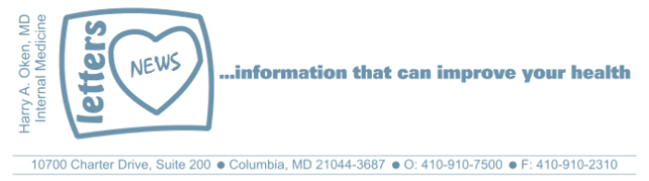
COVID-19-60 – May 15, 16, 17, 2020
Dear Patients,

It's another Friday and today I want address some recent questions I've received by reviewing some facts as we know them today; they may be different from yesterday and may change again tomorrow.
- This is primarily a respiratory virus.
- Stay home if you are coughing or sneezing or if you have other symptoms such as loss of taste or smell, fever, chills, or achy. And be sure to call me.
- A sneeze or cough sends out lots of particles.
- Face masks can decrease transmission from person to person so wear one whenever you are out of your safe zone.
- N-95 masks (that fit properly) are for high-risk situations such as for health care workers taking care of COVID+ people or taking care of high-risk patients.
- Yes, we can demonstrate that under certain conditions, the particles can travel >20', but this was under lab conditions.
- Yes, we can demonstrate that objects and surfaces can become contaminated with low levels of virus.
- Yes, in the lab, the virus can live on surfaces for up to 3 days; this is a very unlikely way to get the infection.
- Yes, you can pick it up from a contaminated object, but if you wash your hands and do not touch your face, your risk is low; wearing a face mask helps decrease the chance of touching your face.
- Direct sunlight kills the virus quickly! You can decontaminate any object by placing it outside in direct sunlight for 5 minutes.
- Be careful in public bathrooms. Yes, COVID has been found in toilets. It is likely not a great mode of transmission but be sure to wear your face mask in a public bathroom. To be extra careful, turn around after flushing.
- When using an elevator, push the button with a pen or key, and afterwards, use hand sanitizer.
- No handshaking, hugs or kisses unless you are with a family member or significant other who has been following safety protocols.
- The majority of people who get the infection won't have any symptoms (50%) or mild symptoms (30%).
- Hydroxychloroquine may have a role in the early treatment of infection.
- Remdesivir may have an impact if used early.
- People taking blood pressure and heart medications who are on ACE and ARBs are safe to continue using them.
- People who are using Advil, Aleve, and prescription anti-inflammatories are safe to continue using them.
- Take Vitamin D, at least 2000 units per day.
- The most vulnerable people are those in nursing facilities; the people who take care of them need protection.
- Eat well, exercise regularly (not too much, not too little), get outside in the sun for 20-30 minutes each day, and get restorative sleep to boost your immune system.
- Stay calm, have gratitude for what you have, and give kindness to those in need.

"I carry a badge. My name's Friday."
"Just the facts, Ma'am."

- Detective Joe Friday of Dragnet

The numbers:
Maryland: 36,986 cases -/- 1,792 deaths -/- 4.8% fatality rate
Greater than 50% of the deaths in Maryland have been nursing facility residents.

The Maryland Rt was updated this afternoon and is 0.96 (stable); the lower the better.

Diagnostics and Therapeutics: Nothing new to report.

My book update:

Another reminder, it's here - both as a paperback and Kindle e-book!
﻿
I have one request of you when you finish reading this email if you haven't already done so, and that is to please consider purchasing a copy or copies of my book to help fund important COVID-19 research.

 | 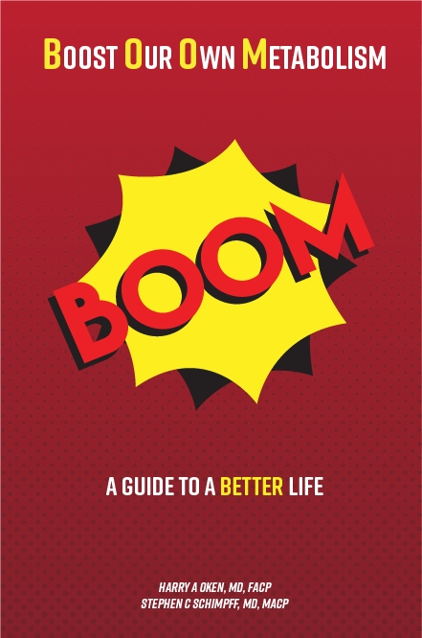
  Please consider purchasing a copy or copies today. Remember, all proceeds benefit COVID-19 research at the University of Maryland Medical Center. Ordering instructions are below.
  

Instructions for ordering the book:

- Paperback version - Click here to go directly to Amazon.
- Kindle e-book -
- If you are purchasing the Kindle e-book from a computer/laptop, click here to have the e-book version delivered to a Kindle app on your tablet or phone. This is the easiest method. Note, you will need to have the Kindle app installed on your tablet or phone. To do this, go to the App Store.
- If you are purchasing the Kindle e-book from an iPad or iPhone, you'll need to have the Kindle app installed. Open Safari on your device and go to this link. Then, in the top search bar, type in 'Oken BOOM' and it will bring you to the page to purchase it.

On a lighter note: (thanks JF): Here's some weekend breaking news!

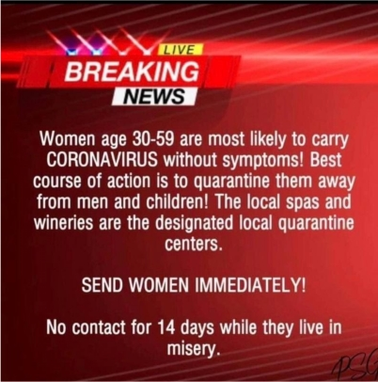

Reach out. Stay connected. Stay home. Save lives. The power of one. Be well.
Feel free to forward this on: spread the word, not the virus.

HAO, 24/7
Harry A. Oken, M.D.
Office: 410-910-7500, Fax: 410-910-2310, Cell: 443-324-0823
Adjunct Professor of Medicine, University of Maryland School of Medicine

Links for Today
- Dragnet, TV Show: https://www.youtube.com/watch?v=AMIZGrgWOO4
- The Maryland Rt:
https://rt.live/?fbclid=IwAR1wdbbX1wtiPpnATDwr1fqRzgTXQZhomcO1lCk6bGrxae0ia8KUWOSa2HM#FL
- Boom Paperback: https://www.amazon.com/dp/B088B4PVZD/ref=sr_1_1?keywords=boom+oken&qid=1589025147&sr=8-1
- Boom, Kindle version:
https://www.amazon.com/BOOM-Boost-Our-Own-Metabolism-ebook/dp/B0882VV9K3/ref=tmm_kin_swatch_0?_encoding=UTF8&qid=1589025147&sr=8-1
- Kindle app: https://www.amazon.com/Kindle-Store/b?ie=UTF8&node=133140011

