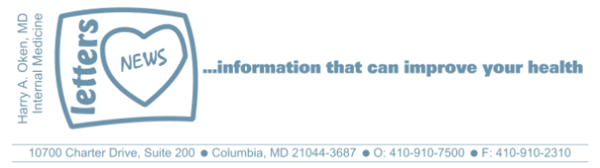
COVID-19-59 – May 14, 2020
Dear Patients,

Yesterday, Governor Hogan gave further guidance concerning the reopening of Maryland. County Executives may allow their county to transition into Phase 1 as of May 15 at 5:00 pm. In Maryland, Governor Hogan has already given the okay for elective surgeries and outside activities such as golf, tennis, and boating. Phase 1 allows additional businesses to open at the discretion of the local County Executive.

In Howard County, we will not be going to Phase 1 tomorrow. Calvin Ball has stated that "Howard County does not meet many of the criteria that the Governor outlined in his four building blocks to reopen."

In Maryland, the hot spots continue to be Baltimore City, Baltimore County, PG County and Montgomery County.

This makes me think about The Lone Ranger Theme Song where the masked ranger would say to his companion Tonto "hold your horses." Yes, let's slowly open up with caution. Timing is important. We absolutely have to get people back to work but at the right time.

"The way I see it, if you want the rainbow,
you gotta put up with the rain."
- Dolly Parton

The numbers:
Maryland: 35,903 cases -/- 1,748 deaths -/- 4.9% fatality rate
Greater than 50% of the deaths in Maryland have been nursing facility residents.

The Maryland Rt was updated this morning and is 0.96 (stable); the lower the better.

Diagnostics and Therapeutics:
Nothing new to report.

My book update:

Another reminder, it's here - both as a paperback and Kindle e-book! ﻿ I have one request of you when you finish reading this email if you haven't already done so, and that is to please consider purchasing a copy or copies of my book to help fund important COVID-19 research.

 | 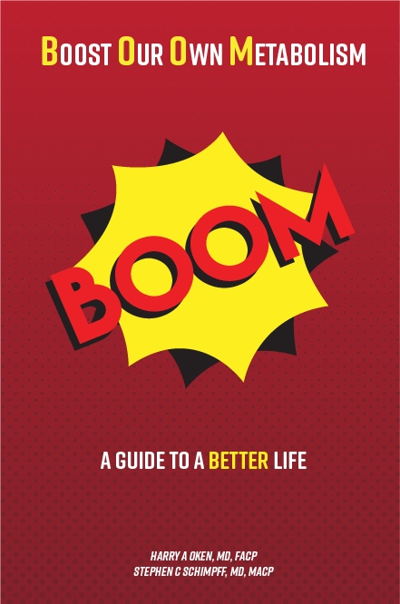
  Please consider purchasing a copy or copies today. Remember, all proceeds benefit COVID-19 research at the University of Maryland Medical Center. Ordering instructions are below.
  

Instructions for ordering the book:

- Paperback version - Click here to go directly to Amazon.
- Kindle e-book -
- If you are purchasing the Kindle e-book from a computer/laptop, click here to have the e-book version delivered to a Kindle app on your tablet or phone. This is the easiest method. Note, you will need to have the Kindle app installed on your tablet or phone. To do this, go to the App Store.
- If you are purchasing the Kindle e-book from an iPad or iPhone, you'll need to have the Kindle app installed. Open Safari on your device and go to this link. Then, in the top search bar, type in 'Oken BOOM' and it will bring you to the page to purchase it.

On a Musical Note:
I'm your Captain/Closer to Home - Grand Funk Railroad



On a lighter note: (thanks JF)
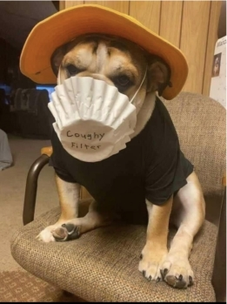

Reach out. Stay connected. Stay home. Save lives. The power of one. Be well.
Feel free to forward this on: spread the word, not the virus.

HAO, 24/7
Harry A. Oken, M.D.
Office: 410-910-7500, Fax: 410-910-2310, Cell: 443-324-0823
Adjunct Professor of Medicine, University of Maryland School of Medicine

Links for Today
- I'm your Captain / Closer to Home - Grand Funk Railroad:
https://www.youtube.com/watch?v=D295vdVGJu4
- Lone Ranger theme music: https://www.youtube.com/watch?v=uUpDG680uew
- The Maryland Rt:
https://rt.live/?fbclid=IwAR1wdbbX1wtiPpnATDwr1fqRzgTXQZhomcO1lCk6bGrxae0ia8KUWOSa2HM#FL
- Boom Paperback: https://www.amazon.com/dp/B088B4PVZD/ref=sr_1_1?keywords=boom+oken&qid=1589025147&sr=8-1
- Boom, Kindle version:
https://www.amazon.com/BOOM-Boost-Our-Own-Metabolism-ebook/dp/B0882VV9K3/ref=tmm_kin_swatch_0?_encoding=UTF8&qid=1589025147&sr=8-1
- Kindle app: https://www.amazon.com/Kindle-Store/b?ie=UTF8&node=133140011

