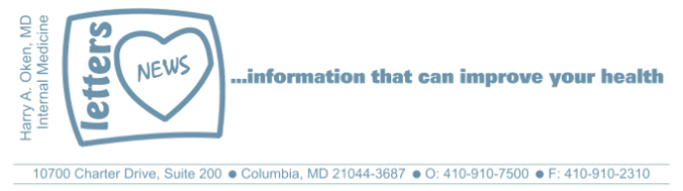
COVID-19-58 – May 13, 2020
Dear Patients,

Governor Hogan is scheduled to hold a press conference today and it is thought he could announce the first stage of his re-opening plan. Yet, we all know that things will never quite be the same. Yesterday, Dr. Fauci, on home quarantine, testified before the Senate by video and stated that "Americans would experience suffering and death that could be avoided, as well as additional economic damage, if states ignore federal guidelines, including delaying reopening of most businesses until they see dramatic declines in cases."

Dr. Fauci, a respected public health care official, scientist and physician, made his statements with an abundance of caution. How can anyone disagree? You may remember that in late January, based on information at that time, we were told not to worry, this will not be a problem. In medicine, we take the best information and process it and make a plan. However, as situations unfold, we may start down a path, while constantly re-evaluating it and change directions.

The Navy SEALS have a saying: "Smooth is slow. Smooth is fast." And Napoleon had his own form of a similar phrase: "Dress me slowly, I am in a hurry.". We are in a war. We are making progress. Let's not get overconfident. Push forward but with an overabundance of caution.

"In three words I can sum up everything I've learned about life: it goes on."
- Robert Frost

The numbers:
Maryland: 34,812 cases -/- 1,694 deaths -/- 4.9% fatality rate
2/3 of the deaths in Maryland are those over the age of 70.

The Maryland Rt was updated yesterday and is 0.97 (stable); the lower the better.

Diagnostics and Therapeutics:
Nothing new to report.

My book update:

Another reminder, it's here - both as a paperback and Kindle e-book! ﻿ I have one request of you when you finish reading this email if you haven't already done so, and that is to please consider purchasing a copy or copies of my book to help fund important COVID-19 research.

 | 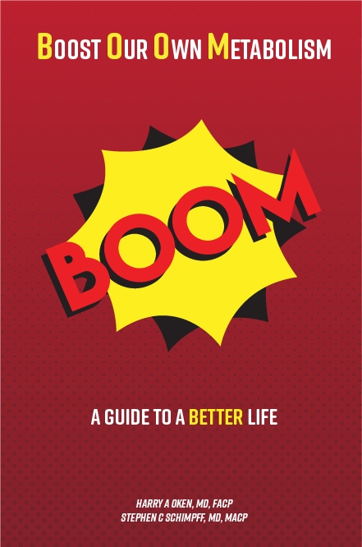
  Please consider purchasing a copy or copies today. Remember, all proceeds benefit COVID-19 research at the University of Maryland Medical Center. Ordering instructions are below.
  

Instructions for ordering the book:

- Paperback version - Click here to go directly to Amazon.
- Kindle e-book -
- If you are purchasing the Kindle e-book from a computer/laptop, click here to have the e-book version delivered to a Kindle app on your tablet or phone. This is the easiest method. Note, you will need to have the Kindle app installed on your tablet or phone. To do this, go to the App Store.
- If you are purchasing the Kindle e-book from an iPad or iPhone, you'll need to have the Kindle app installed. Open Safari on your device and go to this link. Then, in the top search bar, type in 'Oken BOOM' and it will bring you to the page to purchase it.

On a Musical Note: Smooth - Santana



On a lighter note: (thanks JF)
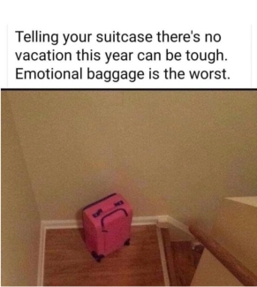

Reach out. Stay connected. Stay home. Save lives. The power of one. Be well.
Feel free to forward this on: spread the word, not the virus.

HAO, 24/7
Harry A. Oken, M.D.
Office: 410-910-7500, Fax: 410-910-2310, Cell: 443-324-0823
Adjunct Professor of Medicine, University of Maryland School of Medicine

Links for Today
- The Maryland Rt:
https://rt.live/?fbclid=IwAR1wdbbX1wtiPpnATDwr1fqRzgTXQZhomcO1lCk6bGrxae0ia8KUWOSa2HM#FL
- Smooth, Santana: https://www.youtube.com/watch?v=QcUxrpIwuQ4
- Boom Paperback: https://www.amazon.com/dp/B088B4PVZD/ref=sr_1_1?keywords=boom+oken&qid=1589025147&sr=8-1
- Boom, Kindle version:
https://www.amazon.com/BOOM-Boost-Our-Own-Metabolism-ebook/dp/B0882VV9K3/ref=tmm_kin_swatch_0?_encoding=UTF8&qid=1589025147&sr=8-1
- Kindle app: https://www.amazon.com/Kindle-Store/b?ie=UTF8&node=133140011

