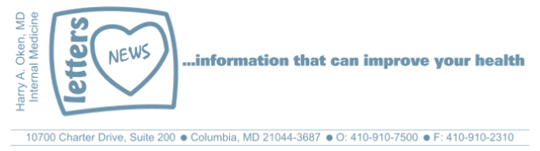
COVID-19-55 – May 9/10, 2020
Dear Patients,

Tomorrow is Mother's Day, of course. My family has had a yearly tradition of brunch every year for my entire married life (almost 42 years). This year is complicated, like it is for most of us. My daughter in NYC will FaceTime, my Nurse Anesthetist will social-distance and come over separately from my local daughter, son-in-law, and grandson. Yes, we need to continue to social distance. There will be no hugging or kissing, it will be different. COVID-19 has deprived us of the human touch. Perhaps until now, we have discounted the importance of this. Touch is healing; a hug, or reassuring embrace, or a kiss on the cheek sends immediate signals to our brain with a near-immediate release of hormones (first oxytocin, followed by cortisol), it also causes a reduction in heart rate and blood pressure by activation of the vagus nerve.

Beyond the value of touch within a family, it's been shown that when a teacher touches a student on the back of the arm, it increases the likelihood of the student paying attention. A high five during athletics improves performance. A waitress who greets you and touches your shoulder increases the likelihood of a larger tip. And in my business, there are few things more uplifting than a reassuring smile and a hand on a shoulder; it means I am with you; we will work out a plan and everything will be alright. And it will. In the big COVID picture, we are making progress, things are different but doable. So, hold the line.

And on this Mother's Day, I will be grateful for my wife, a terrific mom, and our kids and grandson.

The numbers:

Maryland: 31,534 cases -/- 1,510 deaths -/- 4.78% fatality rate
Close to 2/3 of the deaths in Maryland are those over the age of 70.

The Maryland Ro has not been updated since May 2 when it was <1.0; the lower the better.

It's here - both as a paperback and Kindle e-book!

I have one request of you when you finish reading this email, and that is, to please consider purchasing a copy or copies of my book to help fund important COVID-19 research.

This book has been a labor of love for me, and in that spirit, I am thrilled to announce that 100% of the profits are being donated to The University of Maryland Medical Center (UMMC) and COVID-19 research, headed by Greg Schrank, MD, MPH. Dr. Schrank is an epidemiologist with the UMMC Institute of Virology/Infectious Disease and co-chair of their COVID-19 Preparedness and Response Committee.

Steve Schimpff, my co-author, and I have long-term ties with UMMC and are deeply grateful to the opportunities our time there has brought us. Now, more than ever, is an opportunity to give back.

 | 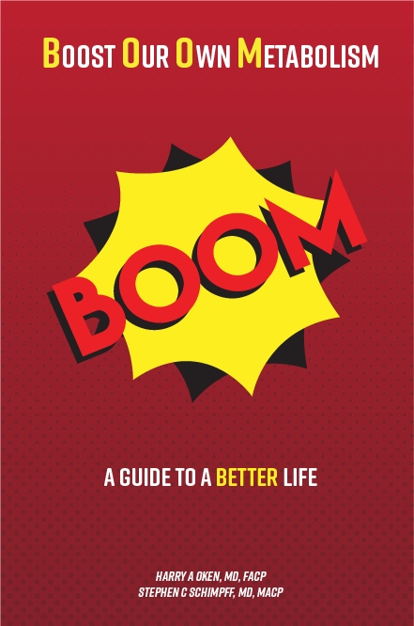
  Please consider purchasing a copy or copies today. Remember, all proceeds benefit COVID-19 research at the University of Maryland Medical Center. Ordering instructions are below.
  

Instructions for ordering the book:
Paperback version - Click here to go directly to Amazon.

Kindle e-book:
- If you are purchasing the Kindle e-book from a computer/laptop, click here to have the e-book version delivered to a Kindle app on your tablet or phone. This is the easiest method. Note, you will need to have the Kindle app installed on your tablet or phone. To do this, go to the App Store.
- If you are purchasing the Kindle e-book from an iPad or iPhone, you'll need to have the Kindle app installed. Open Safari on your device and go to this link. Then, in the top search bar, type in 'Oken BOOM' and it will bring you to the page to purchase it.

On a lighter note: I've often been told "stick to what you're good at!" Unfortunately, gardening doesn't fit into that category. For those of you who commented yesterday about how beautiful my backyard is, the photos yesterday were a joke! Neither photo was my backyard. To regain my credibility, below is a legitimate picture my wife took over our house yesterday afternoon of the Maryland National Guard Flyover as a salute to recognize healthcare workers, first responders, military, and other essential personnel, as well as those staying at home to flatten the curve of the COVID-19 pandemic. | 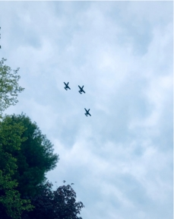

On a Musical Note: Now that some states are easing up, others aren't, and timelines are rapidly changing, everyone has to figure out what works for them while adhering to guidelines and not necessarily My Way. This one is dedicated to you Betty (and to you as well LJA); wishing you both a very happy Mother's Day!



Reach out. Stay connected. Stay home. Save lives. The power of one. Be well.
Feel free to forward this on: spread the word, not the virus.

HAO, 24/7
Harry A. Oken, M.D.
Office: 410-910-7500, Fax: 410-910-2310, Cell: 443-324-0823
Adjunct Professor of Medicine, University of Maryland School of Medicine

Links for Today
Frank Sinatra, My Way: https://www.youtube.com/watch?reload=9&v=iKAAz5xr310
BOOM - Paperback version:
https://www.amazon.com/BOOM-Boost-Our-Own-Metabolism-ebook/dp/B0882VV9K3/ref=sr_1_1?dchild=1&keywords=oken+boom&qid=1589037020&sr=8-1

