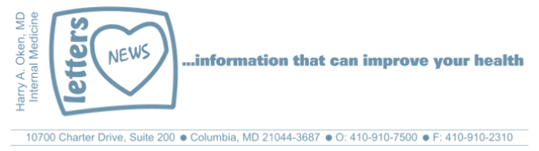
COVID-19-54 – May 8, 2020
Dear Patients,

t's Friday again. That went fast...or did it?

"Time is relative; its only worth depends upon what we do as it is passing." - Albert Einstein

Yesterday, I wrote about sanitizing the areas where we work and live. I mentioned that our attempt to clean, sanitize, sterilize, and isolate ourselves as healthy people has been the strategy for acute mitigation to avoid the health-care surge so that our hospitals, if challenged, would have adequate resources. I also pointed out that long term, there are unintended consequences when our immune system is not challenged by microorganisms naturally in our environment. To maintain a healthy immune system and our ability to have a robust response, we need to be challenged by our normal environment. A healthy immune system will defend us and we see this when we analyze the data.

For the most part, healthy people who get COVID-19 get an asymptomatic or mild infection. Unhealthy people do not fare as well. Analysis of the death rate in Maryland (54% of deaths are from nursing facilities), New York (almost 5,000 nursing facility deaths), and Italy (the oldest per capita population in Europe) demonstrates that the infirm and elderly are most vulnerable and have the highest mortality. This does not mean that an otherwise healthy person cannot get very ill and even die; this has happened, but this makes up a very small fraction of the severely ill. Moreover, we have learned that we must train and protect the health care workers who take care of these compromised patients.

I continue to advocate the continuation of good hand hygiene, social distancing, and strict isolation of these who are sick. We need innovative strategies that decrease the risk in heavily trafficked areas to decrease transmission, particularly in airports, subways, elevators, public bathrooms, etc. Let's do everything we can to make our immune system as strong and capable as possible so that even if challenged, our immune system defends us and wins. This is our best defense against COVID-19, heart disease, cancer, and stroke. And consider this: who is most vulnerable to doing poorly with a COVID-19 infection? Is it the overworked 55-year old sedentary obese male who smokes and has sleep apnea or the 72-year old who eats a plant-based diet, gets regular exercise, and gets 7-8 hours of sleep? Of course, the answer is obvious; good nutrition, adequate sleep, exercise, and controlling stress tips the scale in our direction for all maladies including COVID-19.

The numbers:
Maryland: 30,485 cases -/- 1,453 deaths -/- 4.76% fatality rate

Diagnostics and Therapeutics: Take your vitamin D-3, at least 2000 units per day! Here is the latest publication.

﻿ I'm keeping my fingers crossed that we are ready to go live tomorrow! Watch for upcoming details. | 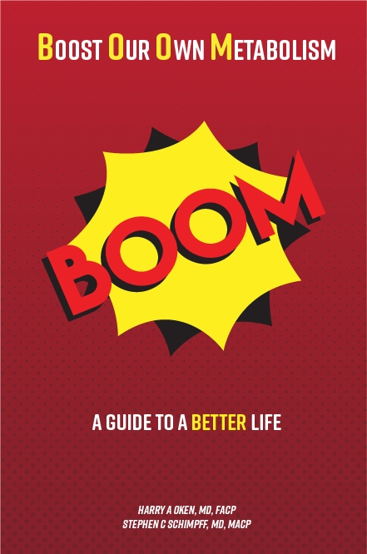

On a Musical Note: "Fly Like an Eagle" - the Steve Miller Band Check out the lyrics and how it relates to time.
https://www.youtube.com/watch?reload=9&v=cIARNcFlRbQ



On another TGIF lighter note: (thank you FS!!) Many of you know that I don't like to sit around; I like to be busy - see below!

People are always asking me, Dr. Oken, what have you been doing during the Coronavirus lockdown?
I just say, “puttering around in my backyard.

Before COVID-19 As of yesterday


Reach out. Stay connected. Stay home. Save lives. The power of one. Be well.
Feel free to forward this on: spread the word, not the virus.

HAO, 24/7
Harry A. Oken, M.D.
Office: 410-910-7500, Fax: 410-910-2310, Cell: 443-324-0823
Adjunct Professor of Medicine, University of Maryland School of Medicine

Links for Today
"Fly Like an Eagle" - the Steve Miller Band Check out the lyrics and how it relates to time.
https://www.youtube.com/watch?reload=9&v=cIARNcFlRbQ
Vitamin D linked to low virus death rate:
https://www.sciencedaily.com/releases/2020/05/200507131012.htm

