
COVID-19-53 – May 7, 2020
Dear Patients,

Well, it's official. Mitigation rules in Maryland are starting to be eased slowly, step by step, inch by inch. Just remember, it will continue to be a long and winding road

Organizations are struggling with new rules for opening. The service industry is particularly hard hit and it will be a while until restaurants are reopened; once they open, it will be different. Your server will be masked, the seating capacity will be reduced; all of this will profoundly change the social experience. And on the production side of food, the meat packaging plants are struggling, including poultry farming on the Eastern Shore of Maryland; a CDC team is actively investigating this hot spot. And this is only a small fraction of struggling industries.

We will learn in the near future the delicate balance between being routinely exposed to benign microorganisms while trying to eradicate the COVID-19 virus. And this will likely have some effect on our own internal ecosystem - the microbiome. Our systems are finely tuned for us to be able to live with bacteria and viruses which are normally abundant. Now, we will be killing bad guys, COVID-19, yet there will be collateral damage since we will have less exposure to normal flora. It is unclear what effects this will ultimately have. Physicians and scientists have to ask ourselves how will this affect our immune defenses in the future. Segregating ourselves from others decreases our exposure to many things that often we would eventually develop immunity to. All interesting questions, presently without an answer.

Let me leave you with this quote: (thank you LF) “I understand the fear, and the anxiety. I am not going to tell you the road ahead will be easy, but I will tell you that you have the power to keep walking one step at a time toward a better future. And I insist that you stand tall. You are strong, you are wise, you are capable. This is a setback, wrapped inside a global disaster, that has nothing to do with your skills, your character, or who you are. It happened to you. Don't let it define you.” - Suze Orman.

The numbers:
Maryland: 29,374 cases -/- 1,401 deaths -/- 4.67% fatality rate

Diagnostics and Therapeutics:
Nothing new to report!

We are finalizing the process  for the purchase of both an e-book  and paperback  and we will have the details soon!  Stay tuned! | 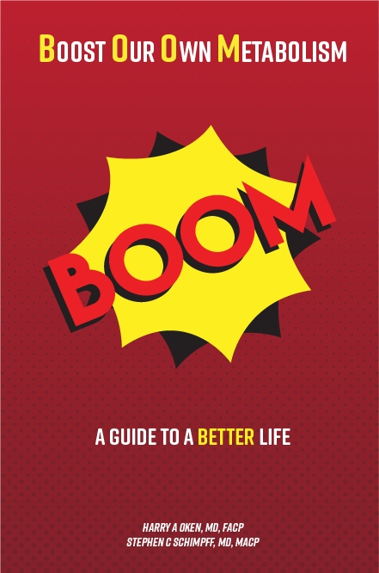

On a Musical Note:  "The Long and Winding Road" - The Beatles: https://www.youtube.com/watch?reload=9&reload=9&v=fR4HjTH_fTM | On the lighter side:
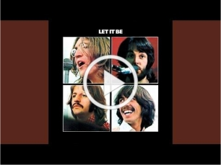 | 

Reach out. Stay connected. Stay home. Save lives. The power of one. Be well.
Feel free to forward this on: spread the word, not the virus.

HAO, 24/7
Harry A. Oken, M.D.
Office: 410-910-7500, Fax: 410-910-2310, Cell: 443-324-0823
Adjunct Professor of Medicine, University of Maryland School of Medicine

Links for Today
"The Long and Winding Road" - The Beatles: youtube.com/watch?reload=9&v=fR4HjTH_fTM

