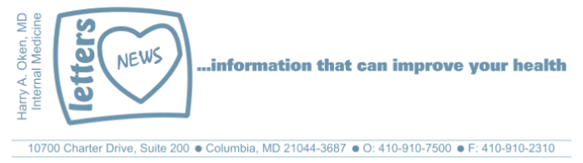
COVID-19-05 – March 17, 2020

Yes, this is serious!

We are in this together. What we do as a nation now will define whether this spins further out of control.

We must shelter in place. This applies to everyone unless you have a critical mission.

Working together, we can control this and stop the surge!

If you want to be part of the solution instead of part of the problem, then stay home!

Do you get it? The remedy is to stay home!

What is this surge? This refers to a doubling of COVID-19 cases every 2 - 4 days, some of which (primarily ages> 60 or underlying issues) will need hospitalization. Some will need to be in the ICU, requiring oxygen and even worse, some requiring a ventilator. The problem is we only have so many personnel, ICU beds and ventilators.

What is the solution? Reduce transmission.

How do we do this? Stay home!

What are COVID-19 symptoms? They are the same as any respiratory viral infection. So if you have symptoms, isolate yourself.
- Mild: runny nose, cough, achy, fever, fatigue
- Significant: the same symptoms as above plus feeling short of breath, possibly chest pain with deep breaths and cough
What do I do if I feel I may have it?
Stay home, get rest, use Tylenol (acetaminophen) preferentially for symptoms. We are not sure yet about OTC NSAIDs (Aleve/naproxen, Advil/ibuprofen). Use OTC cough meds, fluids, steam. If you have these symptoms, assume you may be infected and your job is to self-isolate for 14 days. Your likelihood of needing further medical attention is low but you are potentially infectious to others. And your self-quarantine is the key! Yes, for 14 days!

Should I get tested?
- Maybe, but it is still not easy to be tested
- Hard fast no if you have no symptoms and just want to know
- Yes, if you have a mission-critical job that involves being around other people and you have mild symptoms
- Yes, you will be tested if you have an emergency evaluation
- I will continue to address this ever-changing issue and will change as testing becomes more available
Why should I go to an Emergency Room?
If you are short of breath, running a high fever, unable to take fluids. You should call me first and we can determine the next move.

I am available 24/7 and I am in full technology mode at home; I am monitoring the progress of the pandemic & I'm taking calls & emails.

Be well! Be safe! Stay home!

Smile! It boosts your immune system!

And on a lighter note:


Harry A. Oken, M.D.
Office: 410-910-7500, Fax: 410-910-2310
Cell: 443-324-0823
Adjunct Professor of Medicine
University of Maryland School of Medicine

Confidentiality Statement:
This email message, including any attachments, is for the sole use of the intended recipient(s) and may contain confidential and privileged information. Any unauthorized use, disclosure or distribution is prohibited. If you are not the intended recipient, please contact the sender by reply email and destroy all copies of the original message.

