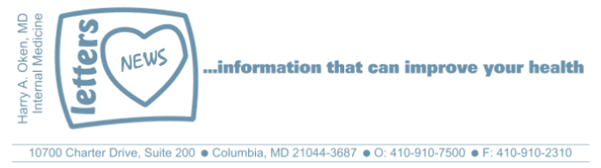
COVID-19-49 – May 2/3, 2020
Dear Patients,

 | Here in Maryland, Governor Hogan has declared today to be Health Care Heroes Day with fly-overs by the Blue Angels and Thunderbirds today in Baltimore followed by Washington, DC. | 

It may seem like we are in an orbit, circling around and around but not making any progress. Re-entry into our new world takes preparation and patience. And just like astronauts, we need to get through our checklist with the help of mission control to be ready to start our descent back. It's coming and it's coming soon.

I've been thinking about space and time. This made me look through one of my favorite biographies of all time, Einstein, by Walter Isaacson; only 551 pages, not including the bibliography. I've read it twice; it took me months. It was a review of college chemistry, math and physics, but more than that, it was about the wonders of life. There is a plethora of famous Einstein quotes that are so applicable to what we are going through these days.

Here are a few of my favorites that are so applicable to today:
- I'd rather be an optimist and a fool than a pessimist and right.
- In the middle of difficulty lies opportunity.
- Life is like riding a bicycle. To keep your balance, you must keep moving.

More on Einstein next week with comments from another one of his quotes "you never fail until you stop trying."

The numbers:
Maryland: 24,473 cases -/- 1,156 deaths -/- 4.7% fatality rate

The Maryland Ro: (see April 22 Update for explanation of Ro)
No real change, we remain stable and in the green zone, 0.89; lower is better.

Locally, all remains stable. Yesterday, I spoke to some colleagues at the University of Maryland Medical Center; their expectation is that in the near future, hospitals in Maryland will be given permission to begin elective procedures soon. This may be the first signal that the door to returning into our new reality is opening just a crack.

Diagnostics and Therapeutics:
Nothing new to report.

On a musical note:
Take a few minutes to watch this moving tribute to our Health Care Heroes recorded by Adam Lambert and Queen - a new version of Queen's classic anthem and retitled You Are The Champions.



And on a weekend lighter note: (thanks JF).



Reach out. Stay connected. Stay home. Save lives. The power of one. Be well.
Feel free to forward this on: spread the word, not the virus.

HAO
24/7

Harry A. Oken, M.D.
Office: 410-910-7500, Fax: 410-910-2310
Cell: 443-324-0823
Adjunct Professor of Medicine
University of Maryland School of Medicine

Videos of the Day
- You Are the Champions: https://www.youtube.com/watch?v=7LcLqIHzNkY

Tips of the Day
- In the Green Zone: https://rt.live/?fbclid=IwAR1wdbbX1wtiPpnATDwr1fqRzgTXQZhomcO1lCk6bGrxae0ia8KUWOSa2HM#FL

