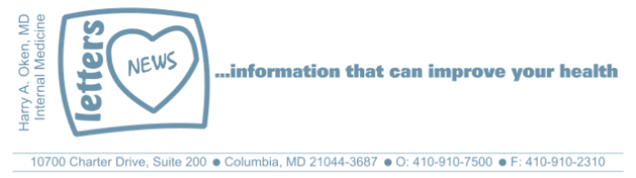
COVID-19-04 – March 16, 2020

Hello everyone,

"If you think you're overreacting, you're doing the right thing" Anthony Fauci, M.D., Director of National Institute of Allergy and Infectious Diseases

Kudos to our Governor! He has been ahead of the curve for COVID-19. And his new declaration closing bars and restaurants is on point!  The remedy for this problem is us - stay put!  We have contingency safety nets for all issues.  Testing continues to show prevalence is low <5% presently. In other words, 95% of patients who are tested with questionable exposure or symptoms do not test positive.  I'm available 24/7. Be well and be safe!  HAO | 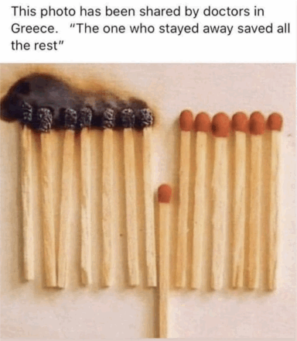
Harry A. Oken, M.D.
Office: 410-910-7500, Fax: 410-910-2310
Cell: 443-324-0823
Adjunct Professor of Medicine
University of Maryland School of Medicine

Confidentiality Statement:
This email message, including any attachments, is for the sole use of the intended recipient(s) and may contain confidential and privileged information. Any unauthorized use, disclosure or distribution is prohibited. If you are not the intended recipient, please contact the sender by reply email and destroy all copies of the original message.

