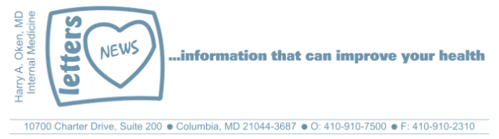
COVID-19-18 – March 31, 2020
Dear Patients,

The numbers:
US: 164,610 cases 3,170 deaths 1.9% fatality rate
Maryland: 1,660 cases 18 deaths 1.1% fatality rate
(11% of test in MD are positive; 14,868 total tests)

Since this pandemic began, I have taken care of many of you virtually and I am so thankful that the remedies and strategies have worked and kept you from harm's way. Yes, emphatically the majority of patients can stay at home, rest, take fluids, fever reducer (Tylenol) and sometimes some prescription medications and we can make it work. Technology helps with very close monitoring so that you never ever feel alone or without a clear-cut plan. I am with you 24/7. You will be found (see below)!

My patients are like my family. And I believe you are all listening. I hope that these daily updates have helped to ensure that you know our shelter in place plan is working. But we must not, we cannot, stop using our atomic weapons: stay home, hand washing, no face touching, frequent hand sanitizer, face masks if you are coughing to protect others.

The USS Comfort, a US Navy hospital ship, arrived in NYC yesterday. Terrific news - more heroes in place. But wait...look at these uninformed selfish people trying to take photos, standing shoulder to shoulder; this is a real photo from yesterday! Didn't they get the memo?? Exasperating!



Here is what our Governor said yesterday:
"This is a deadly public health crisis" said Hogan. "We are no longer asking or suggesting that Marylanders stay home. We are directing them to do so." Hogan said he has ordered state and local police to step up enforcement. Anyone found in violation of the order can be arrested and is subject to one year in jail and a $5,000 fine or both. The Governor said that the order would be sent as an emergency alert to all cellphone users in the state.

This virus is known to spread by respiratory droplets, either directly in your face from a sneeze or a cough, or droplets that end up on a surface. You then touch the surface and then touch your face and you may pick up the infection. Keep hand sanitizer with you. If you touch an elevator button or door handle, sanitize. If you carefully go to a store, sanitize; you leave the store, sanitize. Do not touch your face! Be aware of your hands when you're outside of a clean zone!

Again, do not touch your face! The average person touches their face 23 times per hour. The link below is the study: https://www.sciencedirect.com/science/article/pii/S0196655314012814

Therapeutics:
There is nothing new to report today.

An absolute must: (thanks JF - keep them coming!)
Many of you know from my previous Quarterly Newsletters that Dear Evan Hansen is one of my favorite all-time Broadway shows. There are so many lessons to be learned from this production. Please take a few minutes and watch this with a moving introduction from James Corden, YOU WILL BE FOUND.
https://www.broadwayworld.com/videoplay/VIDEO-Ben-Platt-Performs-You-Will-Be-Found-From-DEAR-EVAN-HANSEN-on-James-Cordens-HOMEFEST-20200331

Reach out. Stay connected. Stay home. Save lives. The power of one. Be well.
HAO
24/7

Harry A. Oken, M.D.
Office: 410-910-7500, Fax: 410-910-2310
Cell: 443-324-0823
Adjunct Professor of Medicine
University of Maryland School of Medicine

Tip of the Day
Face touching: https://www.sciencedirect.com/science/article/pii/S0196655314012814

Video of the Day
You Will Be Found: https://www.youtube.com/watch?v=_10msPMEick

