
COVID-19-12 – March 25, 2020

Dear Patients,

 | The signal that we are starting to control COVID-19 will be a leveling out of the daily death rate. When that starts to happen, most predict that the infection will begin to come under control. How can this come under control? By more strict shelter in place and aggressive measures of limiting inflow and exits from areas. You may have seen in parts of Asia where the workers wearing hazmat suits are spraying down the cities; this seems prudent.

Unfortunately, New York City is doing very poorly:

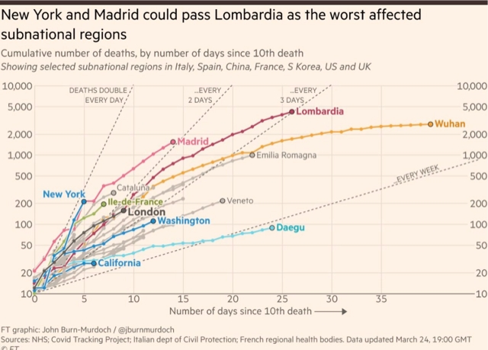
The numbers:
US: 55,225 cases 802 deaths 1.45% fatality rate (increase from yesterday)
South Korea: 9,137 cases 126 deaths 1.37% fatality rate (increase from yesterday)
Germany: 34,009 cases 172 deaths 0.5% fatality rate (stable)
Maryland: 423 cases 4 deaths 0.94% fatality rate

No change in my previous recommendations: stay home, remain vigilant, frequent hand washing, social distancing >6feet.

Therapeutics:
We are on Day 2 of the Columbia/Oz trial: 100 patients randomized with Hydroxychloroquine + Azithroymcin vs placebo.
Multiple vaccine efforts are underway. American ingenuity and the reduction of government rules will likely have something within 6-8 months.
Canada is studying an old gout drug called colchicine to minimize the inflammatory lung reaction caused by COVID-19 which effects 15-20% of those people infected and can lead to respiratory insufficiency. This is called a cytokine storm and is where my group is trying to get some interest in our steroid compound called BEA. It needs to tested and thank you to all of you who have been giving me leads to find partners to pass this baton forward.
Plasma from recovered patients may be of use since it contains neutralizing antibody and efforts are underway using this as a remedy.
There is interesting information about raising intracellular levels of zinc (thanks MM). It looks like this turns off viral replication inside the infected cells. The problem is getting the zinc into the cell; this may be one of the ways Hydroxychloroquine (HC) works. HC may facilitate extracellular zinc to get inside the infected cells to shut down viral replication. We don't know yet if giving extra zinc as a supplement may be helpful.
China claims that both IV and an oral high dose of Vitamin C may be helpful; I see no downside, but we need to prove this with good science.
Where does this leave us:
In the same place! Take care of yourself so you can take care of the people you love and depend on you!
- Stay home, be a hero; as Dr. Oz says: "the power of one".
- Wash your hands frequently.
- Do not touch your face.
- Eat healthy.
- Supplements: Vit D-3, 2000 units per day and a Multivitamin, no downside
- Get some exercise.
- If it's nice out, get 15-30 minutes of direct sunlight.
- Get restorative sleep: 6-8 hours/night.
- Smile: it's good for your head.
- Meditation can combat stress, check out Headspace, and thank you JW and GD for this: Click it
- Don't check your IRA/401k, it will only stress you. Remind yourself that it will come back. Why? Because this is America and that is who we are!
On a calming note:
This song by Adele (https://www.youtube.com/watch?v=hLQl3WQQoQ0) is considered one of the 10 most relaxing songs based on a study by neuroscientists at Mindlab International who measured participants' physiologic responses.

And finally, on a much lighter note: (thanks JF)

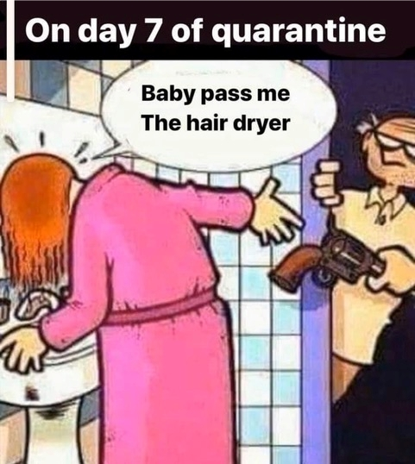

Stay put, be well---HAO
--
Harry A. Oken, M.D.

Office: 410-910-7500, Fax: 410-910-2310
Cell: 443-324-0823
Adjunct Professor of Medicine
University of Maryland School of Medicine

Videos of the Day
Willie Nelson and Friends: https://www.youtube.com/watch?v=tl0SIC3chbc
Adele – Someone Like You: https://www.youtube.com/watch?v=hLQl3WQQoQ0

Tip of Day
FACE COVID: https://drive.google.com/file/d/117HY4z4mY5izJpR44ejuZ8rhTyoWEGEG/view

See all previous COVID19 Updates
http://harryokenmd.com/COVID-19-HOME.htm

